System Design Fundamentals is designed to equip software engineers with the essential knowledge and skills required to design large complex systems.

Vikash Chauhan

System Design Fundamentals

Table of Contents

**Fundamentals Of High-Level System Design3**

**Distributed Systems4**

**Network Essentials7**

**Security17**

**System Design Architectures29**

**API38**

**Load Balancing46**

**API Gateway71**

**Rate Limiting82**

**Heart Beat**8**4**

**Circuit Breaker Pattern86**

**Distributed Tracing88**

**Failover91**

**Proxy Server92**

**Gossip Protocol100**

**Type chapter title (level 1)4**

**Type chapter title (level 1)4**

**Type chapter title (level 1)1**

**Type chapter title (level 1)4**

**Type chapter title (level 1)4**

**Type chapter title (level 1)1**

**Type chapter title (level 1)4**

**Type chapter title (level 1)1**

**Type chapter title (level 1)4**

Fundamentals Of High-Level System Design

High-Level System Design (HLD) provides an overview of a system, product, service, or process. It’s a generic system design that includes the system architecture, database design, and a brief description of systems, services, platforms, and relationships among modules.

Here are some fundamentals of High-Level System Design:

1.     **System Architecture:** The overall structure of the software and the ways in which that structure provides conceptual integrity for a system.

2.     **Database Design:** The process of producing a detailed data model of a database.

3.     **Managing Trade-offs:** While designing large scale applications, it’s important to manage trade-offs between consistency, availability, scalability, and performance.

4.     **Key System Resources:** Compute, storage, and network resources and how they can be scaled in a large-scale system.

5.     **Building Blocks of Large-Scale Systems:** Load balancers, proxies, gateways, caching solutions, and databases.

6.     **Inter-Process Communication:** This is key to architecting large scale micro-service-based applications.

The purpose of HLD is to present a clear and broad understanding of the system’s performance, scalability, and functionality. It describes the system architecture, which includes a database design and a synopsis of the systems’ platforms and services. It also describes the relationships between the modules present in the system.

In order to excel in system design, it is essential to develop a deep understanding of fundamental system design concepts, such as **Load Balancing**, **Caching**, **Partitioning**, **Replication**, **Databases**, and **Proxies**.

Distributed Systems

A distributed system is a collection of independent computers that appear to users as a single, unified system. These separate computers, also called nodes, communicate and coordinate with each other across a network to achieve a common goal.

# Key Characteristics of Distributed Systems

## 1. Scalability

Scalability is the ability of a system to handle an increasing workload, either by adding more resources **(scaling out)** or by upgrading the capacity of existing resources **(scaling up).** In distributed systems, scalability is essential to ensure that the system can effectively manage the growing demands of users, data, and processing power.

### A. Horizontal Scaling

Horizontal scaling, also known as scaling out, involves adding more machines or nodes to a system to distribute the workload evenly. This approach allows the system to handle an increased number of requests without overloading individual nodes. Horizontal scaling is particularly useful in distributed systems because it provides a cost-effective way to manage fluctuating workloads and maintain high availability.

### B. Vertical Scaling

Vertical scaling, or scaling up, refers to increasing the capacity of individual nodes within a system. This can be achieved by upgrading the hardware, such as adding more CPU, memory, or storage. Vertical scaling can help improve the performance of a system by allowing it to handle more workloads on a single node. However, this approach has limitations, as there is a physical limit to the amount of resources that can be added to a single machine, and it can also lead to single points of failure.

**Horizontal vs. Vertical Scaling**

With horizontal-scaling it is often easier to scale dynamically by adding more machines into the existing pool; Vertical-scaling is usually limited to the capacity of a single server and scaling beyond that capacity often involves downtime and comes with an upper limit.

Good examples of horizontal scaling are Cassandra and MongoDB as they both provide an easy way to scale horizontally by adding more machines to meet growing needs. Similarly, a good example of vertical scaling is MySQL as it allows for an easy way to scale vertically by switching from smaller to bigger machines. However, this process often involves downtime.

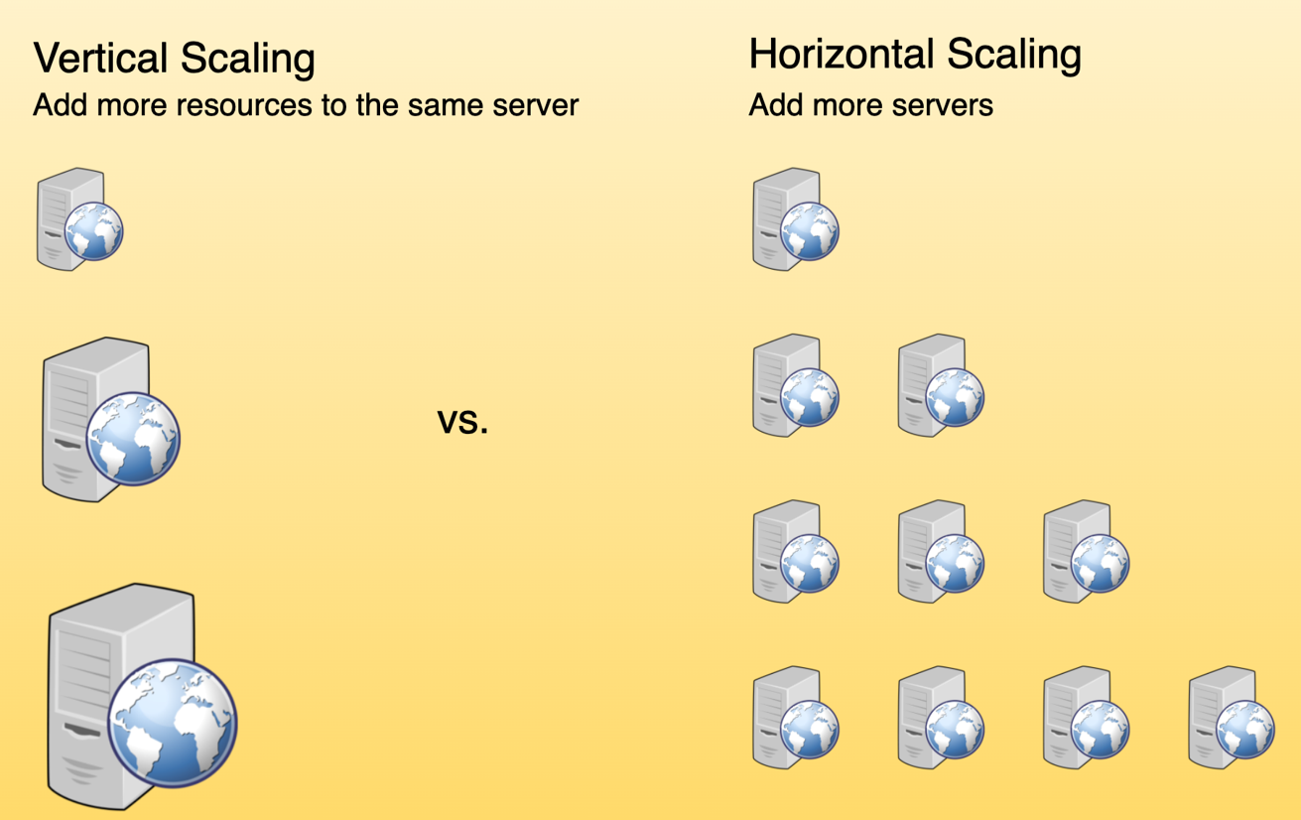

Vertical scaling vs. Horizontal scaling

## 2. Availability

Availability is a measure of how accessible and reliable a system is to its users. In distributed systems, high availability is crucial to ensure that the system remains operational even in the face of failures or increased demand. It is the backbone that enables businesses to provide uninterrupted services to their users, regardless of any unforeseen circumstances. In today’s fast-paced digital world, where downtime can lead to significant financial losses and reputational damage, high availability has become a critical requirement for organizations across various industries.

## 3. Latency and Performance

Latency and performance are critical aspects of distributed systems, as they directly impact the user experience and the system's ability to handle large amounts of data and traffic. In distributed systems, optimizing latency and performance involves considering factors such as data locality, load balancing, and caching strategies.

## 4. Concurrency and Coordination

In distributed systems, multiple processes or components often need to work together concurrently, which can introduce challenges related to coordination, synchronization, and data consistency.

## 5. Monitoring and Observability

Monitoring and observability are essential aspects of managing distributed systems, as they help identify issues, understand system behaviour, and ensure optimal performance.

## 6. Resilience and Error Handling

Resilience and error handling help minimize the impact of failures and ensure that the system can recover gracefully from unexpected events.

## 7. Fault Tolerance vs. High Availability

Fault Tolerance and High Availability are both critical concepts in system design, especially in the context of distributed systems, cloud computing, and IT infrastructure. They are strategies used to ensure reliable and continuous operation of a system, but they address different aspects and have distinct operational focuses.

**Fault Tolerance** refers to a system's ability to continue operating without interruption when one or more of its components fail. Fault-tolerant systems are designed to handle hardware, software, and network failures seamlessly.

Network Essentials

Network essentials are the fundamental concepts and building blocks of computer networks. They encompass the knowledge of how devices and computers communicate and share resources across a network. This foundational knowledge forms the basis for understanding more complex networking topics and configurations.

Here are some key areas covered in network essentials:

* **Network Components:** This includes understanding various networking devices like routers, switches, firewalls, and their functionalities within a network.
* **Network Protocols:** Learning about communication protocols like TCP/IP, which define how data is formatted, transmitted, and received across networks.
* **Network Topologies:** Grasping different network layouts (e.g., bus, star, mesh) and their strengths and weaknesses.
* **Network Security Basics:** Understanding fundamental security concepts like firewalls, access control, and encryption to protect network resources.
* **IP Addressing:** Learning about IP addresses (v4 and v6) and their role in uniquely identifying devices on a network.
* **Subnet Masking:** Understanding subnet masks used to divide networks into smaller logical segments for better organization and security.

# Network Protocols

The network protocols are like the traffic laws of computer networks. They define how devices communicate, ensuring orderly and efficient data exchange.

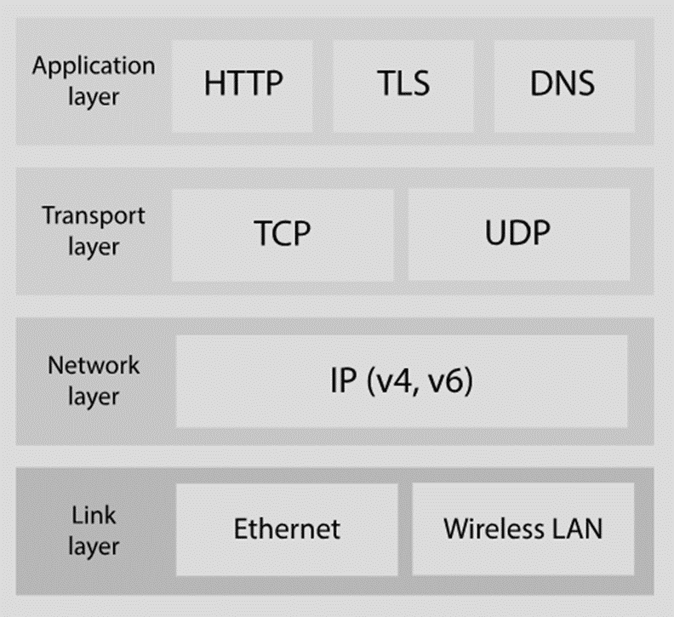

Here’s a focused look at two key layers and their primary protocols:

* **Application Layer (Layer 7):** Manages specific application tasks and data interactions.
* **Transport Layer (Layer 4):** Manages data delivery and reliability between applications.

## Application Layer (Layer 7)

* **HTTP:** Web content transfer
* **HTTPS:** Secure HTTP with encryption
* **FTP:** File transfers
* **SMTP:** Email
* **DNS:** Domain name resolution
* **WebSockets:** Full-duplex, real-time communication between web browsers and servers
* **WebRTC:** Peer-to-peer audio/video communication and data exchange

## Transport Layer (Layer 4)

* **TCP:** Reliable, connection-oriented delivery (like sending a tracked package)

Used by HTTP, HTTPS, WebSockets, WebRTC, and many others for guaranteed delivery.

* **UDP:** Unreliable, connectionless, faster but lossy (like sending a postcard)

Used for real-time applications (streaming, gaming) where some loss is acceptable.

**Key Considerations for System Design:**

* **Application Needs:** Match protocols to specific requirements (e.g., WebSockets for chat, WebRTC for video calls, TCP for file transfers, UDP for real-time gaming).
* **Network Conditions:** Consider bandwidth, latency, and reliability.
* **Security:** Implement appropriate measures based on protocol vulnerabilities.
* **Interoperability:** Ensure compatibility between devices and systems.
* **Reliability vs. Speed:** TCP for critical data, UDP for real-time applications where some loss is acceptable.
* **Latency:** WebRTC often offers lower latency than WebSockets.
* **Scalability:** WebSockets excel in scalability for server-client communication.



## HTTP vs. HTTPS

HTTP (Hypertext Transfer Protocol) and HTTPS (Hypertext Transfer Protocol Secure) are both protocols used for transmitting data over the internet, primarily used for loading webpages. While they are similar in many ways, the key difference lies in the security aspect provided by HTTPS.

Here's a comparison of HTTP and HTTPS:

|  |  |  |
| --- | --- | --- |
| **Feature** | **HTTP** | **HTTPS** |
| **Security** | No encryption, data sent in plain text | Encrypts data using TLS/SSL, securing information |
| **Data Privacy** | Vulnerable to eavesdropping and tampering | Protects data from unauthorized access |
| **Confidentiality** | Information like passwords can be stolen | Sensitive data like credit cards remains confidential |
| **Connection** | Connectionless, new connection per request | Secure connection established before data transfer |
| **Port** | Port 80 (default) | Port 443 (default) |
| **URL address** | Starts with "http://" | Starts with "https://" |
| **Content delivery** | May be faster due to simpler protocol | May be slightly slower due to encryption overhead |
| **SEO** | May be ranked lower by search engines | Preferred by search engines, may rank higher |
| **Trust** | May be seen as less trustworthy | Indicates a more secure and trustworthy connection |

In summary, HTTPS is the more secure version of HTTP because it encrypts data traveling between the browser and server. This encryption protects sensitive information like passwords and credit card numbers from being intercepted by hackers. While HTTP may be slightly faster, the security benefits of HTTPS make it the preferred protocol for most websites.

## TCP vs. UDP

TCP (Transmission Control Protocol) and UDP (User Datagram Protocol) are two of the main protocols used for transmitting data over the internet. Each has its characteristics, advantages, and disadvantages, making them suitable for different types of applications.

Here's a comparison list for TCP vs. UDP:

|  |  |  |
| --- | --- | --- |
| **Feature** | **TCP (Transmission Control Protocol)** | **UDP (User Datagram Protocol)** |
| **Connection Type** | Connection-oriented | Connectionless |
| **Reliability** | Guarantees in-order delivery of data | Does not guarantee delivery or order |
| **Error Checking** | Includes error checking and retransmission | Limited error checking, no retransmission |
| **Flow Control** | Prevents overwhelming receiver with data | No flow control |
| **Speed** | Slower due to connection setup and overhead | Faster due to simpler protocol |
| **Security** | More secure due to connection management | Less secure, no connection management |
| **Applications** | Web browsing, email, file transfer | Online gaming, live streaming, VoIP |

**Additional Points:**

* **Data Stream vs. Message Stream:** TCP treats data as a stream of bytes, ensuring all parts arrive and in order. UDP sends individual datagrams (messages) that may arrive out of order or not at all.
* **Complexity:** TCP is a more complex protocol due to its connection management and error checking features.
* **Suitability:** Choose TCP for reliable data delivery where order and accuracy are crucial. Choose UDP for speed-critical applications where occasional data loss is acceptable.

### HTTP Keep-Alive

**HTTP Keep-Alive, linked to HTTP persistent connections, operates at the application layer.**

HTTP, except for HTTP/3, is built on TCP. Establishing an HTTP connection requires a 3-way TCP handshake. After sending an HTTP request and receiving a response, the TCP connection disconnects.

Sending multiple requests to the same server this way is quite inefficient. Wouldn’t it be better to reuse the same TCP connection? That’s the purpose of HTTP Keep-Alive. It maintains the TCP connection until either party requests disconnection.

HTTP/1.1 enables HTTP Keep-Alive by default.

HTTP Keep-Alive reduces the overhead of opening and closing TCP connections. It's even more powerful when combined with HTTP/2, which introduces the concept of “streams”.

Streams allow us to send multiple requests simultaneously without waiting for server responses. More importantly, these requests and responses can be handled out of order, which is not possible with only HTTP Keep-Alive.

The comparison diagram below shows the difference between HTTP Keep-Alive and HTTP/2 streams. Normally, we wait for the first response before sending a second request. With HTTP/2 streams, we can send multiple requests simultaneously without waiting for the first response, and the server can respond out of order.

Why is this important? This feature is crucial to avoid head-of-line (HOL) blocking. **In earlier versions of HTTP, if the server takes a long time to process one request, subsequent requests have to wait, leading to delays.** **But with HTTP/2 streams, each request is independent. Even if a server takes longer to process one request, it can still respond to other requests.** Responses can come back as soon as they're ready, even if that means they're not in the original request order.

[[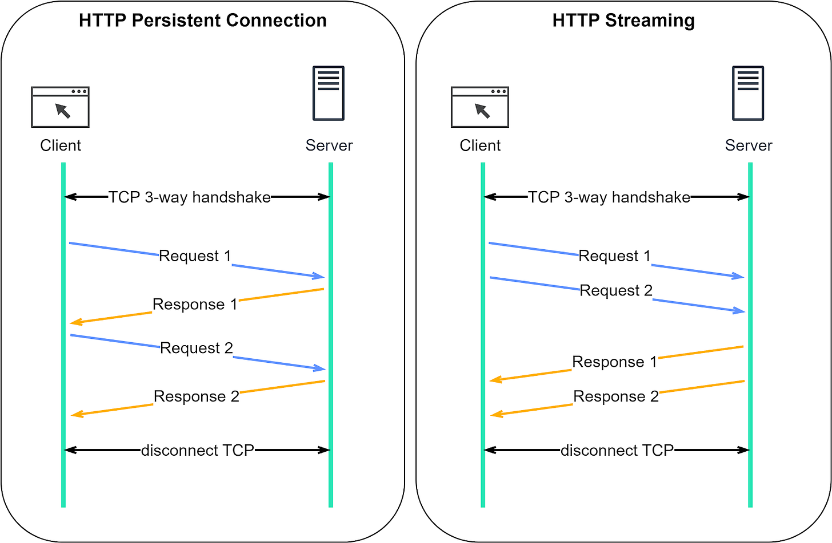](https://substackcdn.com/image/fetch/f_auto,q_auto:good,fl_progressive:steep/https%3A%2F%2Fsubstack-post-media.s3.amazonaws.com%2Fpublic%2Fimages%2Fd9d498fd-b0ce-49af-91a5-3fcae4680514_1600x1046.png)](https://substackcdn.com/image/fetch/f_auto,q_auto:good,fl_progressive:steep/https%3A%2F%2Fsubstack-post-media.s3.amazonaws.com%2Fpublic%2Fimages%2Fd9d498fd-b0ce-49af-91a5-3fcae4680514_1600x1046.png" \t "_blank)

## TCP keepalive

**TCP keepalive, working at the transport layer, keeps a TCP connection alive during periods of data exchange inactivity.**

TCP keepalive is unrelated to HTTP Keep-Alive. In a TCP connection, both parties remain in the ESTABLISHED state until one ends it. **If one party disconnects without notifying the other, the remaining party wouldn’t know about it. TCP keepalive addresses this by periodically sending probes when there’s no data exchange.** We discussed this in our previous TCP issue. The following diagram should serve as a refresher.

[[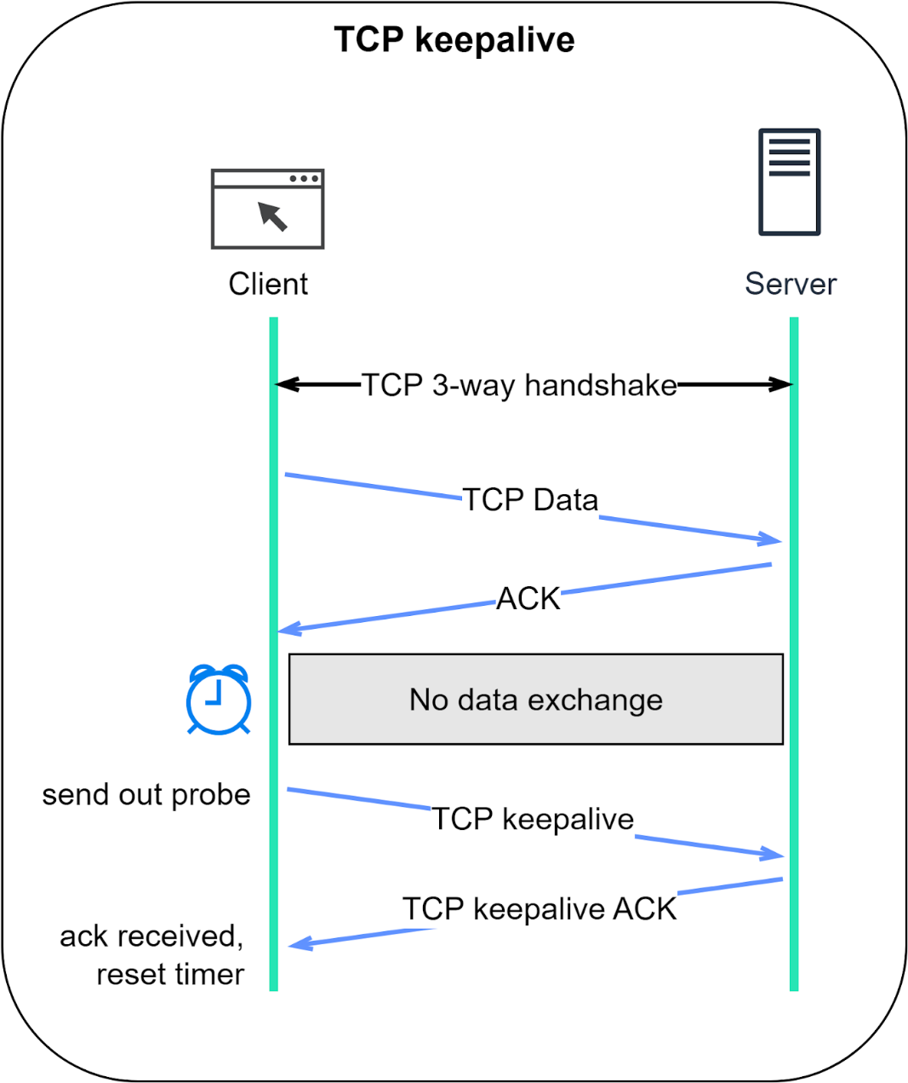](https://substackcdn.com/image/fetch/f_auto,q_auto:good,fl_progressive:steep/https%3A%2F%2Fsubstack-post-media.s3.amazonaws.com%2Fpublic%2Fimages%2F339a0b68-b25f-49a2-a810-35297d4e5bc7_1344x1600.png)](https://substackcdn.com/image/fetch/f_auto,q_auto:good,fl_progressive:steep/https%3A%2F%2Fsubstack-post-media.s3.amazonaws.com%2Fpublic%2Fimages%2F339a0b68-b25f-49a2-a810-35297d4e5bc7_1344x1600.png" \t "_blank)

## URL vs. URI vs. URN

Understanding the differences between URL, URI, and URN can be crucial in web development and networking.

### URI

URI stands for Uniform Resource Identifier. It identifies a logical or physical resource on the web. URL and URN are subtypes of URI. URL locates a resource, while URN names a resource.

A URI is composed of the following parts:

**scheme:[//authority]path[?query][#fragment]**

### URL

URL stands for Uniform Resource Locator, the key concept of HTTP. It is the address of a unique resource on the web. It can be used with other protocols like FTP and JDBC.

### URN

URN stands for Uniform Resource Name. It uses the urn scheme. URNs cannot be used to locate a resource. A simple example given in the diagram is composed of a namespace and a namespace-specific string.

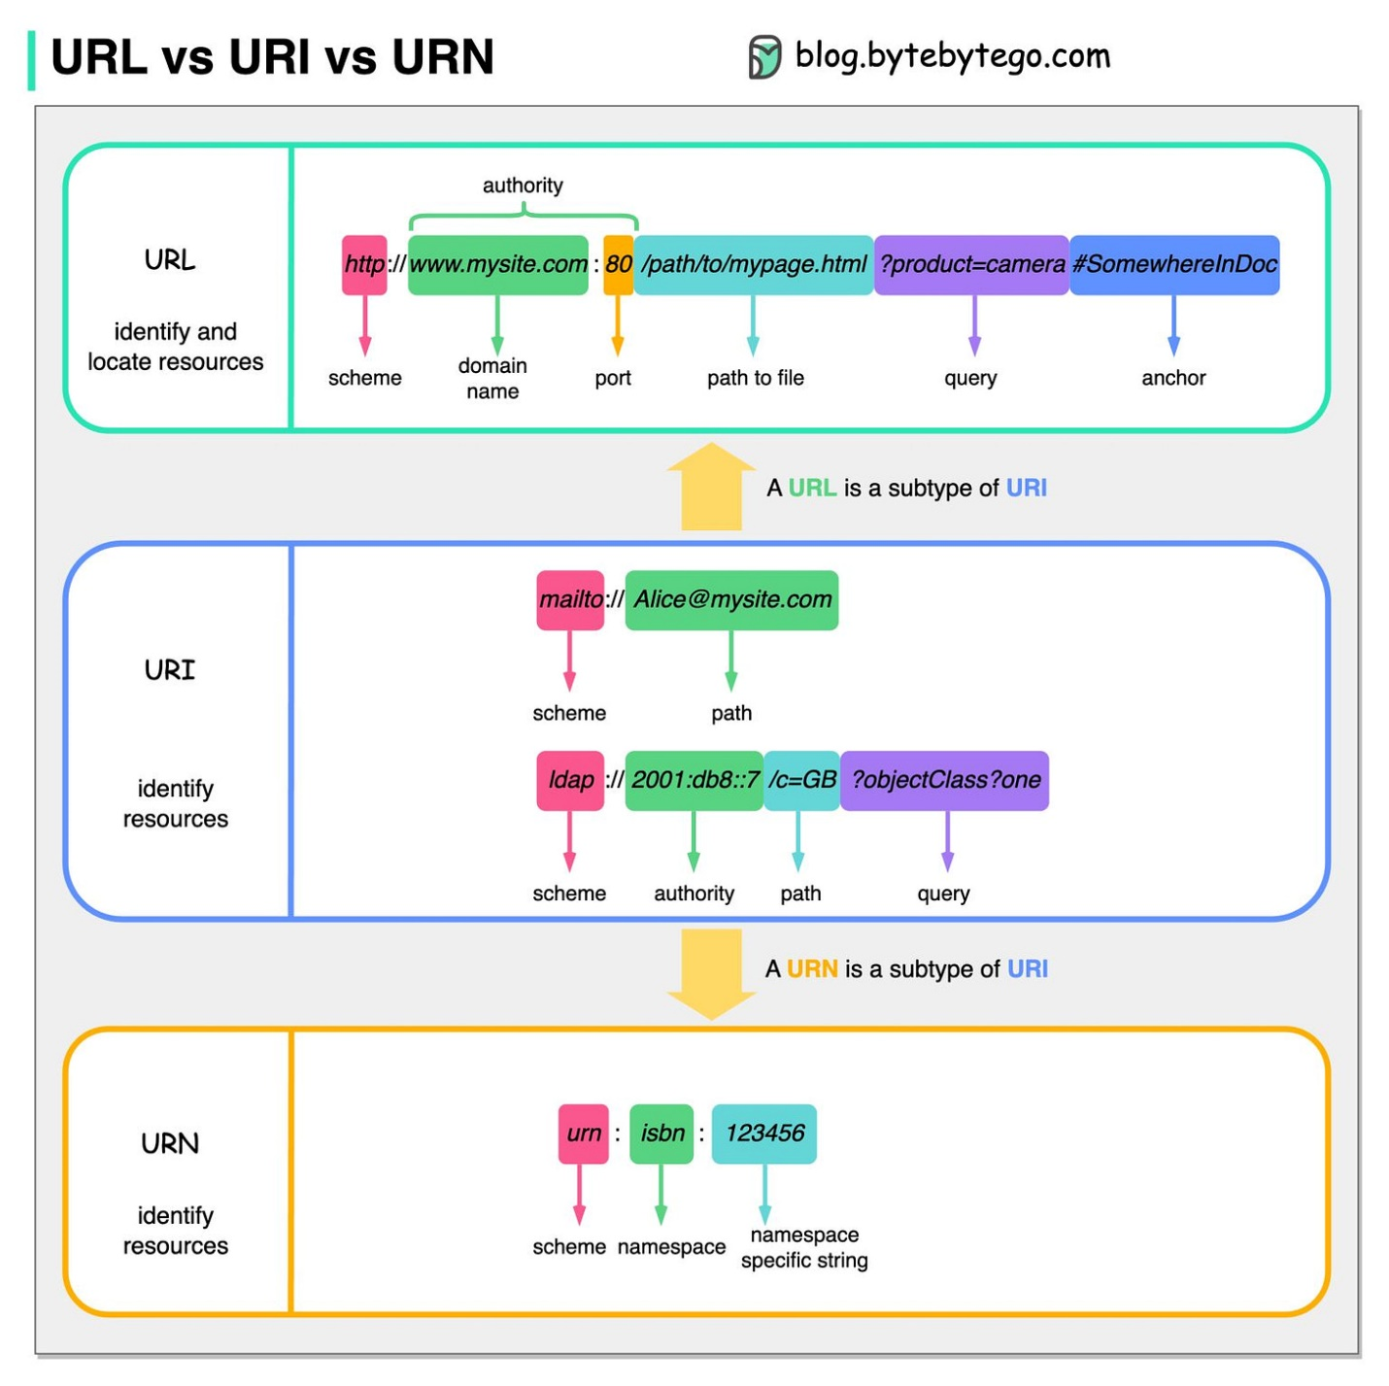

Here's a comparison list for URL vs. URI vs. URN:

|  |  |  |  |
| --- | --- | --- | --- |
| **Feature** | **URL (Uniform Resource Locator)** | **URI (Uniform Resource Identifier)** | **URN (Uniform Resource Name)** |
| **Function** | Locates a resource on a network | Identifies a resource | Names a resource uniquely |
| **Location Specificity** | Includes location (e.g., server address) | May or may not include location | Does not include location |
| **Access Mechanism** | Often implies access method (e.g., HTTP) | Does not imply access method | Does not imply access method |
| **Example** | https://www.example.com/ | urn:isbn:0-302-38402-6 | doi:10.1126/science.1234567 |
| **Permanence** | May change if resource location moves | Can be persistent even if resource moves | Designed to be persistent |
| **Use Case** | Web browsing, downloads | Citations, references | Digital object identifiers (DOIs) |

**Additional Points:**

* **URI Hierarchy:** URL and URN are both types of URIs. A URI acts as an umbrella term for any identifier for a resource.
* **URL Breakdown:** A URL typically consists of a protocol (e.g., https), domain name, path, and query string.
* **URN Breakdown:** A URN usually starts with "urn:" followed by a namespace identifier and a specific identifier for the resource within that namespace.
* **Real-World Analogy:**
  + URL: Like a physical address that tells you how to get to a house (location and access method).
  + URI: Like a name tag that identifies a person (unique identifier).
  + URN: Like a social security number that uniquely identifies a person regardless of their address (unique name).

# Latency vs Throughput

Latency and throughput are two metrics that measure the performance of a computer network. **Latency is the delay in network communication. It shows the time that data takes to transfer across the network from client to server and vice versa** (client->server->Process request->client). Networks with a longer delay or lag have high latency, while those with fast response times have lower latency. In contrast, throughput refers to the average volume of data that can actually pass through the network over a specific time. It indicates the number of data packets that arrive at their destinations successfully and the data packet loss. **In other words, how much data a server can process within a given time frame.** If server is able to process more data in than server has heigh throughput else low throughput.

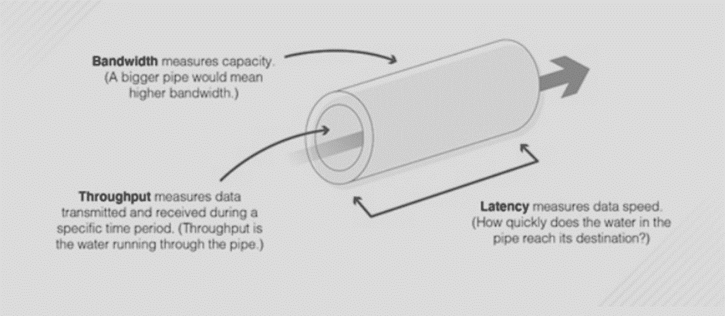

## Network Performance: Key Metrics Explained

**Three vital measures:**

* **Latency:** Delay in data transfer, impacting response times (low = fast, high = slow).
* **Throughput:** Volume of data transferred over time, indicating capacity (high = handles lots of data, low = easily overloaded).
* **Bandwidth:** Bandwidth refers to the amount of data that can be transmitted and received during a specific period of time.

**Why they matter:**

* **Speed:** Determine overall network speed and user experience.
* **Efficiency:** Low latency ensures responsiveness, high throughput supports many users.
* **Impact:** High performance boosts revenue and operational efficiency.

**Measuring them:**

* **Latency:** Ping time (round-trip) in milliseconds (lower = better).
* **Throughput:** Network testing tools or manual calculations (divide file size by transfer time).

**Units:**

* **Latency:** Milliseconds (ms).
* **Throughput:** Bits per second (bps), kilobytes per second (KBps), megabytes per second (MBps), gigabytes per second (GBps).
* **Bandwidth:** Bits per second (bps), kilobytes per second (KBps), megabytes per second (MBps), gigabytes per second (GBps).

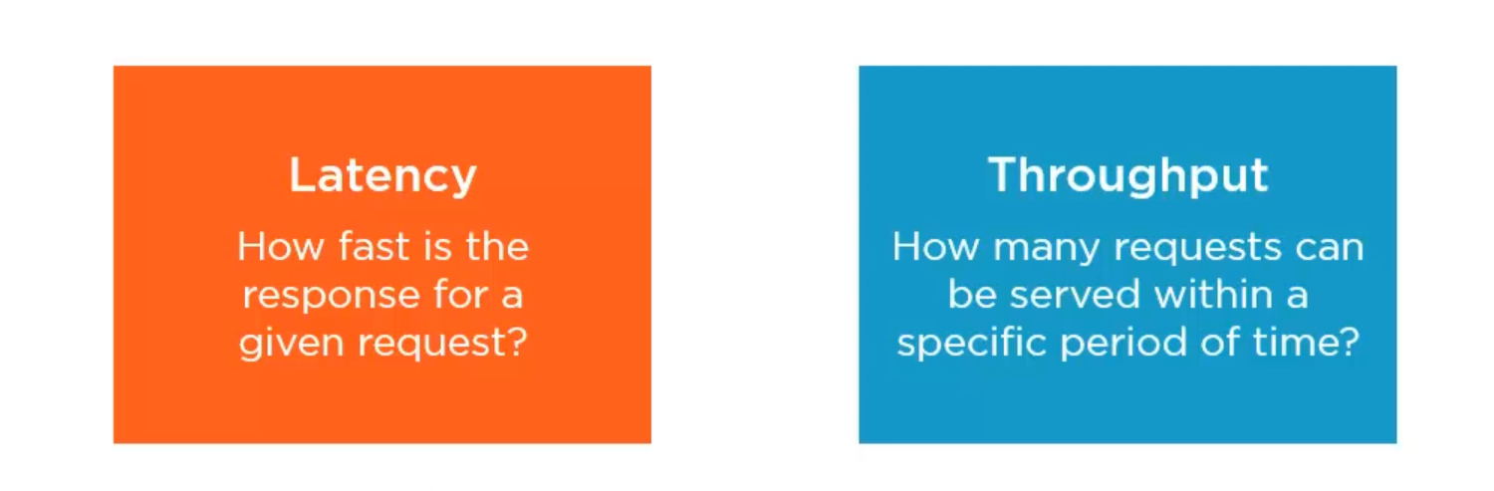

## Bandwidth vs Throughput

While throughput and bandwidth may seem similar, there are some notable differences between them. If bandwidth is the pipe, then throughput is the water running through the pipe. The bigger the pipe, the higher the bandwidth, which means a greater amount of water can move through at any given time.

In a network, **bandwidth availability determines the number of data packets that can be transmitted and received during a specific time period, while throughput informs you of the number of packets actually sent and received.**

**Influencing factors:**

* **Latency:** Location, congestion, protocols, network infrastructure.
* **Throughput:** Bandwidth, processing power, packet loss, network topology.

**Relationship:**

* Both work together for optimal performance.
* Bandwidth sets the upper limit for throughput.
* Low latency improves efficiency even with limited bandwidth.

**Takeaway:** Understand and optimize latency and throughput for a responsive, efficient network that supports your needs.

Security

Ensuring security and privacy in distributed systems is essential to protect sensitive data, user information, and system integrity. Distributed systems face unique challenges related to security and privacy due to their distributed nature, which makes them more vulnerable to attacks and data breaches. Here's an overview of various aspects of security and privacy in distributed systems:

# Authentication and Authorization

Authentication and authorization are critical components of security in distributed systems.

In a distributed system, where tasks and data are spread across multiple servers, securing access to resources and information becomes paramount. Traditional security models designed for centralized systems often fall short in this complex environment. This is where authentication and authorization come into play, acting as a two-step verification process to ensure only authorized users can access specific resources.

## What is Authentication?

Authentication in software systems is like showing your ID at the entrance of a club. It's the process of verifying who you are.

Just like the bouncer checks your ID, authentication in software checks if you are who you say you are. This is usually done through something you know (like a password), something you have (like a phone or security token), or something you are (like your fingerprint).

### Types of Authentication in Distributed Web Development

In distributed web development, where applications are spread across multiple servers, securing access to user data and functionalities becomes even more critical. Traditional single-server authentication methods might not be sufficient. Here's a breakdown of common authentication types used in distributed web development:

**1. Single-Factor Authentication (SFA):**

* **Concept:** Similar to showing a single ID card at a club entrance. Users rely on one factor, typically a password or username, to verify their identity.
* **Security:** Least secure option. Passwords can be vulnerable to hacking, phishing, and brute-force attacks.
* **Use Cases:** Low-security applications where the risk of data breaches is minimal. Often used in conjunction with other security measures like session timeouts.

**2. Multi-Factor Authentication (MFA):**

* **Concept:** Requires two or more verification factors to gain access. This adds layers of security beyond just a password.
* **Common Factors:**
  + **Something you know:** Password, PIN, security question.
  + **Something you have:** Phone with a verification app, security token.
  + **Something you are:** Fingerprint, facial recognition, iris scan.
* **Security:** Significantly improves security compared to SFA. Bypassing MFA usually requires compromising multiple factors, making it more challenging for attackers.
* **Use Cases:** Widely used in distributed web applications, especially those dealing with sensitive user data or financial transactions.

**3. Token-Based Authentication:**

* **Concept:** Uses short-lived tokens issued after successful authentication to verify user identity for subsequent requests. This reduces reliance on constant password verification.
* **Workflow:**
  + User logs in with credentials (username/password).
  + Server validates credentials and issues a token.
  + Subsequent requests include the token for verification.
  + Token expires after a certain time, requiring re-authentication.
* **Security:** Improves security as tokens are time-limited and don't expose actual passwords during every request.
* **Use Cases:** Popular approach in distributed web applications due to its scalability and security benefits. Often used in conjunction with mechanisms like OAuth and OpenID Connect.

**4. API Key Authentication:**

* **Concept:** Uses unique API keys to identify and authorize applications or services to access specific resources within a distributed system.
* **Security:** Provides a mechanism for controlled access to APIs by external applications. Requires proper key management to prevent unauthorized access.
* **Use Cases:** Essential for distributed systems with APIs that allow external applications to interact and access data.

**5. OAuth and OpenID Connect:**

* **Concept:** These are open standards that enable secure sign-in using existing user accounts from third-party providers (e.g., Google, Facebook).
* **Benefits:**
  + Users can sign in with familiar credentials.
  + Applications avoid storing user passwords, reducing security risks.
  + Standardized approach simplifies integration for developers.
* **Use Cases:** Widely used in modern web applications to offer convenient and secure login options for users.

**Choosing the Right Authentication Method:**

The choice of authentication method depends on several factors, including:

* **Security requirements:** How sensitive is the user data and functionality being protected?
* **User experience:** How easy and convenient should the login process be for users?
* **Scalability:** Can the chosen method handle a potentially large number of users and requests efficiently?

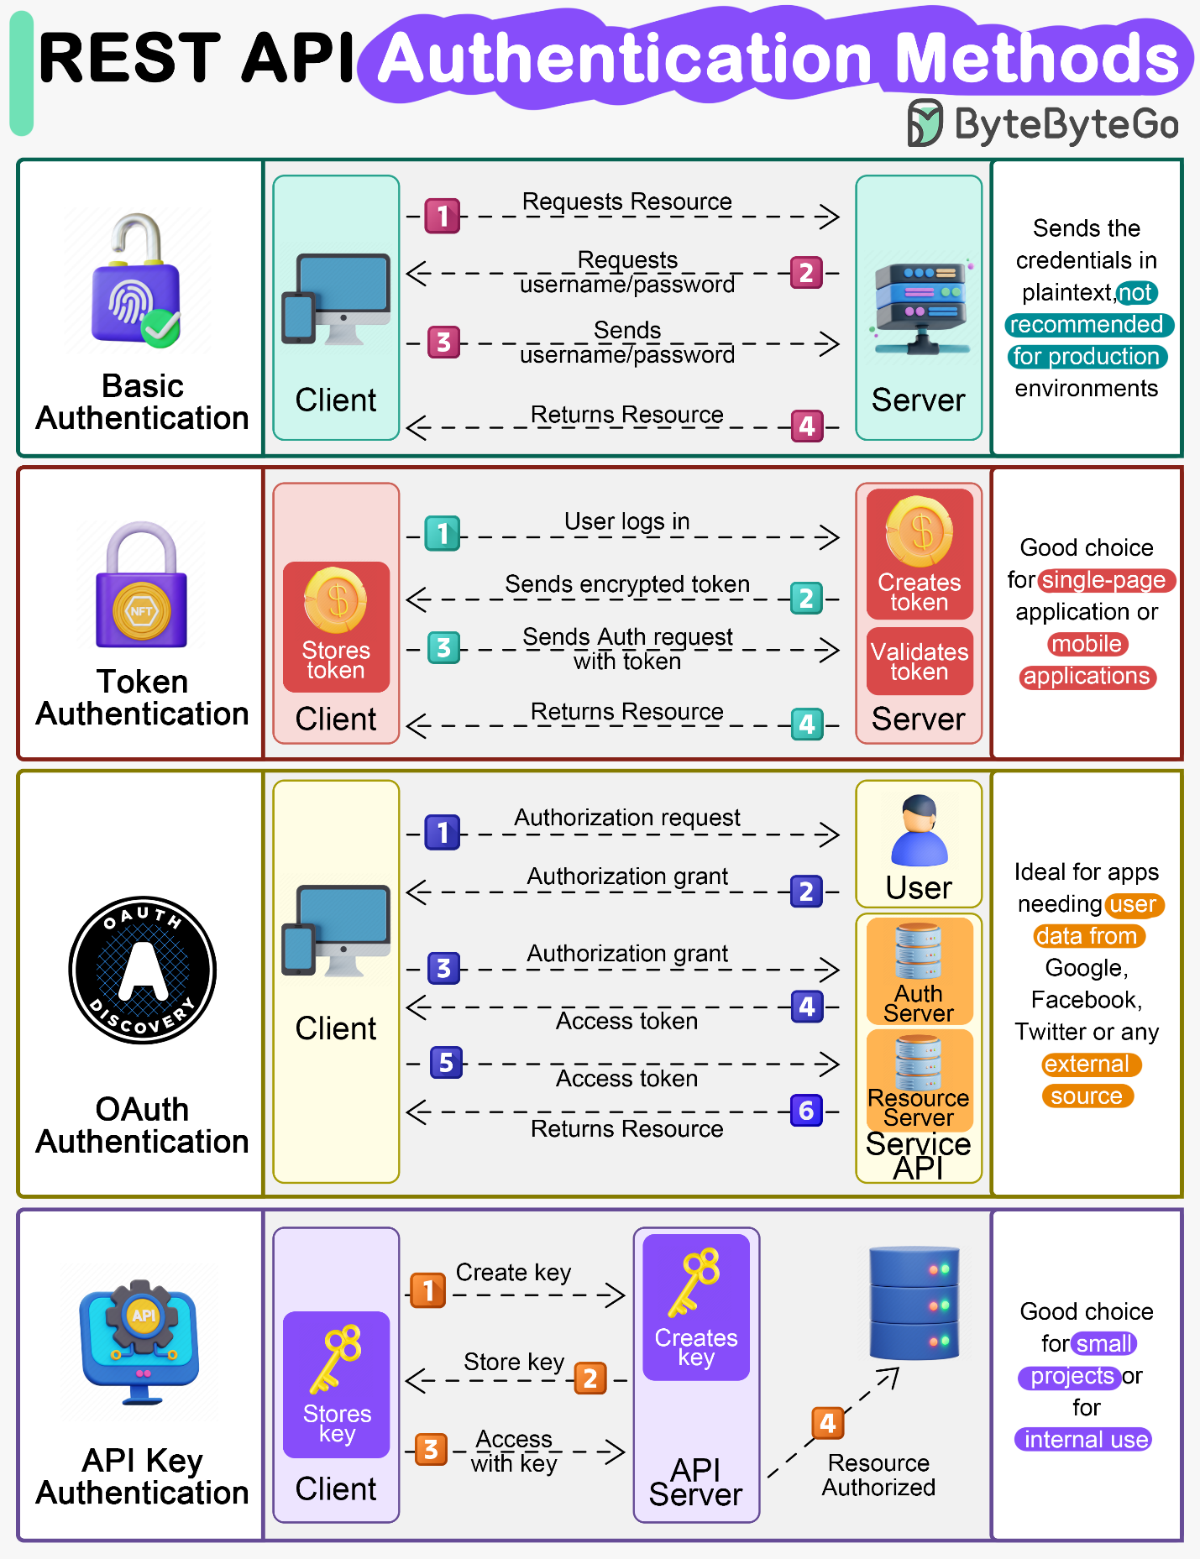

By considering these factors and understanding the different types of authentication available, developers can implement robust security measures for their distributed web applications.

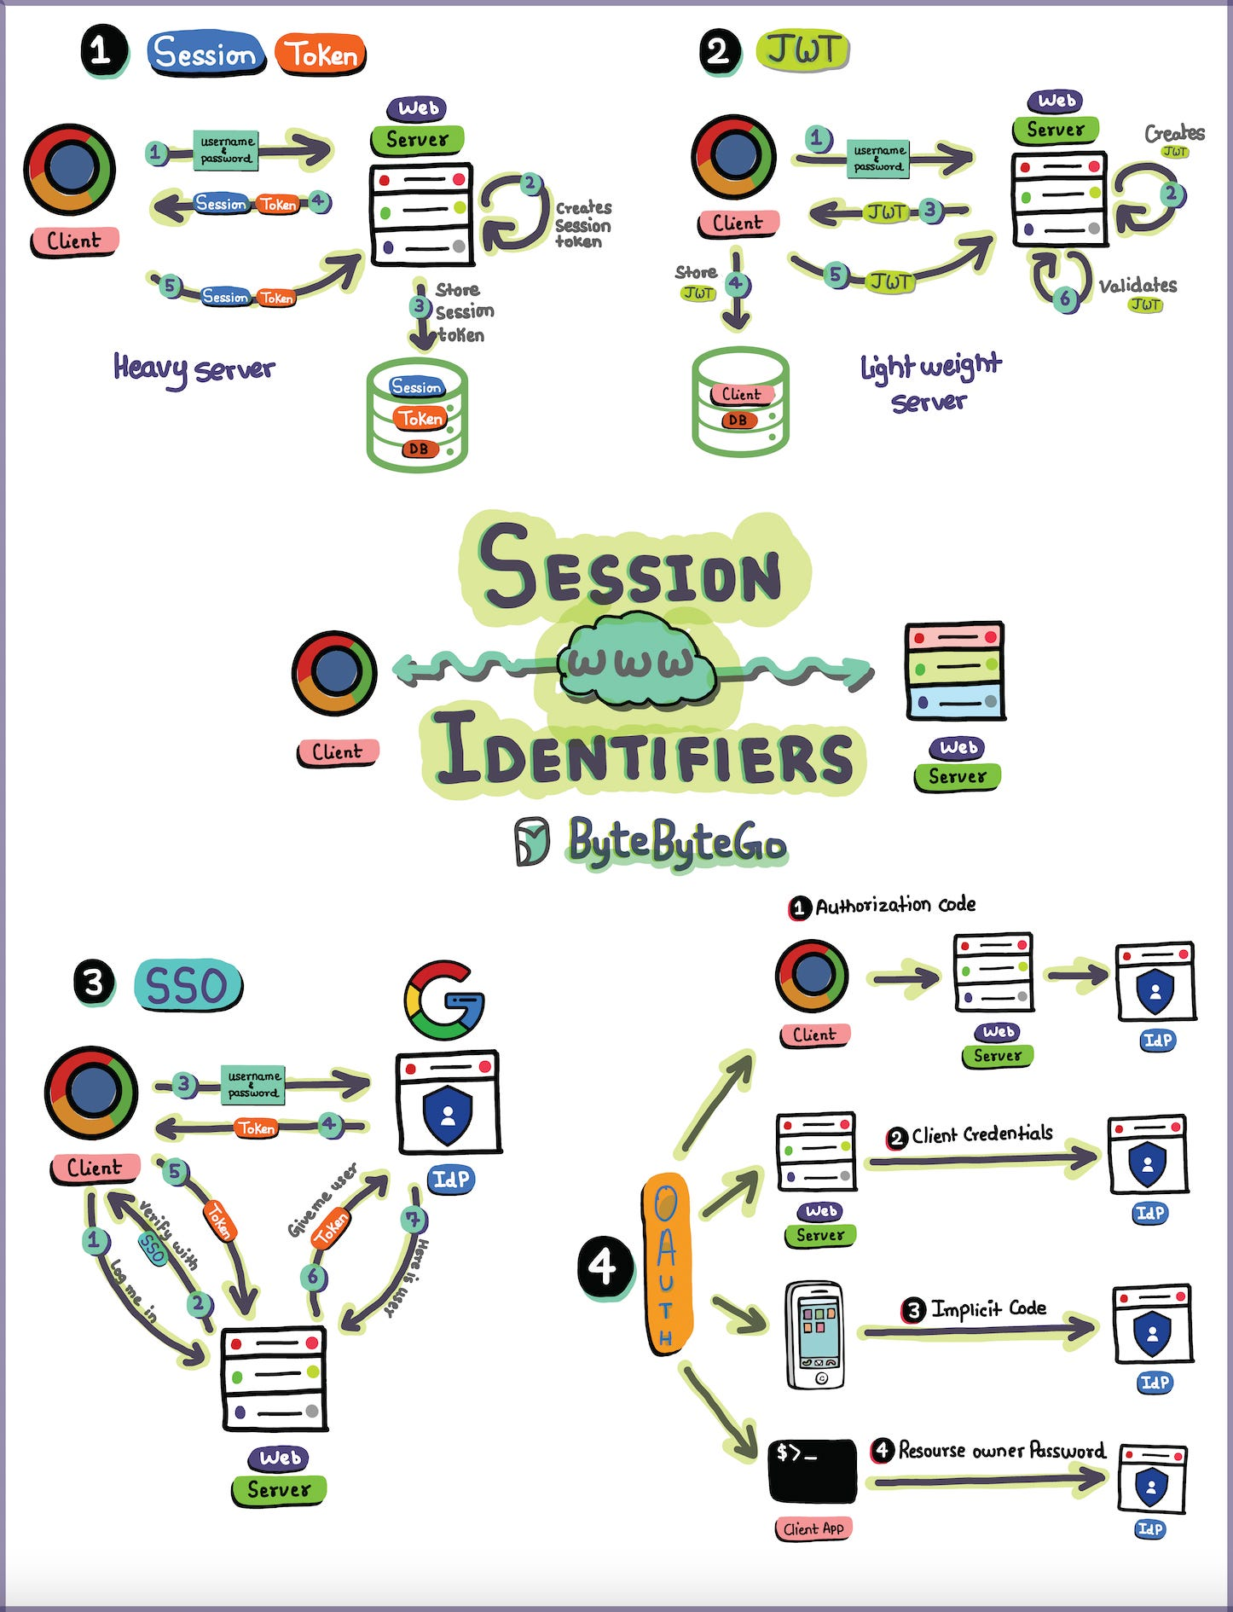

## What is Authorization?

Authorization in software systems is like getting a specific wristband at a festival that allows you access to certain areas. It's about granting or denying permissions to do something after your identity is verified.

Authorization always comes after authentication. First, the system recognizes you (like the club knows who you are), and then it decides what you are allowed to do (like what areas of the club you can enter).

For an example, imagine a music festival with different colored wristbands granting access to specific areas. Authentication verifies your identity at the entrance (checking your ID), while authorization determines which wristband (permission level) you receive (granting access to certain stages or areas).

**Roles and Permissions:**

* **Roles:** These represent different user categories within a system, similar to various colored wristbands at a festival. Examples include "admin," "editor," "user," etc.
* **Permissions:** These are specific actions a user with a particular role can perform. They define what users can do within the system, like "create content," "edit posts," or "view private data."

**Authorization Mechanisms:**

* **Access Control Lists (ACLs):** Explicitly list users or groups and their associated permissions for specific resources. This approach can become complex for large systems with many users and resources.
* **Role-Based Access Control (RBAC):** Defines roles with pre-defined sets of permissions. This simplifies user access management as users are assigned roles with pre-conceived permissions.
* **Attribute-Based Access Control (ABAC):** Makes access decisions based on a combination of factors: user attributes (role, department), resource attributes (confidentiality level), and environmental conditions (time of day). This offers more flexibility but can be more complex to implement.

**Authorization in Distributed Systems:**

* **Centralized vs. Decentralized:** In a distributed system, a central authorization server might not be ideal due to scalability and single point of failure concerns. Decentralized approaches may involve storing authorization policies on individual servers or using tokens with embedded permissions.
* **Consistency:** Ensuring consistent enforcement of access control policies across all servers in the distributed system is crucial to prevent unauthorized access.

**Benefits of Strong Authorization:**

* **Data Security:** Limits access to sensitive data only to authorized users.
* **Compliance:** Helps meet regulatory requirements for data protection.
* **Improved User Experience:** Provides a controlled environment where users can perform intended actions without unnecessary restrictions.

**Choosing the Right Authorization Method:**

The selection of an authorization approach depends on several factors:

* **Complexity of access control needs:** How granular do permissions need to be?
* **System size and scalability:** Can the chosen method handle a large number of users and resources efficiently?
* **Security requirements:** How critical is it to ensure consistent enforcement of access control policies?

By implementing a robust authorization strategy in conjunction with effective authentication, developers can create secure and well-controlled distributed web applications.

## Authentication vs. Authorization

|  |  |  |
| --- | --- | --- |
| **Feature** | **Authentication** | **Authorization** |
| **Purpose** | Verifies a user's identity | Determines what a user can do within the system |
| **Analogy** | Checking ID at a club entrance | Granting specific wristbands for festival areas |
| **Focus** | Who you are | What you can do |
| **Methods** | Username/password, MFA, tokens | Roles, permissions (ACLs, RBAC, ABAC) |
| **Process** | Happens before authorization | Happens after successful authentication |
| **Security Focus** | Prevents unauthorized access to the system | Prevents unauthorized actions within the system |
| **Scalability** | Can be challenging for large user bases | Can become complex with many users and resources |
| **Centralization** | May use a central authentication server | May use centralized or decentralized approaches |

# OAuth vs. JWT for Authentication

OAuth and JWT (JSON Web Tokens) are both widely used in the field of web security, but they serve different purposes and are often used in conjunction with each other rather than in opposition. Understanding their distinct roles is key to implementing effective authentication and authorization strategies in web applications.

While both OAuth and JWT play crucial roles in web application security, they address different aspects of user authentication and authorization. Here's a detailed breakdown to clarify their functionalities:

## ****OAuth: The Authorization Delegate****

* **Concept:** OAuth is an open standard authorization framework. It allows users to grant third-party applications access to their information on other websites, without revealing their passwords.
* **Workflow:**
  1. **User Initiates:** A user attempts to access a resource on a website (Resource Server). This website might not have the user's data and needs to access it from another website (Authorization Server).
  2. **Redirection:** The Resource Server redirects the user to the Authorization Server.
  3. **Login and Consent:** The user logs in to the Authorization Server and grants permission to the application (Client) to access their specific data.
  4. **Authorization Code Grant:** If consent is granted, the Authorization Server sends an authorization code back to the Client.
  5. **Token Request:** The Client sends the authorization code back to the Authorization Server along with its client credentials to request an access token.
  6. **Access Token Grant:** The Authorization Server verifies the Client's credentials and, if valid, issues an access token specific to the requested resource.
  7. **Access Resource:** The Client sends the access token to the Resource Server to access the user's information.
  8. **Resource Access:** The Resource Server validates the access token and, if valid, grants access to the requested information.

### ****Benefits of OAuth:****

* **Improved Security:** Users don't share passwords with third-party applications, reducing security risks.
* **Standardized Approach:** Simplifies integration for developers using a well-defined protocol.
* **Granular Access Control:** Allows users to grant specific permissions (e.g., read-only access) to their data.

### ****Limitations of OAuth:****

* **Complexity:** The OAuth flow can involve multiple steps and redirects, adding complexity to the process.
* **Multiple Servers:** Requires communication between multiple servers (Client, Authorization Server, Resource Server).

## ****JWT: The Secure Token Carrier****

* **Concept:** JSON Web Tokens (JWT) are a compact and self-contained way to securely transmit information between parties. They are often used to implement token-based authentication after a successful login process using other methods (e.g., username/password, OAuth).
* **Structure:** A JWT comprises three parts separated by dots:
  + **Header:** Contains information about the token type (JWT) and signing algorithm used.
  + **Payload:** Contains claims (data about the user) in JSON format. This can include user ID, username, roles, expiration time, etc.
  + **Signature:** Ensures the integrity of the token by being cryptographically signed using a secret key.

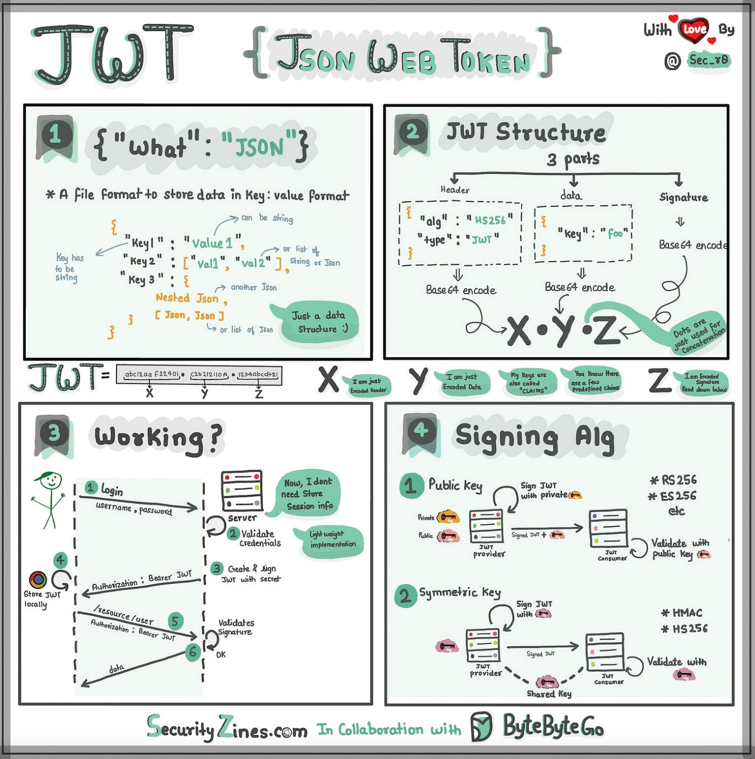

### ****Benefits of JWT:****

* **Stateless:** Eliminates the need for server-side session management, improving scalability.
* **Security:** Signed tokens ensure data integrity and prevent unauthorized modifications.
* **Flexibility:** JWTs can contain various claims, enabling fine-grained authorization decisions.

### ****Limitations of JWT:****

* **Token Revocation:** Revoking access for a specific user requires additional mechanisms (e.g., blacklists) as tokens are self-contained.
* **Large Tokens:** Large amounts of user data within the token can increase payload size and impact performance.

## ****OAuth and JWT Working Together:****

OAuth and JWT are often used in conjunction for a robust authentication and authorization flow:

1. **User Authenticates:** The user logs in to the application using a traditional method (e.g., username/password) or an OAuth flow with another service.
2. **Access Token Grant:** Upon successful authentication, an OAuth flow might be used to obtain an access token from an Authorization Server.
3. **JWT Issuance:** The application server creates a JWT containing user information (claims) signed with a secret key.
4. **Client Receives JWT:** The JWT is sent back to the client (usually stored in browser local storage).
5. **Subsequent Requests:** With each request to a protected resource, the client includes the JWT in the authorization header.
6. **Server Validates Token:** The server receives the JWT, verifies its signature using the same secret key, and extracts user information from the claims.
7. **Access Granted/Denied:** Based on the extracted user information and authorization rules, the server grants or denies access to the requested resource.

By combining OAuth for secure authorization and JWT for efficient user information exchange, developers can create secure and scalable web applications.

# What is Encryption?

Encryption in software systems is like sending a secret letter where the message is scrambled into a code. Only someone with the right key can read it. It's a method to protect data by making it unreadable to unauthorized users.

The encryption transforms readable data (plaintext) into a scrambled, unreadable format (ciphertext). To turn it back into readable form, you need the correct decryption key.

## ****The Encryption Process:****

1. **Plaintext:** The original, readable data you want to protect is called plaintext.
2. **Encryption Algorithm:** A specific encryption algorithm is chosen (e.g., AES, RSA). This algorithm acts as a recipe for scrambling and unsc scrambling the data.
3. **Encryption Key:** A secret key is used by the encryption algorithm to transform the plaintext into ciphertext (unreadable scrambled format).
4. **Ciphertext:** The resulting unreadable data is called ciphertext.

## ****Decryption****

For authorized users to access the protected information, a decryption process is required:

1. **Decryption Key:** The same key used for encryption (or its counterpart in some algorithms) is required for decryption.
2. **Decryption Algorithm:** The decryption algorithm works in conjunction with the decryption key to reverse the transformation, converting ciphertext back to readable plaintext.

## ****Types of Encryption Keys:****

* **Symmetric Encryption:** This approach uses a single secret key for both encryption and decryption. It's efficient but requires secure key distribution to all authorized parties.
* **Asymmetric Encryption (Public Key Encryption):** This method utilizes a key pair: a public key for encryption and a private key for decryption. The public key is widely distributed, while the private key is kept secret. Anyone can encrypt data with the public key, but only the holder of the private key can decrypt it. This is advantageous for scenarios where secure key distribution is challenging.

## ****Benefits of Encryption:****

* **Confidentiality:** Protects sensitive data from unauthorized access, ensuring only authorized users can read it.
* **Data Integrity:** Encryption algorithms can detect any tampering with the data during transmission or storage.
* **Compliance:** Encryption may be required to meet regulatory compliance standards for data protection.

## ****Use Cases of Encryption:****

* **Securing data in transit:** Encrypts data communication over networks (e.g., HTTPS for web traffic, VPNs for secure remote access).
* **Protecting data at rest:** Encrypts data stored on devices (e.g., hard drives, mobile phones) to prevent unauthorized access in case of theft or loss.

## ****Choosing the Right Encryption Method:****

The selection of an encryption method depends on factors like:

* **Security requirements:** The level of sensitivity of the data being protected.
* **Performance:** Some algorithms are faster than others, impacting processing overhead.
* **Key management complexity:** Symmetric encryption requires secure key distribution, while asymmetric encryption might involve complex key pair management.

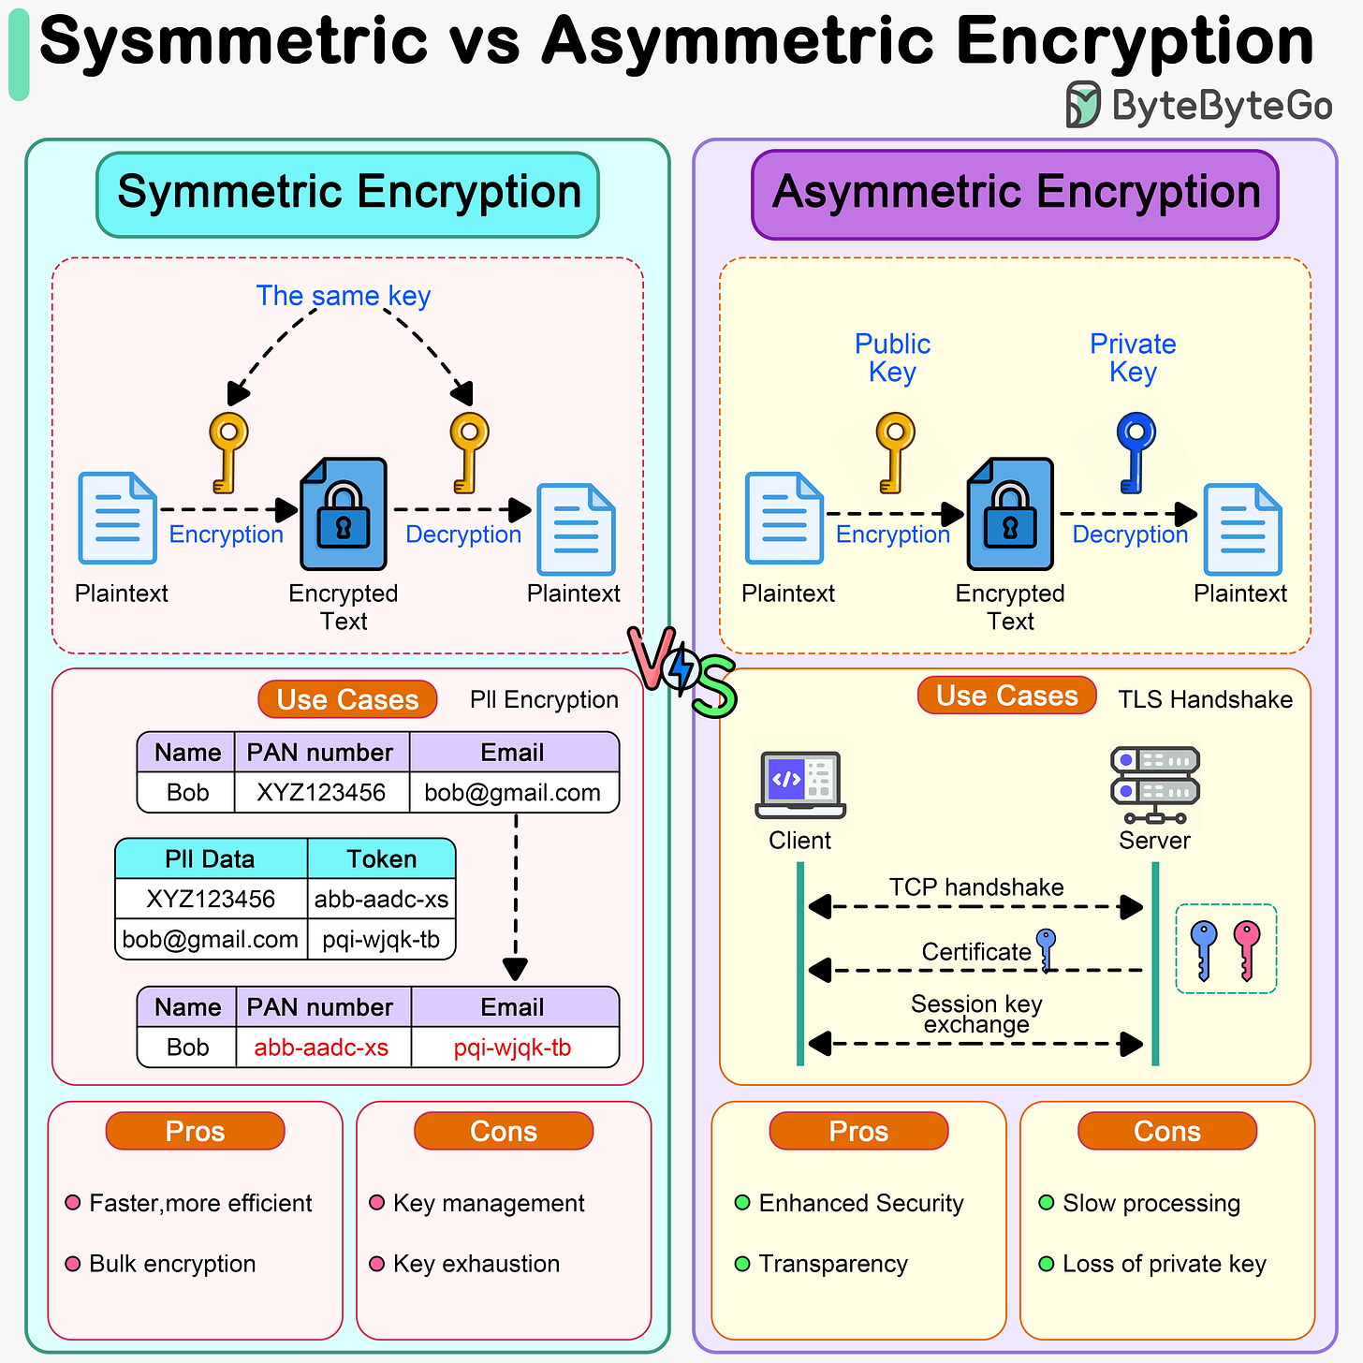

By implementing robust encryption techniques, you can significantly enhance the security of your data and safeguard it from unauthorized access.

# What are DDoS Attacks?

A Distributed Denial of Service (DDoS) attack is a malicious attempt to disrupt normal traffic of a targeted server, service, or network by overwhelming the target or its surrounding infrastructure with a flood of Internet traffic. DDoS attacks achieve effectiveness by utilizing multiple compromised computer systems as sources of attack traffic. These systems can include computers and other networked resources such as IoT devices.

## ****Understanding the Attack:****

* **Goal:** To disrupt normal operations of a server, service, or network by consuming all available resources (bandwidth, processing power).
* **Weapons:** A network of compromised computers or devices (botnet) controlled by the attacker. These bots bombard the target with a massive influx of requests, making it difficult or impossible for legitimate users to access the system.

## ****How DDoS Attacks Work:****

1. **Botnet Recruitment:** Attackers infect a large number of devices (computers, IoT devices) with malware, turning them into bots under their control.
2. **Command and Control:** The attacker establishes a communication channel to remotely control the botnet.
3. **DDoS Launch:** The attacker instructs the botnet to bombard the target with various types of attack traffic, overwhelming its capacity.

## ****Types of DDoS Attacks:****

* **Volume-Based Attacks:** Flood the target with a massive amount of data, saturating its bandwidth and preventing legitimate traffic from reaching its destination.
* **Protocol Attacks:** Exploit vulnerabilities in network protocols to disrupt communication and exhaust server resources.
* **Application-Layer Attacks:** Target specific application functionalities to overload the target system.

## ****Impact of DDoS Attacks:****

* **Disrupted Services:** Websites, online applications, and critical infrastructure can become inaccessible to legitimate users.
* **Financial Losses:** Businesses can suffer revenue loss due to downtime and operational disruptions.
* **Reputational Damage:** DDoS attacks can damage a company's reputation and erode customer trust.

## ****Defending Against DDoS Attacks:****

* **DDoS Mitigation Services:** Specialized services can help absorb attack traffic and protect critical systems.
* **Traffic Filtering:** Techniques can be implemented to identify and filter out malicious traffic.
* **Scalable Infrastructure:** Building a robust and scalable infrastructure can help withstand attack surges.
* **Incident Response Plan:** Having a plan in place to identify, mitigate, and recover from DDoS attacks is crucial.

**DDoS attacks are a continuous threat in the digital landscape. By understanding their tactics and implementing appropriate security measures, organizations can protect their online presence and critical systems.**

System Design Architectures

System Architecture is the overall structure of the software and the ways in which that structure provides conceptual integrity for a system.

There are countless system design architectures, each tailored to specific needs and contexts. Here’s a list of some prominent ones, along with their pros and cons:

# Monolithic Architecture

A Monolithic Architecture is like a well-built castle – everything’s under one roof! All the parts, from foundation to towers, are tightly packed together. It’s simple, efficient, and easy to manage. But just like a castle, adding rooms or changing the layout gets tricky, and one big crack can bring the whole thing down.

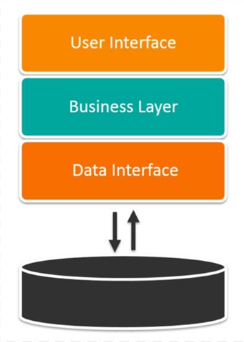

That’s the gist of Monolithic Architecture in the software world. It’s a single codebase where everything’s connected, making it straightforward to develop and deploy. But scaling gets tough, and changes can be risky. Think of it as a strong foundation for smaller projects, but less flexible for grand renovations.

## Multi-Tier Vs Multi-Layer

In the context of software architecture, the terms “multi-tier” and “multi-layer” are often used interchangeably, but they have distinct meanings:

* **Multi-layer architecture** refers to how the codebase is organized into logical layers. Each layer has a specific role and responsibility within the application. For example, a typical three-layer architecture might consist of a presentation layer (UI), a business logic layer, and a data access layer.
* **Multi-tier architecture**, on the other hand, refers to the physical distribution of these layers across multiple servers or machines. In a multi-tier system, each layer runs on a separate hardware platform. This separation can enhance performance, scalability, and security.

In a **monolithic architecture**, all the components of the application are interconnected and interdependent. In the context of a monolithic application, multi-layer refers to the organization of code into layers within a single application, while multi-tier would imply that different parts of the application are deployed on different servers.

The three-tier architecture is the most popular implementation of a multi-tier architecture and consists of a single presentation tier, logic tier, and data tier. The following illustration shows an example of a simple, generic three-tier application.

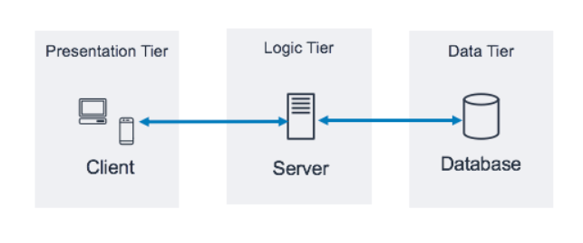

In the two-tier architecture, one tier contains presentation and logic, and data tier.  For example, Mobile app contains both UI and business logic and use Api calls to communicate with database.

To summarize, a layer is a logical separation within the application, and a tier is a physical separation of components. Most of the time, it makes sense to split the above-mentioned tiers to achieve further architecture flexibility, synergy, security, and efficiency.

* **Pros:** Simple to develop and deploy, easy to manage and debug, efficient performance.
* **Cons:** Not scalable, tightly coupled components make changes risky, single point of failure.

# Microservices Architecture

Imagine a bustling city instead of a castle! Microservices Architecture is like a metropolis where everything revolves around specialized districts. Each district, a microservice, handles a specific task like shopping, entertainment, or transportation. They work together through well-defined roads (APIs) to keep the city running smoothly.

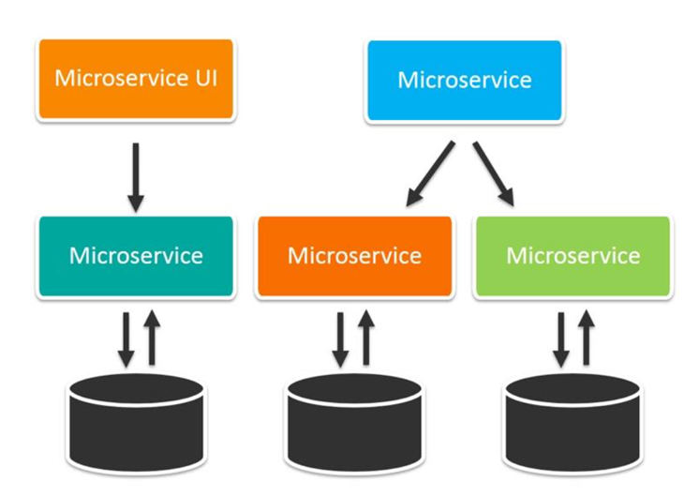

* **Pros:** Highly scalable and fault-tolerant, independent deployment and development cycles, agile and adaptable.
* **Cons:** Increased complexity, challenges in distributed tracing and debugging, higher operational overhead.

Overall, Microservices Architecture is like a flexible, adaptable city, perfect for large, ever-evolving applications. But remember, it comes with its own set of challenges. ️

# Serverless Architecture

Imagine a magical restaurant where you don’t need a kitchen! That’s Serverless Architecture in a nutshell. You focus on crafting delicious dishes (your code), and a trusty wizard (cloud provider) takes care of the cooking (servers) behind the scenes.

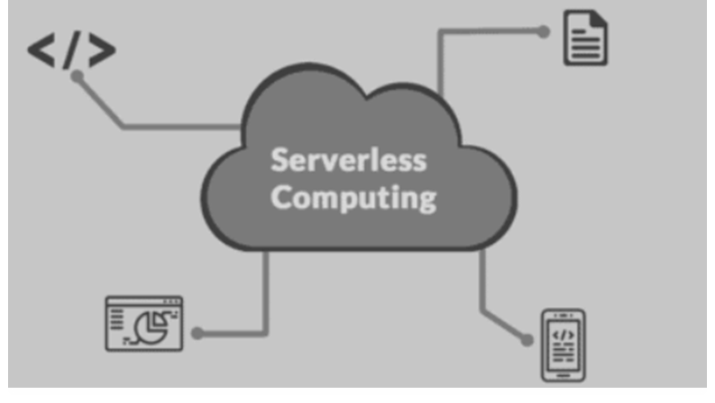

* **Pros:** Highly scalable and elastic, pay-per-use model reduces cost, no server management required.
* **Cons:** Vendor lock-in, potential cold start latency, limited debugging options, can be expensive for long-running tasks.

# Client-Server Architecture

Imagine a fancy restaurant with expert chefs and attentive waiters! That’s Client-Server Architecture in a nutshell.

The kitchen (server) handles cooking and food preparation, while the waiters (clients) take orders and deliver meals. Each has clear responsibilities. Waiters communicate orders to the kitchen, and the kitchen sends back prepared dishes. They work together through a well-defined process.

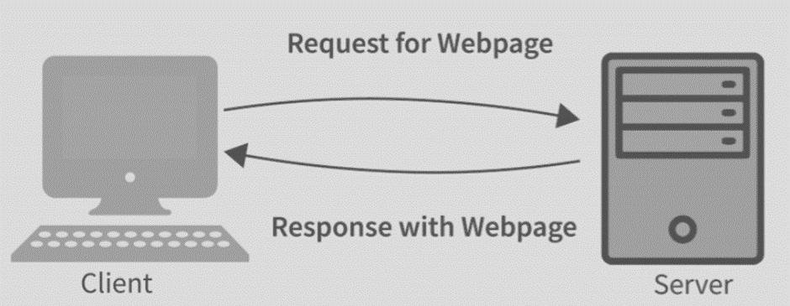

All the food and recipes are stored in the kitchen, ensuring consistency and control. It’s like a central hub for data and services.

* **Pros:** Clear separation of concerns, improved security, centralized data management.
* **Cons:** Increased network traffic, single point of failure at the server, potential performance bottlenecks.

# Event-Driven Architecture

Imagine a bustling cityscape where things happen in response to events, not schedules. That’s the essence of Event-Driven Architecture. The is genially use in one direction communication.

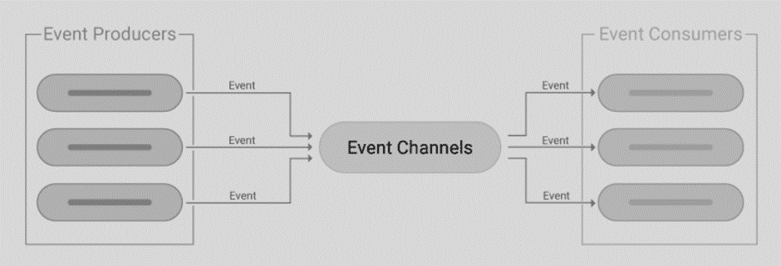

* **Pros:** Highly decoupled components, responsive to real-time events, scalable and reliable.
* **Cons:** Increased complexity, debugging challenges, requires robust event handling infrastructure.

# Layered Architecture

Imagine a beautiful cake! Layered Architecture is like building that cake with distinct, delicious layers, each with its own purpose.

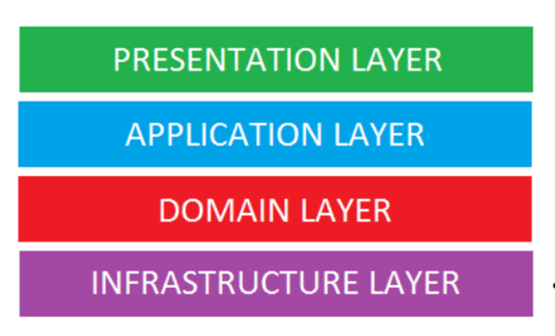

* **Pros:** Organized and maintainable, promotes code reuse, simplifies testing and deployment.
* **Cons:** Can be inflexible, performance overhead due to layered dependencies, potential bottlenecks at lower layers.

# Peer-to-Peer Architecture

Imagine a lively market where everyone is both shopkeeper and shopper! That’s the essence of Peer-to-Peer (P2P) Architecture, where everyone plays an equal role in sharing resources and completing tasks.

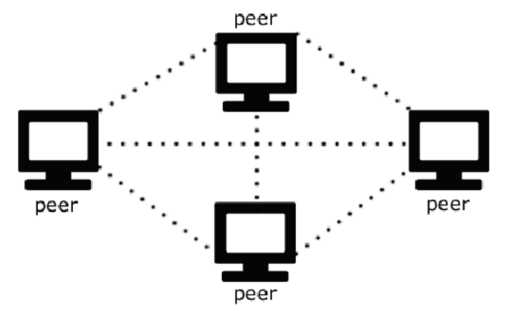

* **Pros:** Highly scalable and resilient, no central point of failure, efficient for sharing resources.
* **Cons:** Increased complexity, security challenges, potential for data inconsistencies.

# API-Driven Architecture

Imagine a bustling transportation hub with interconnected trains, buses, and taxis! That’s API-Driven Architecture in a nutshell. It’s all about building a system where different components communicate seamlessly through well-defined routes, like a network of transportation options.

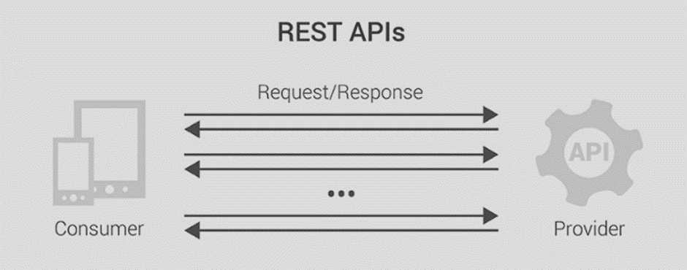

* **Pros:** Enables integration with diverse systems, promotes loose coupling, provides flexibility and scalability.
* **Cons:** Requires well-defined and documented APIs, increased security considerations, potential compatibility issues.

## Choosing the right architecture depends on various factors

* System requirements and functionality
* Scalability and performance needs
* Development and operational resources
* Existing infrastructure and constraints

Remember, there’s no **“one-size-fits-all”** architecture. Understanding the *pros* and *cons* of each can help you make informed decisions for your specific needs.

API

APIs are mechanisms that enable two software components to communicate with each other using a set of definitions and protocols.

**Think of an API as a translator for applications.** It lets them talk to each other, share data, and work together seamlessly.

## What it is?

* A set of rules and tools for apps to communicate.
* Like a waiter taking orders between a kitchen and diners.
* Different types: SOAP, REST (most popular), GraphQL.

## How it works

* Client app (like your phone) sends a request (order).
* Server app (like a weather service) processes and sends response (food).
* Data flows back and forth through APIs.

## Benefits

* **Easier development:** Use existing code instead of starting from scratch.
* **Faster innovation:** Adapt to new needs quickly by changing APIs, not whole apps.
* **Better integrations:** Connect different apps and services effortlessly.
* **Wider reach:** Offer your data and functionality to others via public APIs.

## Types of APIs

* **Private:** Internal to a company for connecting systems.
* **Public:** Open to anyone, often with fees or restrictions.
* **Partner:** Accessible only to authorized external developers.
* **Composite:** Combines multiple APIs for complex tasks.

## Important aspects

* **Endpoints:** Specific locations where data is sent and received.
* **Security:** Authentication and monitoring to protect your data.
* **Documentation:** Clear instructions for developers to use your API.
* **Testing:** Ensuring your API works correctly and securely.

**Remember**, APIs are the invisible bridges connecting the software world. Master them, and your app possibilities become endless!

# RESTful API

It’s a type of API that follows the REST architectural style, providing a set of guidelines for designing web services.

Representational State Transfer (REST) is a software architecture that imposes conditions on how an API should work.

In the context of REST (Representational State Transfer), “Representational State” refers to the state of a resource date at any given moment, which can be represented in a format that the client understands. So, when we say **“Representational State”**, we’re talking about a snapshot of a resource’s data (state) in a format (representation) that can be understood by the client.

## Benefits of RESTful APIs

* **Scalability:** They can handle large volumes of requests without performance bottlenecks.
* **Flexibility:** They are independent of specific technologies and platforms, allowing for easier development and integration.
* **Independence:** Clients and servers are decoupled, enabling independent evolution and updates.

## How do RESTful APIs work?

* **Client sends a request:** It specifies the desired resource (often through a URL) and the intended action (e.g., GET, POST, PUT, PATCH, DELETE) using HTTP methods.
* **Server authenticates and processes:** It verifies the client’s identity and performs the requested action on the resource.
* **Server sends a response:** It includes a status code indicating success or failure, and optionally, the requested data in a structured format (e.g., JSON, XML).



## Additional key points

* **Statelessness:** Each request is independent and the server doesn’t need to remember past interactions.
* **Caching:** Responses can be cached to improve performance.
* **Code on demand:** Servers can send code to clients for temporary customization.
* **Authentication:** Various methods like HTTP basic, OAuth, and API keys ensure secure access control.

The following are some common status codes:

**1xx (Informational):**

* **100 Continue:** The server has received the request and is waiting for the client to continue.
* **101 Switching Protocols:** The server is switching protocols as requested by the client.

**2xx (Success):**

* **200 OK:** The request was successful, and the requested resource has been delivered.
* **201 Created:** The request was successful, and a new resource has been created.
* **202 Accepted:** The request has been accepted, but the processing is not complete.
* **204 No Content:** The request was successful, but there is no content to return.

**3xx (Redirection):**

* **301 Moved Permanently:** The requested resource has been permanently moved to a new location.
* **302 Found:** The requested resource has been temporarily moved to a new location.
* **304 Not Modified:** The requested resource has not been modified since the last request.

**4xx (Client Error):**

* **400 Bad Request:** The request was invalid or malformed.
* **401 Unauthorized:** The request requires authentication.
* **403 Forbidden:** The request was denied by the server (Permissions check).
* **404 Not Found:** The requested resource was not found.
* **405 Method Not Allowed:** The requested method is not supported for the resource.

**5xx (Server Error):**

* **500 Internal Server Error:** An unexpected error occurred on the server.
* **502 Bad Gateway:** The server received an invalid response from an upstream server.
* **503 Service Unavailable:** The server is currently unavailable.
* **504 Gateway Timeout:** The server did not receive a timely response from an upstream server.

## Idempotency

**Idempotency is a property of operations or API requests that ensures the same result is produced, regardless of how many times the operation is repeated**. It’s a fundamental property that ensures consistency, predictability, and reliability in APIs and distributed systems.

Key points about idempotency include:

* Safe methods are idempotent but not all idempotent methods are safe.
* HTTP methods like GET, HEAD, PUT, DELETE, OPTIONS, and TRACE are idempotent, while POST and PATCH are generally non-idempotent.
* Understanding and leveraging the idempotent nature of HTTP methods helps create more consistent, reliable, and predictable web applications and APIs.
* Most HTTP methods used in REST APIs are idempotent, except for POST.

Idempotency is crucial in APIs as it helps maintain consistency and predictability in situations such as network issues, request retries, or duplicated requests. For example, in a scenario where an API facilitates monetary transactions between accounts, idempotency ensures that only one transfer will occur, regardless of the number of duplicate requests. This principle simplifies error handling, concurrency management, debugging, and monitoring, enhancing the overall user experience.

Idempotency is important because non-idempotent operations can cause significant unintended side-effects by creating additional resources or changing them unexpectedly when a resource may be called multiple times if the network is interrupted. This poses a significant risk when a business relies on the accuracy of its data.

# RPC

**RPC (Remote Procedure Call)** is an architectural style for distributed systems. It has been around since the 1980s. Here are some key points about RPC:

1. **Procedure-Centric**: The central concept in RPC is the procedure. RPC APIs allow developers to call remote functions in external servers as if they were local to their software. This means that you can execute procedures on a server as if they were local function calls.
2. **Language Independent**: Developers can implement an RPC API in any language they choose. So long as the network communication element of the API conforms with the RPC interface standard, you can write the rest of the code in any programming language.
3. **Communication**: Both REST and RPC use HTTP as the underlying protocol. The most popular message formats in RPC are JSON and XML. JSON is favored due to its readability and flexibility.
4. **Abstraction**: While network communications are the main aim of APIs, the lower-level communications themselves are abstracted away from API developers. This allows developers to focus on function rather than technical implementation.

Now, let’s discuss the role of **Interface Description Language (IDL)** and **Marshalling/Unmarshalling** in RPC:

* **Interface Description Language (IDL)**: An IDL is used to set up communications between clients and servers in RPC. You use an IDL to specify the interface between client and server so that the RPC mechanism can create the code stubs required to call functions across the network. The IDL files can then be used to generate code to interface between the client and servers.
* **Marshalling**: Marshalling is the process of transferring and formatting a collection of data structures into an external data representation type appropriate for transmission in a message.
* **Unmarshalling**: The converse of this process is unmarshalling, which involves reformatting the transferred data upon arrival to recreate the original data structures at the destination.

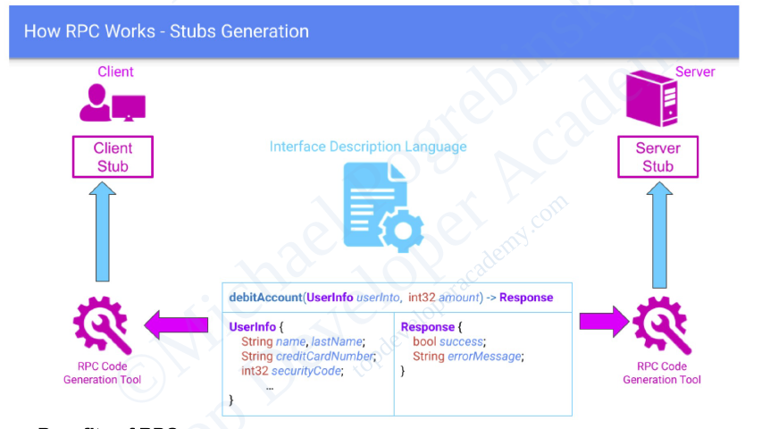

Here are some **benefits and limitations** of RPC:

**Benefits**:

* RPC provides interoperability between different implementations.
* A lightweight RPC protocol permits efficient implementations.
* They provide usage of applications in both local and distributed environments.
* They have lightweight payloads, therefore, provides high performance.
* They are easy to understand and work as the action is part of the URL.

**Limitations**:

* RPC implementations are not yet mature.
* It requires the TCP/IP protocol. Other transport protocols are not supported yet.
* Not yet proven over wide-area networks.
* It can be implemented in many ways as it is not well standardized.
* The Interface Description Language (IDL) is needed to generate subs classes for both client and server.

## REST vs RPC

Remote Procedure Call (RPC) and REST are two architectural styles in API design. RPC APIs allow developers to call remote functions as if they were local, while REST APIs perform specific data operations on a remote server. Both are essential in modern web design and other distributed systems, allowing two separate applications or services to communicate without knowing the internals of how the other one works.

## Similarities

* Both ways to design APIs for server-to-server or client-server communication.
* Both use HTTP and common formats like JSON or XML.
* Both abstract network communications.

## Key Differences

* Feature : Focus
* RPC : Functions/actions
* REST : Resources/objects
* Feature : Operations
* RPC : Custom function calls
* REST : Standardized HTTP verbs (GET, POST, etc.)
* Feature : Data format
* RPC : Fixed by server; limited flexibility
* REST : Any format, multiple formats within same API
* Feature : Statefulness
* RPC : Can be stateful or stateless
* REST : Always stateless

## When to use

* **RPC:** Complex calculations, remote function calls, hiding processes from client and service-to-service communication.
* **REST:** CRUD operations, exposing server data uniformly, easier development.

## Why REST is more popular?

* Easier to understand and implement.
* Modern versions like gRPC are performant.
* Faster than RPC.
* More reliable than RPC.

Load Balancing

Load balancing is the method of distributing network traffic equally across a pool of resources that support an application. Modern applications must process millions of users simultaneously and return the correct text, videos, images, and other data to each user in a fast and reliable manner.

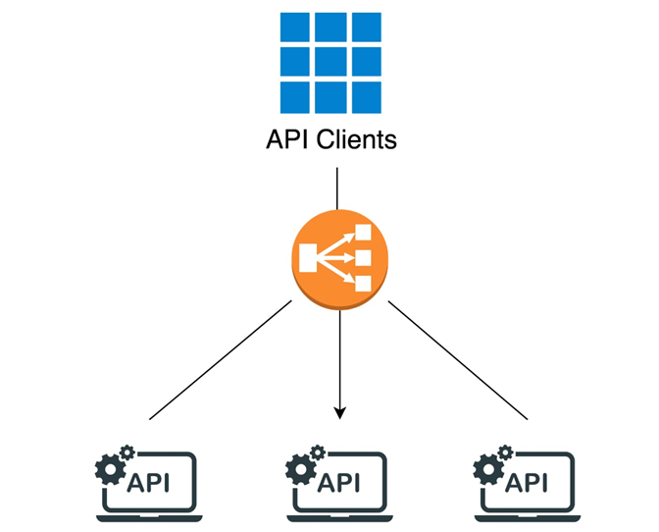

Load balancing algorithms help to prevent any single server or resource from becoming overwhelmed, which could lead to performance degradation or failure. By distributing the workload, load balancing algorithms can optimize response times, maximize throughput, and enhance user experience. These algorithms can consider factors such as server capacity, active connections, response times, and server health, among others, to make informed decisions on how to best distribute incoming requests.

Load balancing is a crucial component of System Design, as it helps distribute incoming requests and traffic evenly across multiple servers. The main goal of load balancing is to ensure high availability, reliability, and performance by avoiding overloading a single server and avoiding downtime.

Typically a load balancer sits between the client and the server accepting incoming network and application traffic and distributing the traffic across multiple backend servers using various algorithms. By balancing application requests across multiple servers, a load balancer reduces the load on individual servers and prevents any one server from becoming a single point of failure, thus improving overall application availability and responsiveness.

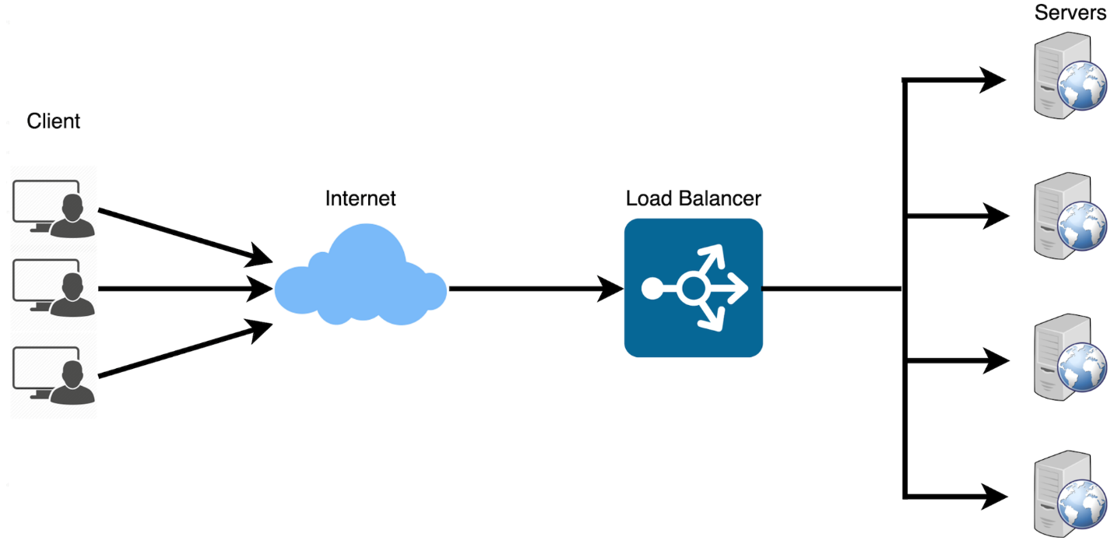

To utilize full scalability and redundancy, we can try to balance the load at each layer of the system. We can add LBs at three places:

* Between the user and the web server
* Between web servers and an internal platform layer, like application servers or cache servers
* Between internal platform layer and database.

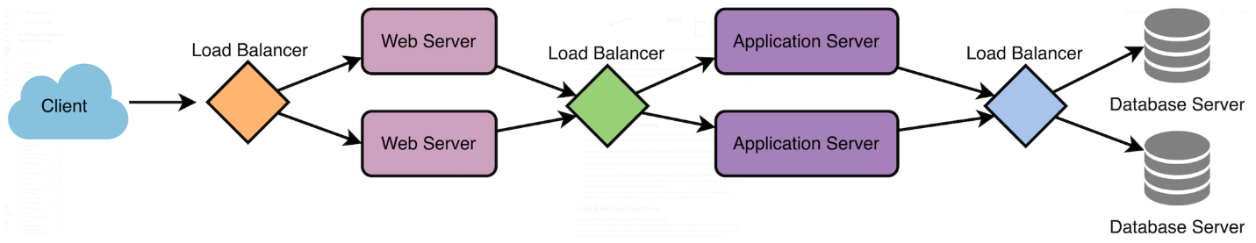

## What is Load Balancing?

* Distributes network traffic across multiple servers for a faster, more reliable experience.
* Increases application availability, scalability, security, and performance.

## Benefits

* **Availability:** Prevents downtime by redirecting traffic around failed servers.
* **Scalability:** Handles traffic spikes by adding or removing servers.
* **Security:** Blocks attacks and enhances security features.
* **Performance:** Improves response times and reduces latency.

## Uses of Load Balancing

Load balancing is a technique used to distribute workloads evenly across multiple computing resources, such as servers, network links, or other devices, in order to optimize resource utilization, minimize response time, and maximize throughput. This technique helps ensure that no single resource is overwhelmed, thus maintaining a high level of performance and reliability. Here are some common uses of load balancing:

### 1. Improving website performance

Load balancing can distribute incoming web traffic among multiple servers, reducing the load on individual servers and ensuring faster response times for end users.

**Example:** An e-commerce website experiences a sudden surge in traffic during a holiday sale. A load balancer distributes incoming requests among multiple web servers, ensuring that each server handles a manageable number of requests, resulting in faster page load times for users.

### 2. Ensuring high availability and reliability

By distributing the workload among multiple servers, load balancing helps prevent single points of failure. If one server fails or experiences an issue, the load balancer can redirect traffic to other available servers, maintaining uptime and minimizing service disruptions.

**Example:** A banking application relies on several servers to handle user transactions. The load balancer monitors the health of each server and, in the event of a server failure, redirects traffic to the remaining healthy servers, minimizing downtime and maintaining user access to the application.

### 3. Scalability

Load balancing allows organizations to easily scale their infrastructure as traffic and demand increase. Additional servers can be added to the load balancing pool to accommodate increased demand, without the need for significant infrastructure changes.

**Example:** A video streaming platform sees a steady increase in users as it gains popularity. To handle the growing demand, the platform adds new servers to the load balancing pool, allowing it to scale seamlessly without overloading existing infrastructure.

### 4. Redundancy

Load balancing can be used to maintain redundant copies of data and services across multiple servers, reducing the risk of data loss or service outages due to hardware failure or other issues.

**Example:** An online file storage service uses load balancing to maintain multiple copies of user data across different servers. If one server experiences a hardware failure, users can still access their data from the redundant copies stored on other servers.

### 5. Network optimization

Load balancing can help optimize network traffic by distributing it across multiple paths or links, reducing congestion and improving overall network performance.

**Example:** A large organization has multiple internet connections to handle its network traffic. A load balancer distributes the incoming and outgoing traffic across these connections, reducing congestion and improving overall network performance.

### 6. Geographic distribution

For global organizations, load balancing can be used to distribute traffic across data centres in different geographic locations. This ensures that users are directed to the nearest or best-performing data canter, reducing latency and improving user experience.

**Example:** A multinational company has data centres in North America, Europe, and Asia. A load balancer directs users to the nearest data canter based on their geographic location, reducing latency and improving the user experience.

### 7. Application performance

Load balancing can be used to distribute requests for specific applications or services among dedicated servers or resources, ensuring that each application or service receives the necessary resources to perform optimally.

**Example:** An enterprise uses a suite of applications, including email, file storage, and collaboration tools. A load balancer assigns dedicated resources to each application, ensuring that each service performs optimally without affecting the performance of other applications.

### 8. Security

Load balancers can help protect against distributed denial-of-service (DDoS) attacks by distributing incoming traffic across multiple servers, making it more difficult for attackers to overwhelm a single target.

**Example:** A news website faces a distributed denial-of-service (DDoS) attack, with a large number of malicious requests targeting its servers. The load balancer distributes the traffic among multiple servers, making it more difficult for the attackers to overwhelm a single target and mitigating the impact of the attack.

### 9. Cost savings

By distributing workloads across available resources more efficiently, load balancing can help organizations save money on hardware and infrastructure costs, as well as reduce energy consumption.

**Example:** A small business utilizes cloud-based infrastructure for its web applications. By using load balancing to optimize resource usage, the business can minimize the number of servers needed, resulting in lower infrastructure and energy costs.

### 10. Content caching

Some load balancers can cache static content, such as images and videos. This cached content is then served directly from the load balancer, reducing the demand on the servers and providing faster response times for users.

**Example:** In a streaming service like Netflix, users access a wide variety of content like TV shows, movies, etc. Now, consider a very popular TV show that millions of users might want to watch. If each request for this show was routed to the servers, it would result in a huge load on the servers, potentially slowing down response times or even leading to server failure. By caching such popular content on the load balancer, the streaming service can drastically reduce the load on its main servers.

## Types of Load Balancing Algorithms

Here’s a concise version of the content, covering important points about load balancing algorithms:

**Two Categories:**

1.     **Static:** Follow set rules, independent of server state. Examples:

* **Round-robin:** Sends traffic to servers in turn (fair but doesn’t consider server load).
* **Weighted round-robin:** Assigns weights to servers for priority (better than round-robin).
* **IP hash:** Maps client IP to a specific server (sticky traffic, good for sessions).

2.     **Dynamic:** Consider server state before distributing traffic. Examples:

* **Least connection:** Sends traffic to server with fewest connections (simple but assumes equal workloads).
* **Weighted least connection:** Accommodates different server capacities (more efficient than least connection).
* **Least response time:** Chooses server with fastest response time and fewest connections (prioritizes speed).
* **Resource-based:** Analyzes server resource usage (CPU, memory) for optimal distribution (most versatile).

## How it Works

* User requests go to the load balancer.
* Load balancer chooses the best server based on algorithm and request type.
* Server fulfills the request and sends response back to user.

## Static Load Balancers

### Round Robin

This algorithm distributes incoming requests to servers in a cyclic order. It assigns a request to the first server, then moves to the second, third, and so on, and after reaching the last server, it starts again at the first.

**Pros:**

* Ensures an equal distribution of requests among the servers, as each server gets a turn in a fixed order.
* Easy to implement and understand.
* Works well when servers have similar capacities.

**Cons:**

* May not perform optimally when servers have different capacities or varying workloads.
* No consideration for server health or response time.
* Round Robin is predictable in its request distribution pattern, which could potentially be exploited by attackers who can observe traffic patterns and might find vulnerabilities in specific servers by predicting which server will handle their requests.

**Example:** A website with three web servers receives requests in the order A, B, C, A, B, C, and so on, distributing the load evenly among the servers.



### Weighted Round Robin

The Weighted Round Robin algorithm is an extension of the Round Robin algorithm that assigns different weights to servers based on their capacities. The load balancer distributes requests proportionally to these weights.

**Pros:**

* Accounts for different server capacities, balancing load more effectively.
* Simple to understand and implement.

**Cons:**

* Weights must be assigned and maintained manually.
* No consideration for server health or response time.

**Example:** A content delivery network has three servers with varying capacities. The load balancer assigns weights of 3, 2, and 1 to these servers, respectively, distributing requests in a 3:2:1 ratio.



### IP Hash

The IP Hash algorithm determines the server to which a request should be sent based on the source and/or destination IP address. This method maintains session persistence, ensuring that requests from a specific user are directed to the same server.

**Pros:**

* Maintains session persistence, which can be useful for applications requiring a continuous connection with a specific server.
* Can distribute load evenly when using a well-designed hash function.

**Cons:**

* May not balance load effectively when dealing with a small number of clients with many requests.
* No consideration for server health, response time, or varying capacities.

**Example:** An online multiplayer game uses the IP Hash algorithm to ensure that all requests from a specific player are directed to the same server, maintaining a continuous connection for a smooth gaming experience.



## Dynamic Load Balancers

### Least Connections

The Least Connections algorithm directs incoming requests to the server with the lowest number of active connections. This approach accounts for the varying workloads of servers.

**Pros:**

* Adapts to differing server capacities and workloads.
* Balances load more effectively when dealing with requests that take a variable amount of time to process.

**Cons:**

* Requires tracking the number of active connections for each server, which can increase complexity.
* May not factor in server response time or health.

**Example:** An email service receives requests from users. The load balancer directs new requests to the server with the fewest active connections, ensuring that servers with heavier workloads are not overwhelmed.



### Weighted Least Connections

The Weighted Least Connections algorithm combines the Least Connections and Weighted Round Robin algorithms. It directs incoming requests to the server with the lowest ratio of active connections to assigned weight.

**Pros:**

* Balances load effectively, accounting for both server capacities and active connections.
* Adapts to varying server workloads and capacities.

**Cons:**

* Requires tracking active connections and maintaining server weights.
* May not factor in server response time or health.

**Example:** An e-commerce website uses three servers with different capacities and assigned weights. The load balancer directs new requests to the server with the lowest ratio of active connections to weight, ensuring an efficient distribution of load.



### Least Response Time

The Least Response Time algorithm directs incoming requests to the server with the lowest response time and the fewest active connections. This method helps to optimize the user experience by prioritizing faster-performing servers.

**Pros:**

* Accounts for server response times, improving user experience.
* Considers both active connections and response times, providing effective load balancing.

**Cons:**

* Requires monitoring and tracking server response times and active connections, adding complexity.
* May not factor in server health or varying capacities.

**Example:** A video streaming service uses the Least Response Time algorithm to direct users to the server with the fastest response time, ensuring that videos start quickly and minimize buffering times.



### Random

The Random algorithm directs incoming requests to a randomly selected server from the available pool. This method can be useful when all servers have similar capacities and no session persistence is required.

**Pros:**

* Simple to implement and understand.
* Can provide effective load distribution when servers have similar capacities.

**Cons:**

* No consideration for server health, response times, or varying capacities.
* May not be suitable for applications requiring session persistence.
* Security systems that rely on detecting anomalies or implementing rate limiting (e.g., to mitigate DDoS attacks) might find it slightly more challenging to identify malicious patterns if a Random algorithm is used, due to the inherent unpredictability in request distribution. This could potentially dilute the visibility of attack patterns.

**Example:** A static content delivery network uses the Random algorithm to distribute requests for images, JavaScript files, and CSS stylesheets among multiple servers. This ensures an even distribution of load and reduces the chances of overloading any single server.



### Least Bandwidth

The Least Bandwidth algorithm directs incoming requests to the server currently utilizing the least amount of bandwidth. This approach helps to ensure that servers are not overwhelmed by network traffic.

**Pros:**

* Considers network bandwidth usage, which can be helpful in managing network resources.
* Can provide effective load balancing when servers have varying bandwidth capacities.

**Cons:**

* Requires monitoring and tracking server bandwidth usage, adding complexity.
* May not factor in server health, response times, or active connections.

**Example:** A file hosting service uses the Least Bandwidth algorithm to direct users to the server with the lowest bandwidth usage, ensuring that servers with high traffic are not overwhelmed and that file downloads are fast and reliable.



### Custom Load

The Custom Load algorithm allows administrators to create their own load balancing algorithm based on specific requirements or conditions. This can include factors such as server health, location, capacity, and more.

**Pros:**

* Highly customizable, allowing for tailored load balancing to suit specific use cases.
* Can consider multiple factors, including server health, response times, and capacity.

**Cons:**

* Requires custom development and maintenance, which can be time-consuming and complex.
* May require extensive testing to ensure optimal performance.

**Example:** An organization with multiple data centers around the world develops a custom load balancing algorithm that factors in server health, capacity, and geographic location. This ensures that users are directed to the nearest healthy server with sufficient capacity, optimizing user experience and resource utilization.

## Types of Load Balancers

A load balancing type refers to the method or approach used to distribute incoming network traffic across multiple servers or resources to ensure efficient utilization, improve overall system performance, and maintain high availability and reliability. Different load balancing types are designed to meet various requirements and can be implemented using hardware, software, or cloud-based solutions.

Each load balancing type has its own set of advantages and disadvantages, making it suitable for specific scenarios and use cases. Some common load balancing types include hardware load balancing, software load balancing, cloud-based load balancing, DNS load balancing, and Layer 4 and Layer 7 load balancing. By understanding the different load balancing types and their characteristics, you can select the most appropriate solution for your specific needs and infrastructure.

### 1. Hardware Load Balancing

Hardware load balancers are physical devices designed specifically for load balancing tasks. They use specialized hardware components, such as Application-Specific Integrated Circuits (ASICs) or Field-Programmable Gate Arrays (FPGAs), to efficiently distribute network traffic.

**Pros:**

* High performance and throughput, as they are optimized for load balancing tasks.
* Often include built-in features for network security, monitoring, and management.
* Can handle large volumes of traffic and multiple protocols.

**Cons:**

* Can be expensive, especially for high-performance models.
* May require specialized knowledge to configure and maintain.
* Limited scalability, as adding capacity may require purchasing additional hardware.

**Example:** A large e-commerce company uses a hardware load balancer to distribute incoming web traffic among multiple web servers, ensuring fast response times and a smooth shopping experience for customers.

### 2. Software Load Balancing

Software load balancers are applications that run on general-purpose servers or virtual machines. They use software algorithms to distribute incoming traffic among multiple servers or resources.

**Pros:**

* Generally more affordable than hardware load balancers.
* Can be easily scaled by adding more resources or upgrading the underlying hardware.
* Provides flexibility, as they can be deployed on a variety of platforms and environments, including cloud-based infrastructure.

**Cons:**

* May have lower performance compared to hardware load balancers, especially under heavy loads.
* Can consume resources on the host system, potentially affecting other applications or services.
* May require ongoing software updates and maintenance.

**Example:** A startup with a growing user base deploys a software load balancer on a cloud-based virtual machine, distributing incoming requests among multiple application servers to handle increased traffic.

### 3. Cloud-based Load Balancing

Cloud-based load balancers are provided as a service by cloud providers. They offer load balancing capabilities as part of their infrastructure, allowing users to easily distribute traffic among resources within the cloud environment.

**Pros:**

* Highly scalable, as they can easily accommodate changes in traffic and resource demands.
* Simplified management, as the cloud provider takes care of maintenance, updates, and security.
* Can be more cost-effective, as users only pay for the resources they use.

**Cons:**

* Reliance on the cloud provider for performance, reliability, and security.
* May have less control over configuration and customization compared to self-managed solutions.
* Potential vendor lock-in, as switching to another cloud provider or platform may require significant changes.

**Example:** A mobile app developer uses a cloud-based load balancer provided by their cloud provider to distribute incoming API requests among multiple backend servers, ensuring smooth app performance and quick response times.

### 4. DNS Load Balancing

DNS (Domain Name System) load balancing relies on the DNS infrastructure to distribute incoming traffic among multiple servers or resources. It works by resolving a domain name to multiple IP addresses, effectively directing clients to different servers based on various policies.

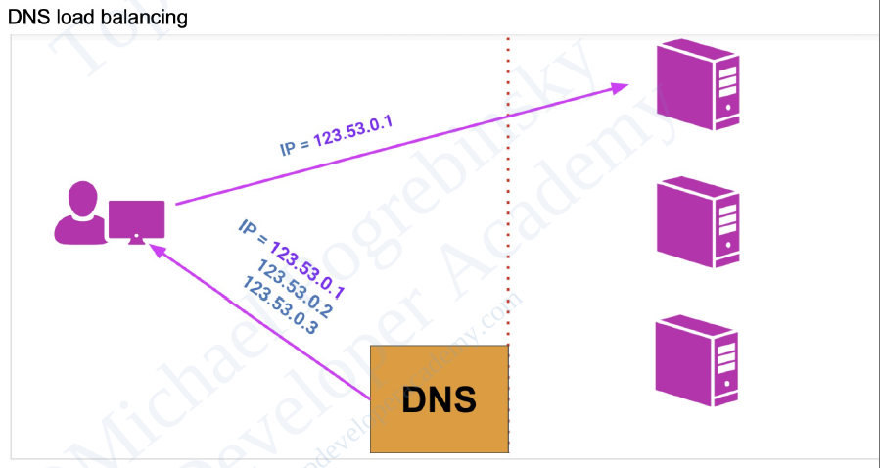

**Pros:**

* Relatively simple to implement, as it doesn't require specialized hardware or software.
* Provides basic load balancing and failover capabilities.
* Can distribute traffic across geographically distributed servers, improving performance for users in different regions.

**Cons:**

* Limited to DNS resolution time, which can be slow to update when compared to other load balancing techniques.
* No consideration for server health, response time, or resource utilization.
* May not be suitable for applications requiring session persistence or fine-grained load distribution.

**Example:** A content delivery network (CDN) uses DNS load balancing to direct users to the closest edge server based on their geographical location, ensuring faster content delivery and reduced latency.

### 5. Global Server Load Balancing (GSLB)

Global Server Load Balancing (GSLB) is a technique used to distribute traffic across geographically dispersed data centers. It combines DNS load balancing with health checks and other advanced features to provide a more intelligent and efficient traffic distribution method.

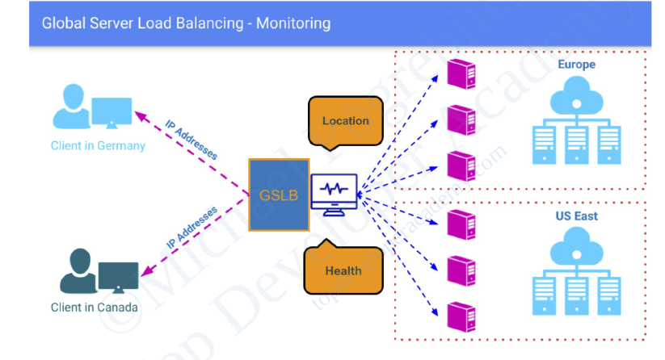

**Pros:**

* Provides load balancing and failover capabilities across multiple data centers or geographic locations.
* Can improve performance and reduce latency for users by directing them to the closest or best-performing data center.
* Supports advanced features, such as server health checks, session persistence, and custom routing policies.

**Cons:**

* Can be more complex to set up and manage than other load balancing techniques.
* May require specialized hardware or software, increasing costs.
* Can be subject to the limitations of DNS, such as slow updates and caching issues.

**Example:** A multinational corporation uses GSLB to distribute incoming requests for its web applications among several data centers around the world, ensuring high availability and optimal performance for users in different regions.

### 6. Hybrid Load Balancing

Hybrid load balancing combines the features and capabilities of multiple load balancing techniques to achieve the best possible performance, scalability, and reliability. It typically involves a mix of hardware, software, and cloud-based solutions to provide the most effective and flexible load balancing strategy for a given scenario.

**Pros:**

* Offers a high degree of flexibility, as it can be tailored to specific requirements and infrastructure.
* Can provide the best combination of performance, scalability, and reliability by leveraging the strengths of different load balancing techniques.
* Allows organizations to adapt and evolve their load balancing strategy as their needs change over time.

**Cons:**

* Can be more complex to set up, configure, and manage than single-technique solutions.
* May require a higher level of expertise and understanding of multiple load balancing techniques.
* Potentially higher costs, as it may involve a combination of hardware, software, and cloud-based services.

**Example:** A large-scale online streaming platform uses a hybrid load balancing strategy, combining hardware load balancers in their data centers for high-performance traffic distribution, cloud-based load balancers for scalable content delivery, and DNS load balancing for global traffic management. This approach ensures optimal performance, scalability, and reliability for their millions of users worldwide.

### 7. Layer 4 Load Balancing

Layer 4 load balancing, also known as transport layer load balancing, operates at the transport layer of the OSI model (the fourth layer). It distributes incoming traffic based on information from the TCP or UDP header, such as source and destination IP addresses and port numbers.

**Pros:**

* Fast and efficient, as it makes decisions based on limited information from the transport layer.
* Can handle a wide variety of protocols and traffic types.
* Relatively simple to implement and manage.

**Cons:**

* Lacks awareness of application-level information, which may limit its effectiveness in some scenarios.
* No consideration for server health, response time, or resource utilization.
* May not be suitable for applications requiring session persistence or fine-grained load distribution.

**Example:** An online gaming platform uses Layer 4 load balancing to distribute game server traffic based on IP addresses and port numbers, ensuring that players are evenly distributed among available game servers for smooth gameplay.

### 8. Layer 7 Load Balancing

Layer 7 load balancing, also known as application layer load balancing, operates at the application layer of the OSI model (the seventh layer). It takes into account application-specific information, such as HTTP headers, cookies, and URL paths, to make more informed decisions about how to distribute incoming traffic.

**Pros:**

* Provides more intelligent and fine-grained load balancing, as it considers application-level information.
* Can support advanced features, such as session persistence, content-based routing, and SSL offloading.
* Can be tailored to specific application requirements and protocols.

**Cons:**

* Can be slower and more resource-intensive compared to Layer 4 load balancing, as it requires deeper inspection of incoming traffic.
* May require specialized software or hardware to handle application-level traffic inspection and processing.
* Potentially more complex to set up and manage compared to other load balancing techniques.

**Example:** A web application with multiple microservices uses Layer 7 load balancing to route incoming API requests based on the URL path, ensuring that each microservice receives only the requests it is responsible for handling.

# Stateless vs. Stateful Load Balancing

Stateless and stateful load balancing represent two distinct methods for distributing traffic among multiple servers or resources.

## Stateless Load Balancing

Stateless load balancers operate without maintaining any information about the clients' session or connection state. They make routing decisions based solely on the incoming request data, such as the client's IP address, request URL, or other headers. Because stateless load balancers do not store session information, they can quickly and efficiently distribute incoming traffic without considering the clients' history or past interactions with the application.

**Example:** Consider a web application that enables users to search for products according to their location. A stateless load balancer can allocate requests to servers based on the user's geographic location, without retaining any session data.

## Stateful Load Balancing

In contrast, stateful load balancing preserves session information between requests. The load balancer assigns a client to a specific server and ensures that all subsequent requests from the same client are directed to that server. This method is beneficial when requests pertain to a particular session and necessitate session data.

**Example:** Suppose a web application that requires users to log in to access their personal information. A stateful load balancer can guarantee that requests from the same user are routed to the same server, allowing session data such as login credentials to be available.

Stateful load balancing can be further categorized into two types:

* **Source IP Affinity:** This form of stateful load balancing assigns a client to a specific server based on the client's IP address. While this approach ensures that requests from the same client consistently reach the same server, it may pose issues if the client's IP address frequently changes, such as in mobile networks.
* **Session Affinity:** In this type of stateful load balancing, the load balancer allocates a client to a specific server based on a session identifier, such as a cookie or URL parameter. This method ensures that requests from the same client consistently reach the same server, regardless of the client's IP address.

Ultimately, the decision between stateless and stateful load balancing depends on the application or service's requirements. Stateless load balancing is useful for applications capable of processing requests independently, while stateful load balancing is more appropriate for applications that depend on session data.

# High Availability and Fault Tolerance

## Redundancy and failover strategies for load balancers

To ensure high availability and fault tolerance, load balancers should be designed and deployed with redundancy in mind. This means having multiple instances of load balancers that can take over if one fails. Redundancy can be achieved through several failover strategies:

* **Active-passive configuration:** In this setup, one load balancer (the active instance) handles all incoming traffic while the other (the passive instance) remains on standby. If the active load balancer fails, the passive instance takes over and starts processing requests. This configuration provides a simple and reliable failover mechanism but does not utilize the resources of the passive instance during normal operation.
* **Active-active configuration:** In this setup, multiple load balancer instances actively process incoming traffic simultaneously. Traffic is distributed among the instances using methods such as DNS load balancing or an additional load balancer layer. If one instance fails, the others continue to process traffic with minimal disruption. This configuration provides better resource utilization and increased fault tolerance compared to the active-passive setup.

## Health checks and monitoring

Effective health checks and monitoring are essential components of high availability and fault tolerance for load balancers. Health checks are periodic tests performed by the load balancer to determine the availability and performance of backend servers. By monitoring the health of backend servers, load balancers can automatically remove unhealthy servers from the server pool and avoid sending traffic to them, ensuring a better user experience and preventing cascading failures.

Monitoring the load balancer itself is also crucial. By keeping track of performance metrics, such as response times, error rates, and resource utilization, we can detect potential issues and take corrective action before they lead to failures or service degradation.

In addition to regular health checks and monitoring, it is essential to have proper alerting and incident response procedures in place. This ensures that the appropriate personnel are notified of any issues and can take action to resolve them quickly.

## Synchronization and State Sharing

In active-active and active-passive configurations, it is crucial to ensure that the load balancer instances maintain a consistent view of the system's state, including the status of backend servers, session data, and other configuration settings. This can be achieved through various mechanisms, such as:

* **Centralized configuration management:** Using a centralized configuration store (e.g., etcd, Consul, or ZooKeeper) to maintain and distribute configuration data among load balancer instances ensures that all instances are using the same settings and are aware of changes.
* **State sharing and replication:** In scenarios where load balancers must maintain session data or other state information, it is crucial to ensure that this data is synchronized and replicated across instances. This can be achieved through database replication, distributed caching systems (e.g., Redis or Memcached), or built-in state-sharing mechanisms provided by the load balancer software or hardware.

By addressing these aspects of high availability and fault tolerance, we can design and deploy load balancers that provide reliable, consistent service even in the face of failures or other issues.

# Scalability and Performance

## Horizontal and vertical scaling of load balancers

As traffic to an application increases, it is essential to ensure that the load balancer can handle the increased demand. There are two primary methods for scaling load balancers:

* **Horizontal scaling:** This involves adding more load balancer instances to distribute traffic among them. Horizontal scaling is particularly effective for active-active configurations, where each load balancer instance actively processes traffic. Horizontal scaling can be achieved using DNS load balancing or by implementing an additional load balancer layer to distribute traffic among the instances.
* **Vertical scaling:** This involves increasing the resources (e.g., CPU, memory, and network capacity) of the existing load balancer instance(s) to handle increased traffic. Vertical scaling is often limited by the maximum capacity of a single instance, which is why horizontal scaling is typically preferred for large-scale applications.

## Connection and request rate limits

Managing the number of connections and request rates is crucial for optimizing the performance of load balancers. Overloading a load balancer or backend servers can result in decreased performance or even service outages. Implementing rate limiting and connection limits at the load balancer level can help prevent overloading and ensure consistent performance.

Load balancers can enforce rate limits based on various criteria, such as IP addresses, client domains, or URL patterns. Implementing these limits can also help mitigate the impact of Denial of Service (DoS) attacks and prevent individual clients from monopolizing resources.

## Caching and content optimization

Caching and content optimization can significantly improve the performance of load-balanced applications. Load balancers can cache static content, such as images, CSS, and JavaScript files, to reduce the load on backend servers and improve response times. Additionally, some load balancers support content optimization features like compression or minification, which can further improve performance and reduce bandwidth consumption.

## Impact of load balancers on latency

Introducing a load balancer into the request-response path adds an additional network hop, which can result in increased latency. While the impact is typically minimal, it is important to consider the potential latency introduced by the load balancer and optimize its performance accordingly.

Optimizing the performance of the load balancer can be achieved through various strategies, including:

* **Geographical distribution:** Deploying load balancers and backend servers in geographically distributed locations can help reduce latency for users by ensuring that their requests are processed by a nearby instance.
* **Connection reuse:** Many load balancers support connection reuse or keep-alive connections, which reduce the overhead of establishing new connections between the load balancer and backend servers for each request.
* **Protocol optimizations:** Some load balancers support protocol optimizations, such as HTTP/2 or QUIC, which can improve performance by reducing latency and increasing throughput.

By focusing on these aspects of scalability and performance, you can ensure that your load balancer can handle increased traffic and provide consistent, fast service for your application's users.

# Challenges of Load Balancers

Load balancers play a crucial role in distributing traffic and optimizing resource utilization in modern applications. However, they are not without potential challenges or problems. Some common issues associated with load balancers include:

## 1. Single Point of Failure

If not designed with redundancy and fault tolerance in mind, a load balancer can become a single point of failure in the system. If the load balancer experiences an outage, it could impact the entire application.

* **Remedy**: Implement high availability and failover mechanisms, such as redundant load balancer instances, to ensure continuity even if one instance fails.

## 2. Configuration Complexity

Load balancers often come with a wide range of configuration options, including algorithms, timeouts, and health checks. Misconfigurations can lead to poor performance, uneven traffic distribution, or even service outages.

* **Remedy**: Regularly review and update configurations, and consider using automated configuration tools or expert consultation to ensure optimal settings.

## 3. Scalability Limitations

As traffic increases, the load balancer itself might become a performance bottleneck, especially if it is not configured to scale horizontally or vertically.

* **Remedy**: Plan for horizontal or vertical scaling of the load balancer to match traffic demands, and use scalable cloud-based load balancing solutions.

## 4. Latency

Introducing a load balancer into the request-response path adds an additional network hop, which could lead to increased latency. While the impact is typically minimal, it is essential to consider the potential latency introduced by the load balancer and optimize its performance accordingly.

* **Remedy**: Optimize load balancer performance through efficient routing algorithms and by placing the load balancer geographically close to the majority of users.

## 5. Sticky Sessions

Some applications rely on maintaining session state or user context between requests. In such cases, load balancers must be configured to use session persistence or "sticky sessions" to ensure subsequent requests from the same user are directed to the same backend server. However, this can lead to uneven load distribution and negate some of the benefits of load balancing.

* **Remedy**: Employ advanced load balancing techniques that balance the need for session persistence with even traffic distribution, or redesign the application to reduce dependence on session state.

## 6. Cost

Deploying and managing load balancers, especially in high-traffic scenarios, can add to the overall cost of your infrastructure. This may include hardware or software licensing costs, as well as fees associated with managed load balancing services provided by cloud providers.

* **Remedy**: Opt for cost-effective load balancing solutions, such as open-source software or cloud-based services that offer pay-as-you-go pricing models.

## 7. Health Checks and Monitoring

Implementing effective health checks for backend servers is essential to ensure that the load balancer accurately directs traffic to healthy instances. Misconfigured or insufficient health checks can lead to the load balancer sending traffic to failed or underperforming servers, resulting in a poor user experience.

* **Remedy**: Implement comprehensive and regular health checks for backend servers, and use real-time monitoring tools to ensure traffic is always directed to healthy instances.

Despite these potential challenges, load balancers are an essential component of modern applications and can significantly improve performance, fault tolerance, and resource utilization when configured and managed correctly.

API Gateway

An API gateway is a component of the app-delivery infrastructure that sits between clients and services and provides centralized handling of API communication between them.

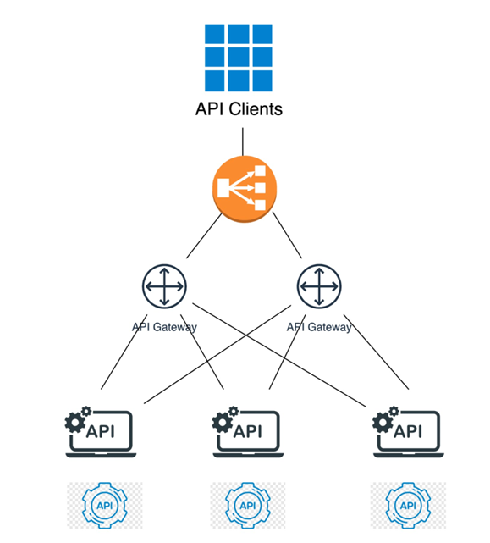

 It provides a unified interface for clients to access backend services. Think of **it as a single-entry point for all API calls,** **regardless of the underlying services and their complexities.**

An API Gateway is a server-side architectural component in a software system that acts as an intermediary between clients (such as web browsers, mobile apps, or other services) and backend services, microservices, or APIs.

Its main purpose is to provide a single entry point for external consumers to access the services and functionalities of the backend system. It receives client requests, forwards them to the appropriate microservice, and then returns the server’s response to the client.

The API gateway is responsible for tasks such as routing, authentication, and rate limiting. This enables microservices to focus on their individual tasks and improves the overall performance and scalability of the system.

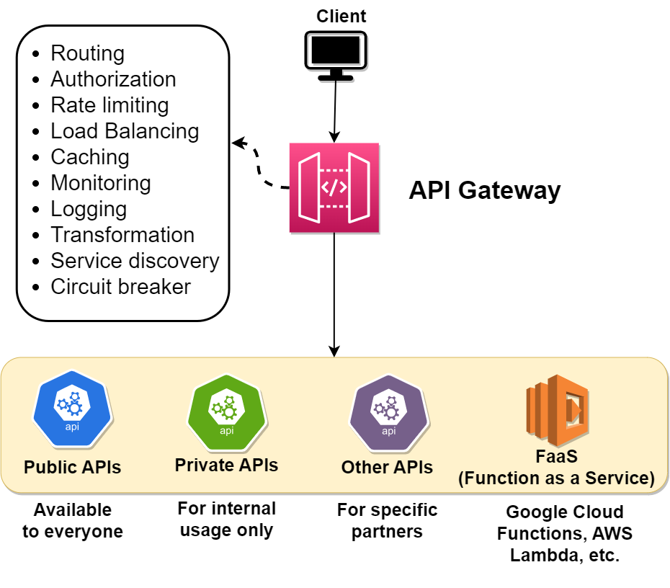

## What it is

* Entry point for client requests to microservices & services.
* Centralizes API communication, security, and policy enforcement.
* Simplifies app delivery by decoupling internal architecture from clients.

## Key benefits

* Reduced complexity & faster app releases.
* Streamlined request processing & policy enforcement.
* Simplified troubleshooting with granular metrics.

## For microservices

* Single entry point for simplified client & service implementations.
* Handles routing, composition, and policy enforcement.
* Offloads non-functional requirements for faster development.

## Deployment options

* **Kubernetes:** Edge (Ingress controller), cluster-level (load balancer), or within (service mesh).
* **Standalone:** Platform & runtime agnostic for maximum flexibility.

**Not the same as:**

* **Ingress Gateway/Controller:** Limited capabilities, often extended with custom resources for API gateway features.
* **Kubernetes Gateway API:** Standardized & improved service networking in Kubernetes, supports fine-grained policy definitions.
* **Service Mesh:** Primarily for service-to-service communication, can be a lightweight API gateway for microservices.
* 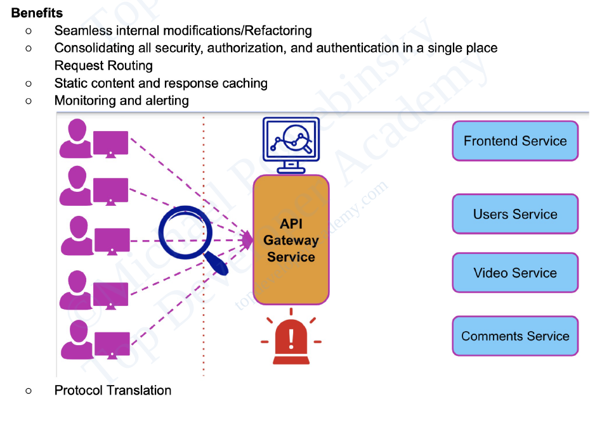
* 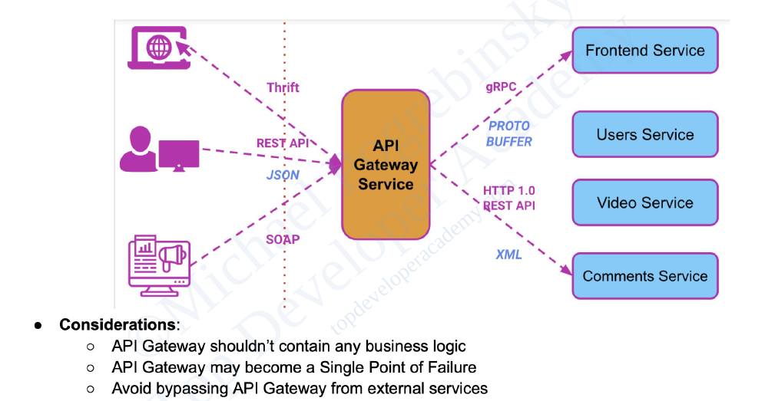

## Difference between an API gateway and a load balancer

An API gateway is focused on **routing** requests to the appropriate microservice, while a load balancer is focused on **distributing** requests evenly across a group of backend servers.

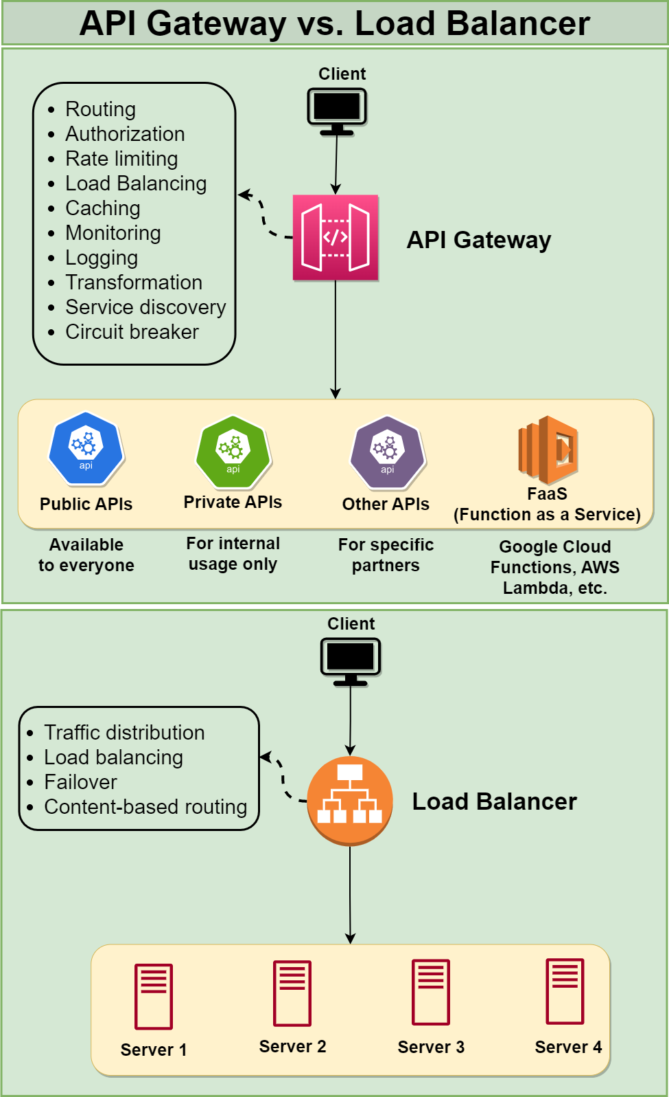

**Another difference** between the two is the type of requests that they typically handle. An API gateway is typically used to handle requests for APIs, which are web-based interfaces that allow applications to interact with each other over the internet. These requests typically have a specific URL that identifies the API that the client is trying to access, and the API gateway routes the request to the appropriate microservice based on this URL. A load balancer, on the other hand, is typically used to handle requests that are sent to a single, well-known IP address, and then routes them to one of many possible backend servers based on factors such as server performance and availability.

## API Gateway vs. API Management

* Gateway: Data-plane entry point for API calls (request processing, routing, load balancing).
* Management: Process of deploying, documenting, operating, and monitoring APIs (policy definition, developer portals).

# Usage of API gateway

API gateways are used for a variety of purposes in microservice architectures, including the following:

## 1. Routing

The API gateway receives requests from clients and routes them to the appropriate microservice. This enables clients to access the various microservices through a single entry point, simplifying the overall system design.

## 2. Rate limiting and throttling

You can rate limit client access to microservices with an API gateway. This can help prevent denial of service attacks and other types of malicious behavior.

## 3. Caching

The API gateway can cache responses from the microservices, reducing the number of requests that need to be forwarded to the microservices and improving the overall performance of the system.

## 4. Authentication and Authorization

The API gateway can be used to authenticate clients and enforce access control policies for the microservices. This helps to ensure that only authorized clients can access the microservices and helps to prevent unauthorized access.

## 5. Load balancing

The API gateway can distribute incoming requests among multiple instances of a microservice, enabling the system to handle a larger number of requests and improving its overall performance and scalability.

## 6. Monitoring

The API gateway can collect metrics and other data about requests and responses, providing valuable insights into the performance and behavior of the microservices. This can help to identify and diagnose problems, and improve the overall reliability and resilience of the system.

## 7. Transformation

The API gateway can be used to transform the data received from the microservices into a format that is more convenient for the clients to use. This can include tasks such as converting between different data formats, such as XML and JSON, or aggregating data from multiple microservices into a single response.

## 8. Request and response validation

The API gateway can be used to validate the requests and responses from the microservices to ensure that they conform to the expected format and structure. This can help to prevent errors and ensure that the microservices are functioning properly.

## 9. Circuit breaker

The API gateway can be used to implement a circuit breaker pattern, which can help to prevent a single failed microservice from bringing down the entire system. The circuit breaker can monitor the health of the microservices and automatically fail over to a backup service if necessary.

## 10. Service discovery

The API gateway can be used to discover the available microservices and their locations, enabling the clients to access them without knowing their specific addresses. This can make it easier to add new microservices or make changes to the existing ones without impacting the clients.

## 11. API Versioning

The API Gateway can manage multiple versions of an API, allowing developers to introduce new features or make changes to existing ones without disrupting existing clients.

## 12. Error Handling

The API Gateway can provide a consistent way to handle errors and generate error responses to clients, even when backend services are unavailable or return unexpected results.

## 13. Service Aggregation

The API Gateway can combine responses from multiple backend services into a single response for the client, reducing the number of requests a client has to make and simplifying the integration process.

## 14. Web Application Firewall (WAF)

The API Gateway can incorporate a Web Application Firewall to protect backend services from common web-based threats, such as SQL injection, cross-site scripting (XSS), or distributed denial-of-service (DDoS) attacks.

## 15. API Documentation

The API Gateway can generate and serve API documentation based on a standard format, such as Swagger or OpenAPI, making it easier for developers to understand and use the APIs.

# Advantages and disadvantages of using API gateway

## Advantages of using API Gateway

Using an API Gateway in a software system brings several advantages that can streamline the development process, enhance performance, and improve security. Here are the key advantages of using an API Gateway:

### 1. Improved performance

The API Gateway can cache responses, rate limit requests, and optimize communication between clients and backend services, resulting in improved performance and reduced latency for end users.

### 2. Simplified system design

The API Gateway provides a single entry point for all API requests, making it easier to manage, monitor, and maintain APIs across multiple backend services. This simplifies the development and deployment process and reduces the complexity of the overall system.

### 3. Enhanced security

The API Gateway can enforce authentication and authorization policies, helping protect backend services from unauthorized access or abuse. By handling security at the gateway level, developers can focus on implementing core business logic in their services without worrying about implementing security measures in each service individually.

### 4. Improved scalability

The API gateway can distribute incoming requests among multiple instances of a microservice, enabling the system to scale more easily and handle a larger number of requests.

### 5. Better monitoring and visibility

The API gateway can collect metrics and other data about the requests and responses, providing valuable insights into the performance and behavior of the system. This can help to identify and diagnose problems, and improve the overall reliability and resilience of the system.

### 6. Simplified Client Integration

By providing a consistent and unified interface for clients to access multiple backend services, the API Gateway simplifies client-side development and reduces the need for clients to manage complex service interactions.

### 7. Protocol and Data Format Transformation

The API Gateway can convert requests and responses between different protocols (e.g., HTTP to gRPC) or data formats (e.g., JSON to XML), enabling greater flexibility in how clients and services communicate and easing the integration process.

### 8. API Versioning and Backward Compatibility

The API Gateway can manage multiple versions of an API, allowing developers to introduce new features or make changes without breaking existing clients. This enables a smoother transition for clients and reduces the risk of service disruptions.

### 9. Enhanced Error Handling

The API Gateway can provide a consistent way to handle errors and generate error responses, improving the user experience and making it easier to diagnose and fix issues.

### 10. Load Balancing and Fault Tolerance

The API Gateway can distribute incoming traffic evenly among multiple instances of a backend service, improving performance and fault tolerance. This helps ensure that the system remains responsive and available even if individual services or instances experience failures or become overloaded.

## Disadvantages of using API Gateway

While API Gateways provide numerous benefits, there are some potential disadvantages to consider when deciding whether to use one in your software system:

### 1. Additional Complexity

Introducing an API Gateway adds an extra layer of complexity to your architecture. Developers need to understand and manage this additional component, which might require additional knowledge, skills, and tools.

### 2. Single Point of Failure

If not configured correctly, the API Gateway could become a single point of failure in your system. If the gateway experiences an outage or performance issues, it can affect the entire system. It is crucial to ensure proper redundancy, scalability, and fault tolerance when deploying an API Gateway.

### 3. Latency

The API Gateway adds an extra hop in the request-response path, which could introduce some latency, especially if the gateway is responsible for performing complex tasks like request/response transformation or authentication. However, the impact is usually minimal and can be mitigated through performance optimizations, caching, and load balancing.

### 4. Vendor Lock-in

If you use a managed API Gateway service provided by a specific cloud provider or vendor, you may become dependent on their infrastructure, pricing, and feature set. This could make it more challenging to migrate your APIs to a different provider or platform in the future.

### 5. Cost

Running an API Gateway, especially in high-traffic scenarios, can add to the overall cost of your infrastructure. This may include the cost of hosting, licensing, or using managed API Gateway services from cloud providers.

### 6. Maintenance Overhead

An API Gateway requires monitoring, maintenance, and regular updates to ensure its security and reliability. This can increase the operational overhead for your development team, particularly if you self-host and manage your own API Gateway.

### 7. Configuration Complexity

API Gateways often come with a wide range of features and configuration options. Setting up and managing these configurations can be complex and time-consuming, especially when dealing with multiple environments or large-scale deployments.

## Choosing an API Gateway

* Architecture: Platform, runtime, cloud provider options.
* Performance: High throughput & low latency.
* Scalability: Vertical & horizontal scaling for traffic demands.
* Security: Access control, mTLS, WAF, schema validation.
* Cost: TCO comparison of custom vs. enterprise solutions.

## NGINX Options

* Kubernetes-native: NGINX Ingress Controller, NGINX Service Mesh.
* Universal: NGINX Plus, F5 NGINX Management Suite API Connectivity Manager.

## Key Takeaways

* API gateways simplify app delivery and microservices communication.
* Choose the right deployment option based on your needs.
* NGINX offers various API gateway solutions for different use cases.

Rate Limiting

Rate limiting is a technique to limit network traffic to prevent users from exhausting system resources. Rate limiting makes it harder for malicious actors to overburden the system and cause attacks like Denial of Service (DoS). This involves attackers flooding a target system with requests and consuming too much network capacity, storage, and memory.

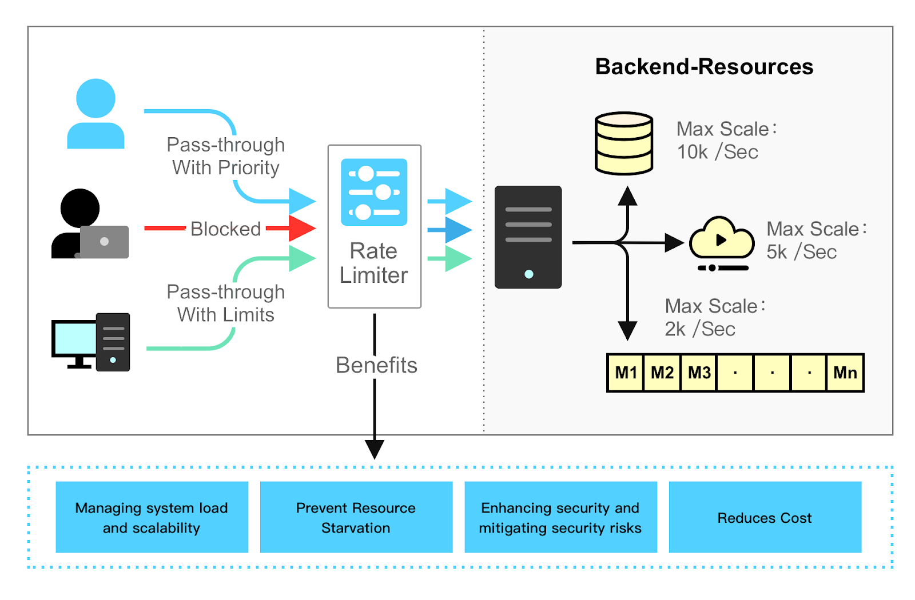

APIs that use rate limiting can throttle or temporarily block any client that tries to make too many API calls. It might slow down a throttled user’s requests for a specified time or deny them altogether. Rate limiting ensures that legitimate requests can reach the system and access information without impacting the overall application’s performance.

**Problem:** Malicious actors flood systems with requests, causing outages and resource exhaustion.

**Solution:** Rate limiting throttles requests to protect services and ensure fair access.

**Benefits:**

* **Prevents DoS attacks:** Blocks attackers from overwhelming the system.
* **Stops account takeovers:** Limits bot activity and credential stuffing.
* **Saves resources:** Optimizes resource usage for legitimate requests.

**How it Works:**

* Tracks IP addresses and request times.
* Sets limits on requests per user/region/server in a timeframe.
* Throttles or blocks exceeding requests.

**Types of Rate Limits:**

* **User:** Based on individual users (IP address, API key).
* **Geographic:** Specific rate limits for different regions.
* **Server:** Different limits for different servers within an application.

**Rate Limiting Algorithms:**

* **Fixed-window:** Allows a set number of requests within a defined time window.
* **Leaky bucket:** Limits requests based on queue size, not time.
* **Sliding-window:** Tracks requests within a moving time window starting from the last request.

**Why Choose Imperva:**

* **Comprehensive protection:** Secures websites, apps, APIs, and microservices.
* **Advanced bot protection:** Stops account takeovers and data scraping.
* **Multiple security layers:** Web Application Firewall, RASP, API Security, DDoS Protection.

**Remember:** Rate limiting is a crucial security measure for protecting your systems and ensuring optimal performance.

Heart Beat

Show a server is available by periodically sending a message to all the other servers.

## Problem

When multiple servers form a cluster, each server is responsible for storing some portion of the data, based on the partitioning and replication schemes used. Timely detection of server failures is important for taking corrective actions by making some other server responsible for handling requests for the data on a failed server.

## Solution

Periodically send a request to all the other servers indicating liveness of the sending server. Select the request interval to be more than the network round trip time between the servers. All the listening servers wait for the timeout interval, which is a multiple of the request interval.

**Purpose:**

* **Maintain connections:** Prevent idle connections from being terminated, ensuring availability for real-time data exchange or long-running operations.
* **Monitor health:** Detect inactive or unresponsive servers, enabling proactive actions to maintain service uptime.
* **Coordinate tasks:** Synchronize actions between servers or services in distributed systems.

**Mechanism:**

* Server sends periodic “heartbeat” signals (often simple pings) to clients.
* Clients respond to confirm their presence and responsiveness.
* If a client fails to respond within a specified timeout, server takes action (e.g., connection closure, recovery attempts).

**Implementation:**

* **Transport-level heartbeats:** Embedded within network protocols (e.g., TCP Keep-Alive, WebSocket ping/pong).
* **Application-level heartbeats:** Custom-built into the API logic using timers, threads, or asynchronous mechanisms.
* **Third-party libraries or frameworks:** Available to simplify implementation (e.g., SignalR for ASP.NET).

**Considerations:**

* **Frequency:** Balance overhead with responsiveness (typically every few seconds to minutes).
* **Timeouts:** Set appropriate thresholds to detect failures without false positives.
* **Actions:** Define appropriate responses to missed heartbeats (e.g., reconnection, failover, notifications).
* **Security:** Protect heartbeat signals from unauthorized access or manipulation.

**Common Use Cases:**

* Long-polling for real-time updates in web applications.
* Maintaining persistent connections in chat or messaging apps.
* Monitoring server health in load-balanced environments.
* Coordinating tasks in distributed systems.
* Detecting failed services or clients in microservice architectures.

Circuit Breaker Pattern

The Circuit Breaker design pattern is used to stop the request and response process if a service is not working, as the name suggests. When the number of failures reaches a certain threshold, the circuit breaker trips for a defined duration of time.

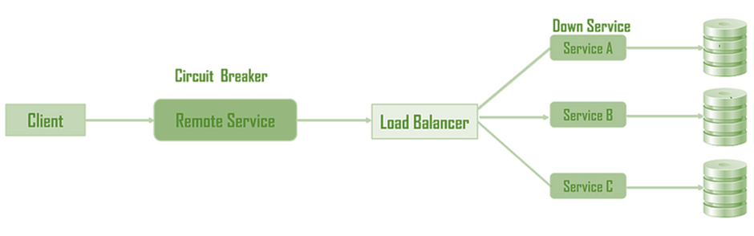

**Problem:** Services in microservices architecture can fail, causing cascading failures and resource exhaustion.

**Solution:** Circuit Breaker pattern acts as a proxy, protecting other services by monitoring and controlling calls to a potentially failing service.

**Benefits:**

* **Prevents cascading failures:** Isolates the failing service, stopping it from affecting others.
* **Improves resilience:** Allows the failing service to recover without impacting other services.
* **Optimizes resource usage:** Limits calls to the failing service, preventing resource exhaustion.

**Key Concepts:**

* **States:** Closed (normal operation), Open (blocks requests), Half-Open (allows few test calls).
* **Thresholds:** Define failure and recovery criteria (e.g., number of failures, timeout).
* **Fallback:** Handles failed requests gracefully (e.g., error message, default value).

**Use Cases:**

* Protecting downstream services from a slow or unresponsive service.
* Preventing overload and resource exhaustion on the failing service.
* Implementing graceful service degradation during outages.

**Main Example:**

* Mercantile Finance employee microservice with aggregation pattern calls various backend services.
* Circuit breaker protects the aggregator and other services from a failing backend service.

**How it Works:**

1.     **Closed:** Normal operation, requests flow through to the service.

2.     **Failure threshold reached:** Circuit opens, requests fail immediately.

3.     **Timeout period:** Service sends test calls during this period.

4.     **Test calls succeed:** Circuit closes, normal operation resumes.

5.     **Test calls fail:** Circuit remains open, timeout restarts.

**Additional Notes:**

* Choose appropriate thresholds and timeouts based on service behavior and dependencies.
* Implement monitoring and alerting for circuit breaker states and service health.
* Consider fallback strategies for different failure scenarios.

**Remember:** While some requests might fail during an outage, the Circuit Breaker pattern prevents catastrophic system failures and enables faster recovery.

Distributed Tracing

Distributed tracing is a tool for understanding how requests travel through your application in complex, cloud-native environments like microservices. Imagine it like following a detective trail for a single user request as it winds through different services and servers.

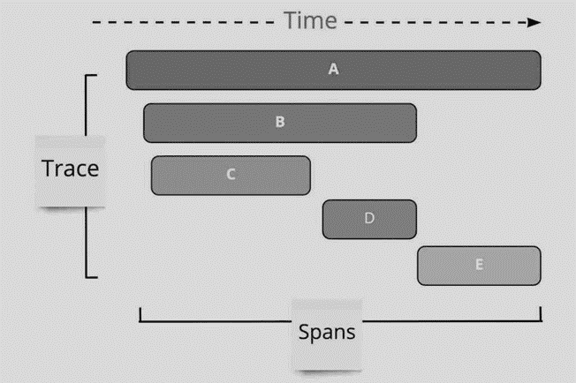

**What it does:**

* Tracks a single request (think detective following footprints) as it interacts with various services (think different rooms in a building).
* Tags each request with a unique identifier (think suspect photo) so you can follow its path.
* Records details like timestamps and performance metrics (think notes and clues) at each step.
* Connects the dots (analyzes the clues) to show you the complete journey of the request and identify any issues.

## Why it’s important

* **Troubleshooting:** When your app runs slow or crashes, distributed tracing helps you pinpoint the exact service causing the problem, saving you time and frustration.
* **Performance optimization:** You can see where bottlenecks are slowing down your requests and optimize your code or infrastructure accordingly.
* **Better user experience:** By understanding how user requests flow, you can ensure smooth performance and avoid frustrating delays.
* **Improved collaboration:** Different teams working on different services can see how their work affects the overall user experience, enabling better communication and teamwork.

## Think of it this way

* Traditional monitoring is like looking at a city from afar – you see traffic jams but not the cause.
* Distributed tracing is like going down to street level and following the traffic jam to its source, allowing you to fix it.

## Benefits

* **Reduced MTTR (mean time to repair):** Faster identification and resolution of performance issues.
* **Improved SLAs:** Consistent user experience and better compliance with service-level agreements.
* **Faster time to market:** Quicker innovation and release cycles due to efficient troubleshooting.
* **Enhanced collaboration:** Clear visibility into performance bottlenecks fosters better communication and teamwork across teams.

## Challenges:

* **Manual instrumentation:** Some tools require code changes, adding complexity.
* **Limited coverage:** Some tools only focus on backend, omitting frontend interactions.
* **Sampling limitations:** Random sampling might miss crucial traces.

## When to use it

* **Microservices architectures:** Essential for understanding complex interactions between services.
* **Troubleshooting performance issues:** Quickly identify bottlenecks and root causes.
* **Optimizing code:** Proactively improve performance by analyzing problematic microservices.

## Alternatives

* **Logging:** Provides valuable data but lacks the comprehensive view of distributed tracing.
* **Centralized logging:** Aggregates logs from multiple services, but requires careful management.
* **Distributed logging:** Stores logs across the environment, reducing network load but increasing complexity.

|  |
| --- |
|  |

Overall, distributed tracing is a crucial tool for observability in modern cloud-native environments. It empowers teams to troubleshoot issues faster, optimize performance, and deliver a consistent, high-quality user experience.

Failover

Failover is the ability to seamlessly and automatically switch to a reliable backup system. Either redundancy or moving into a standby operational mode when a primary system component fails should achieve failover and reduce or eliminate negative user impact.

## What it is

* Automatic switch to a backup system when the primary fails.
* Reduces downtime and protects against disasters.
* Achieved through redundancy or standby systems.

## Types

* **Failover:** Automatic, triggered by heartbeat signals.
* **Switchover:** Manual intervention needed.
* **Clusters:** Groups of servers for continuous availability.

## Benefits

* **Minimal downtime:** Services stay online during failures.
* **Data protection:** Prevents data loss in case of outages.
* **Improved reliability:** Systems remain operational most of the time.

## Configurations

* **Active-Active:** Both servers active, load balanced.
* **Active-Standby:** One server active, one on standby.

## Common Failovers

* **SQL Server:** Redundant servers and shared storage.
* **DHCP:** Multiple servers share IP address assignment.
* **DNS:** Backup IP addresses for server redirection.
* **Application Server:** Separate servers with load balancing.

## Important details

* Failover testing validates system recovery capabilities.
* Secure communication crucial for failover partners.
* VMware NSX offers high availability clusters for load balancers.

Proxy Server

A proxy server is a system or router that provides a gateway between users and the internet. Therefore, it helps prevent cyber attackers from entering a private network. It is a server, referred to as an “intermediary” because it goes between end-users and the web pages they visit online.

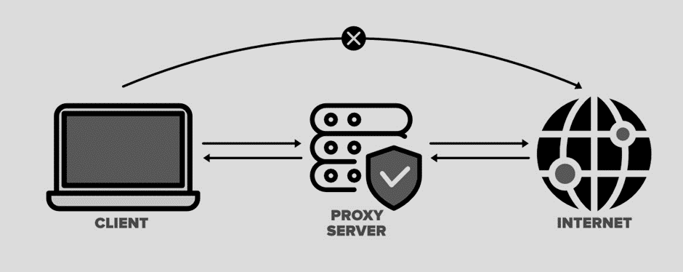

## What it is

* Gateway between users and the internet.
* Protects private networks from cyberattacks.
* Acts as an intermediary for web requests.

## Benefits

* **Enhanced security:** Acts as a firewall, hiding your IP address.
* **Privacy:** Browse, watch, and listen privately.
* **Location access:** Bypass geo-restrictions.
* **Content control:** Block unwanted websites for employees.
* **Bandwidth saving:** Cache files and compress traffic.

## Types

* **Forward:** Single point of entry for internal networks.
* **Transparent:** Undetectable, seamless user experience.
* **Anonymous:** Hides identity and computer information.
* **High anonymity:** Further erases information before connection.
* **Distorting:** Hides its own identity while showing a fake location.
* **Data center:** Fast and inexpensive, but not highly anonymous.
* **Residential:** Uses real, physical devices for increased trust.
* **Public:** Free but slow and potentially risky.
* **Shared:** Affordable but prone to misuse by others.
* **SSL:** Provides encrypted communication for enhanced security.
* **Rotating:** Assigns different IP addresses for anonymity and web scraping.
* **Reverse:** Forwards requests to web servers and balances load.

## How it works

1.     User sends request to proxy.

2.     Proxy forwards request to website.

3.     Website sends response to proxy.

4.     Proxy forwards response to user.

## Choosing a proxy

* Consider your needs: security, privacy, location, etc.
* Compare different types and providers.
* Balance cost and performance.

# Forward proxy

A forward proxy, also known as a "proxy server," or simply "proxy," is a server that sits in front of one or more client machines and acts as an intermediary between the clients and the internet. When a client machine makes a request to a resource (like a web page or file) on the internet, the request is first sent to the forward proxy. The forward proxy then forwards the request to the internet on behalf of the client machine and returns the response to the client machine.

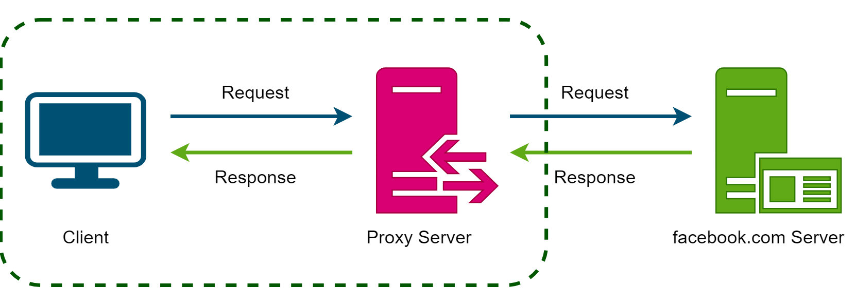

Typically, forward proxies are used to cache data, filter requests, log requests, or transform requests (by adding/removing headers, encrypting/decrypting, or compressing a resource).

**A forward proxy can hide the identity of the client from the server by sending requests on behalf of the client.**

In addition to coordinating requests from multiple servers, proxies can also optimize request traffic from a system-wide perspective. Proxies can combine the same data access requests into one request and then return the result to the user; this technique is called collapsed forwarding. Consider a request for the same data across several nodes, but the data is not in cache. By routing these requests through the proxy, they can be consolidated into one so that we will only read data from the disk once.

# Reverse Proxy

A reverse proxy is a server that sits in front of one or more web servers and acts as an intermediary between the web servers and the Internet. When a client makes a request to a resource on the internet, the request is first sent to the reverse proxy. The reverse proxy then forwards the request to one of the web servers, which returns the response to the reverse proxy. The reverse proxy then returns the response to the client.

**Contrary to the forward proxy, which hides the client's identity, a reverse proxy hides the server's identity.**

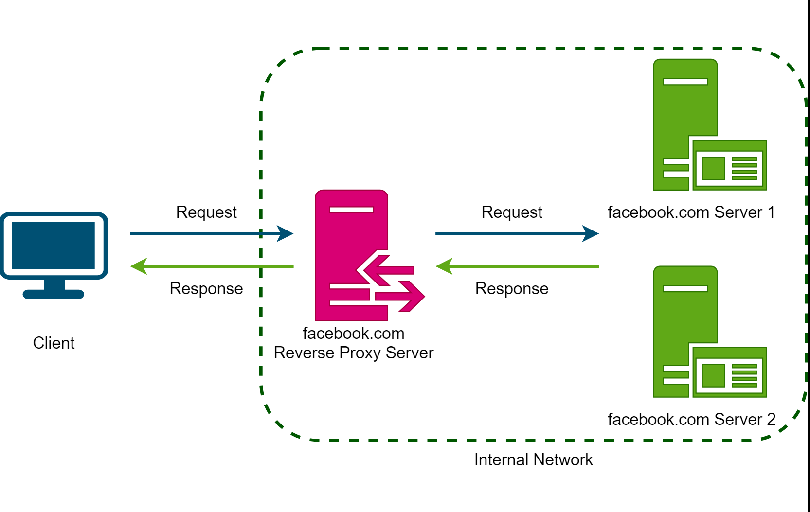

In the above diagram, the reverse proxy hides the final server that served the request from the client. The client makes a request for some content from facebook.com; this request is served by facebook’s reverse proxy server, which gets the response from one of the backend servers and returns it to the client.

A reverse proxy, just like a forward proxy, can be used for caching, load balancing, or routing requests to the appropriate servers.

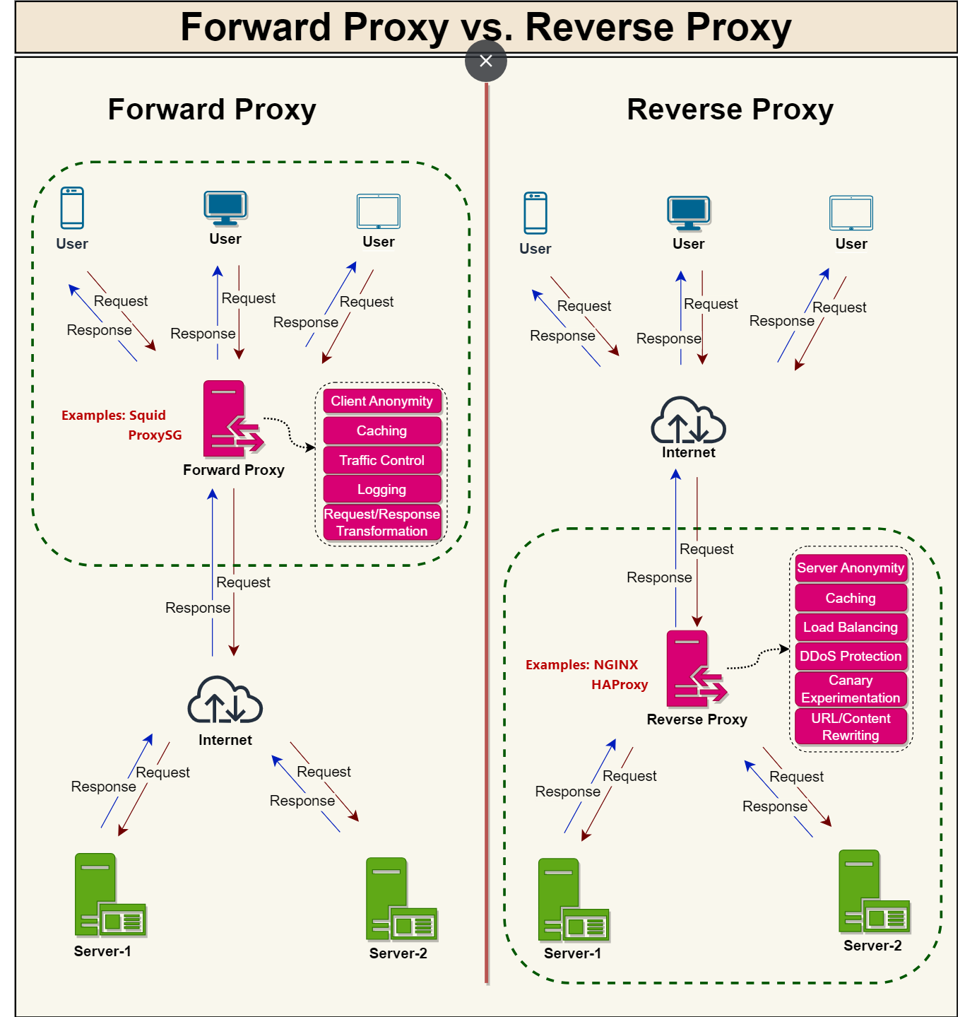

Proxy servers serve a variety of purposes in networked environments, often enhancing performance, security, and privacy.

# VPN vs. Proxy Server

VPN (Virtual Private Network) and Proxy Servers are both tools used for privacy and security online, but they function differently and serve distinct purposes. Understanding their differences is essential in determining which one to use based on your needs.

## VPN (Virtual Private Network)

A **VPN** creates a secure, encrypted tunnel between your device and a remote server operated by the VPN service. All your internet traffic is routed through this tunnel, meaning that your data is secure from external observation.

The encryption process scrambles your data, making it unreadable to anyone intercepting it (e.g., on public Wi-Fi). This enhances online security and privacy.

**Benefits:**

* **Stronger Security:** Encrypts all your internet traffic, protecting data from snooping on public Wi-Fi or unsecured networks.
* **IP Address Masking:** Hides your actual IP address, making it appear as if you're connecting from the VPN server's location. This can be useful for bypassing geo-restrictions on websites or content.
* **Privacy Enhancement:** Provides a higher level of online privacy by obscuring your online activity from your internet service provider (ISP) and other potential observers.

**Limitations:**

* **Performance Impact:** Encryption and decryption processes can add overhead, potentially slowing down your internet connection speed.
* **Cost:** Many reputable VPN services require a subscription fee.
* **Not a Foolproof Security Solution:** While VPNs enhance security, they don't guarantee complete anonymity.

## ****Proxy Server****

A proxy server acts as an intermediary between your device and the internet. When you access a website through a proxy, your request first goes to the proxy server, which then forwards it to the website on your behalf. The website sees the proxy server's IP address instead of your own.

Proxy servers offer some level of privacy by masking your IP address. However, they typically don't encrypt your data traffic, so it might still be readable by the proxy server itself or anyone monitoring its network.

**Benefits:**

* **Limited Privacy:** Can mask your IP address, potentially helping bypass geo-restrictions on some websites.
* **Potential Performance Improvement:** Caching mechanisms in some proxies can improve loading times for frequently accessed websites.
* **Often Free:** Many basic proxy services are available for free, although some might have limitations on usage or bandwidth.

**Limitations:**

* **Weaker Security:** Data isn't encrypted, so it's not suitable for activities requiring strong privacy protection (e.g., online banking).
* **Limited Functionality:** May not bypass all geo-restrictions and can be unreliable for certain websites or services.
* **Potential Trust Issues:** Free proxy servers might be less trustworthy and could potentially monitor or inject ads into your traffic.

## ****Choosing Between VPN and Proxy****

**Use a VPN for:**

* Enhanced online security and privacy, especially on public Wi-Fi.
* Bypassing geo-restrictions on websites or content.
* Protecting sensitive data while using online banking or financial transactions.

**Use a Proxy Server for:**

* Basic privacy by masking your IP address for occasional use cases.
* Potentially improving website loading times (depends on the proxy).
* Bypassing basic geo-restrictions (effectiveness varies).

Gossip Protocol

Gossip protocol is like the grapevine for your computer network, spreading information quickly and efficiently like rumors through small towns. Here’s the lowdown:

**What it does:**

* Imagine messages hopping from node to node in your network, whispering the latest news to each other.
* Each node randomly picks a few neighbors and shares the messages it knows.
* These neighbors repeat the process, spreading the messages further like ripples in a pond.
* Eventually, everyone in the network gets the news, even if it takes a few whispers.

**Why it’s useful:**

* **Fast updates:** Information spreads quickly without a central hub, keeping everyone in the loop.
* **Resilient to failures:** Even if some nodes go down, the gossip continues through other paths.
* **Scalable:** Works well for large networks with many nodes, just like gossip thrives in big communities.
* **Simple to implement:** No complex infrastructure needed, just nodes talking to each other.

**Real-world examples:**

* **Service discovery:** Nodes learn about each other’s availability and capabilities.
* **Data replication:** Updates reach all nodes, keeping everyone’s data consistent.
* **Distributed consensus:** Nodes agree on a common state even without a central authority.

**Challenges to consider:**

* **False rumors:** Inaccuracy can spread alongside rumors, requiring verification mechanisms.
* **Overload:** Too much gossip can overwhelm nodes, affecting network performance.
* **Inefficiency:** Redundant transmissions can occur, especially in dense networks.

Overall, gossip protocol is a powerful tool for information dissemination in decentralized networks, offering speed, resilience, and scalability with inherent challenges to manage.

Bloom Filters

Bloom filters are like probabilistic bouncers for your data sets. They offer quick, space-efficient membership checks with a slight risk of letting imposters in, but they’re great for large datasets where speed and memory matters.

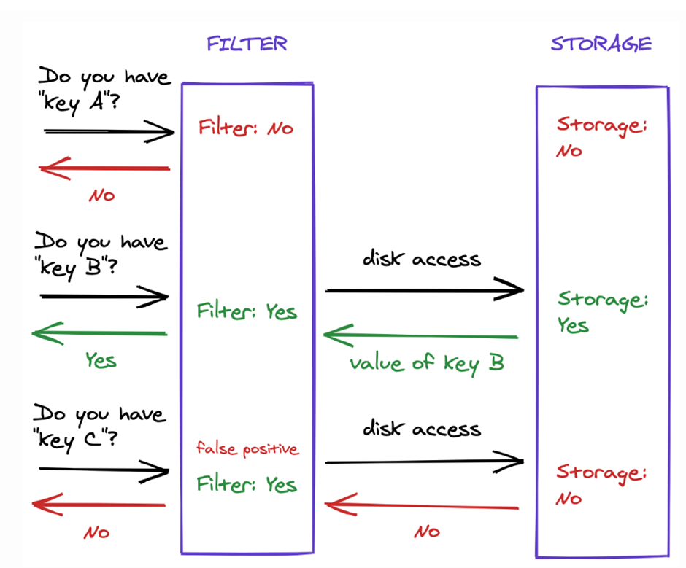

**What they do:**

* Imagine a big party with a million guests. A traditional guest list would be huge and slow to check.
* A Bloom filter uses a few strategically placed bouncers (hash functions) at different doorways.
* Each bouncer asks a different “are you X?” question, based on the guest’s name (data element).
* If all bouncers say “yes,” the guest is definitely on the list (element is definitely in the set).
* But if even one bouncer says “no,” the guest might be an imposter (element might not be in the set).

**Why they’re useful:**

* **Fast & compact:** Checking millions of items becomes super quick, saving time and memory.
* **Good for large sets:** Ideal for massive datasets where traditional methods like searching through lists become cumbersome.
* **Trade-off with accuracy:** Slight chance of false positives (imposters getting in), but often worth it for the speed and efficiency.

**Real-world uses:**

* **Spell checking:** Quickly suggesting potential words while you type, even if they’re not exactly in the dictionary.
* **Caching:** Checking if a web page has been accessed before, without storing the entire page in memory.
* **Network security:** Identifying potential spam or malware before it enters your network.

**Not perfect, but powerful:**

* False positives can happen, but the risk can be minimized with careful configuration.
* Not ideal for situations where absolute accuracy is crucial.

**Overall, Bloom filters are a clever tool for fast and efficient membership checks in large datasets, even if they have a slight chance of letting a few imposters slip through.**

Consistent Hashing

Consistent hashing is a hashing technique that performs really well when operated in a dynamic environment where the distributed system scales up and scales down frequently.

Consistent hashing is a specific kind of hashing in which when a hash table is re-sized i.e when the number of servers in the server pool change, only k/n keys need to be remapped on an average, where k is the number of keys, and n is the number of servers.

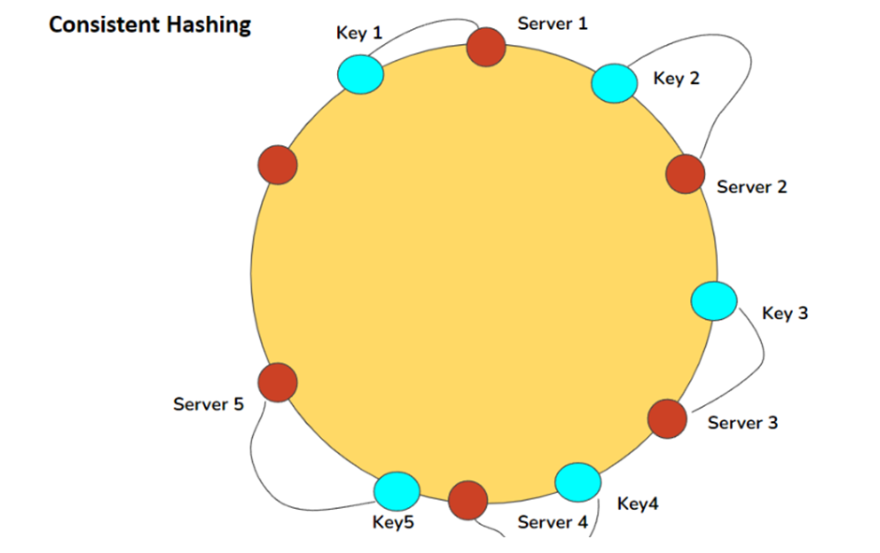

**Problem:** Efficiently store and retrieve data in a dynamic distributed system (scales up/down frequently).

**Solution:** Consistent hashing - maps data and servers to a virtual ring, minimizing data movement and load imbalance during server changes.

## How does consistent hashing work ?

It has two main components- **Hash Space** and **Hash Ring**. Hash space is the range of the output of the hash function. Those outputs are assigned a position on the hash ring. It operates independently of the number of servers or objects in a distributed hash table by assigning them a position on a hash ring. **If we map the hash output range onto the edge of a circle, it would mean that the minimum possible hash value, zero, would correspond to an angle of zero and the maximum possible value 360 degrees, and all other hash values would linearly fit somewhere in between.**

Consistent Hashing technique stores the data managed by a distributed system in a ring. Each node in the ring is assigned a range of data. Here is an example of the consistent hash ring:

With consistent hashing, the ring is divided into smaller, predefined ranges. Each node is assigned one of these ranges. The start of the range is called a **token**. This means that each node will be assigned one token. The range assigned to each node is computed as follows:

**Range start:**  Token value  
**Range end:**    Next token value - 1

Here are the tokens and data ranges of the four nodes described in the above diagram:

|  |  |  |  |
| --- | --- | --- | --- |
| Server | Token | Range Start | Range End |
| Server 1 | 1 | 1 | 25 |
| Server 2 | 26 | 26 | 50 |
| Server 3 | 51 | 51 | 75 |
| Server 4 | 76 | 76 | 100 |

Whenever the system needs to read or write data, the first step it performs is to apply the MD5 hashing algorithm to the key. The output of this hashing algorithm determines within which range the data lies and hence, on which node the data will be stored. As we saw above, each node is supposed to store data for a fixed range. Thus, the hash generated from the key tells us the node where the data will be stored.

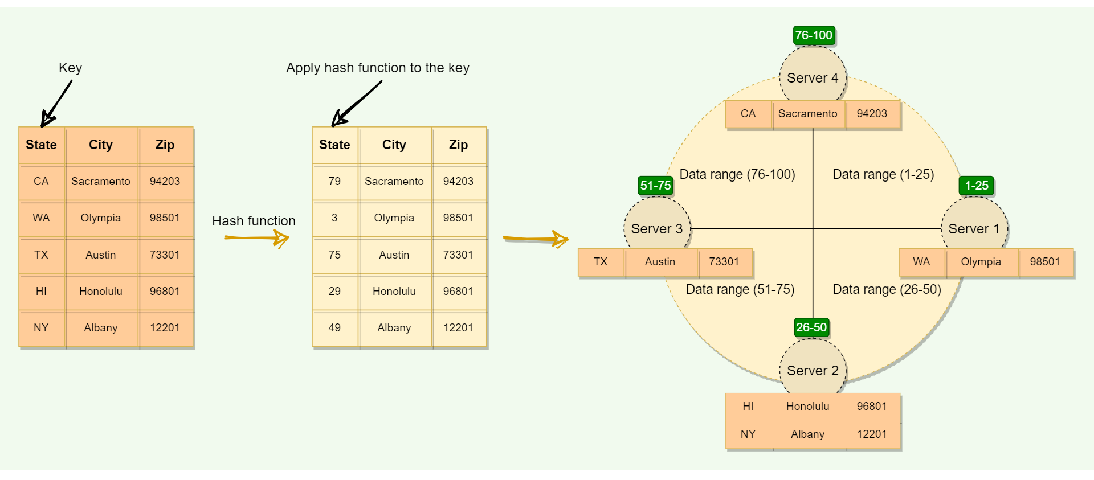

The Consistent Hashing scheme described above works great when a node is added or removed from the ring, as in these cases, since only the next node is affected. For example, when a node is removed, the next node becomes responsible for all of the keys stored on the outgoing node. However, this scheme can **result in non-uniform data and load distribution**. This problem can be solved with the help of Virtual nodes.

### Virtual nodes

Adding and removing nodes in any distributed system is quite common. Existing nodes can die and may need to be decommissioned. Similarly, new nodes may be added to an existing cluster to meet growing demands. To efficiently handle these scenarios, Consistent Hashing makes use of virtual nodes (or Vnodes).

As we saw above, the basic Consistent Hashing algorithm assigns a single token (or a consecutive hash range) to each physical node. This was a static division of ranges that requires calculating tokens based on a given number of nodes. This scheme made adding or replacing a node an expensive operation, as, in this case, we would like to rebalance and distribute the data to all other nodes, resulting in moving a lot of data. Here are a few potential issues associated with a manual and fixed division of the ranges:

* **Adding or removing nodes**: Adding or removing nodes will result in recomputing the tokens causing a significant administrative overhead for a large cluster.
* **Hotspots**: Since each node is assigned one large range, if the data is not evenly distributed, some nodes can become hotspots.
* **Node rebuilding**: Since each node's data might be replicated (for fault-tolerance) on a fixed number of other nodes, when we need to rebuild a node, only its replica nodes can provide the data. This puts a lot of pressure on the replica nodes and can lead to service degradation.

To handle these issues, Consistent Hashing introduces a new scheme of distributing the tokens to physical nodes. Instead of assigning a single token to a node, the hash range is divided into multiple smaller ranges, and each physical node is assigned several of these smaller ranges. Each of these subranges is considered a Vnode. With Vnodes, instead of a node being responsible for just one token, it is responsible for many tokens (or subranges).

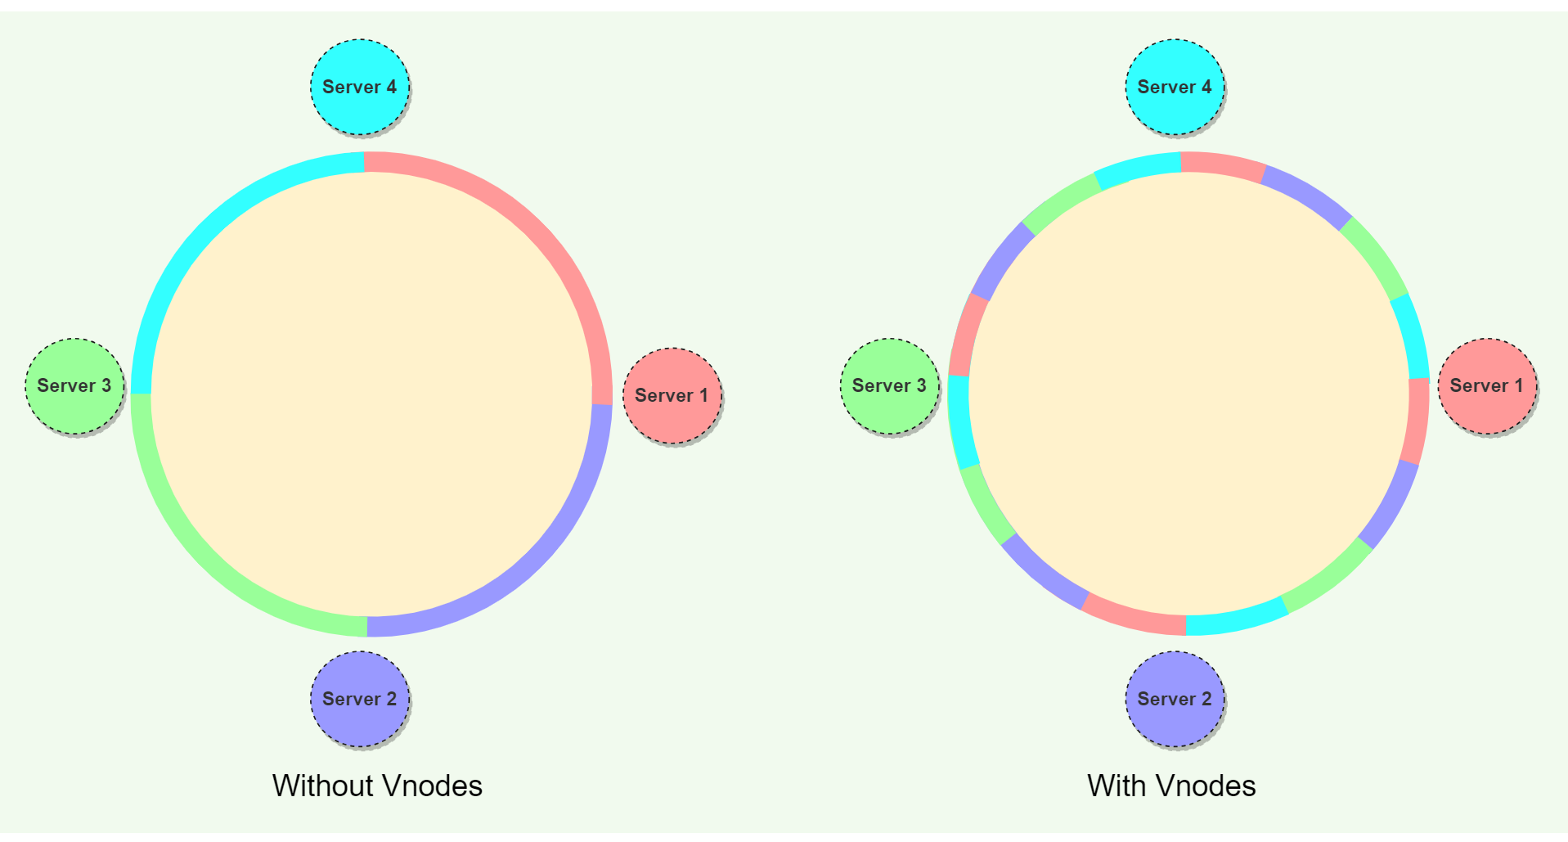

Practically, Vnodes are **randomly distributed** across the cluster and are generally **non-contiguous** so that no two neighboring Vnodes are assigned to the same physical node or rack. Additionally, nodes do carry replicas of other nodes for fault tolerance. Also, since there can be heterogeneous machines in the clusters, some servers might hold more Vnodes than others. The figure below shows how physical nodes A, B, C, D, & E use Vnodes of the Consistent Hash ring. Each physical node is assigned a set of Vnodes and each Vnode is replicated once.

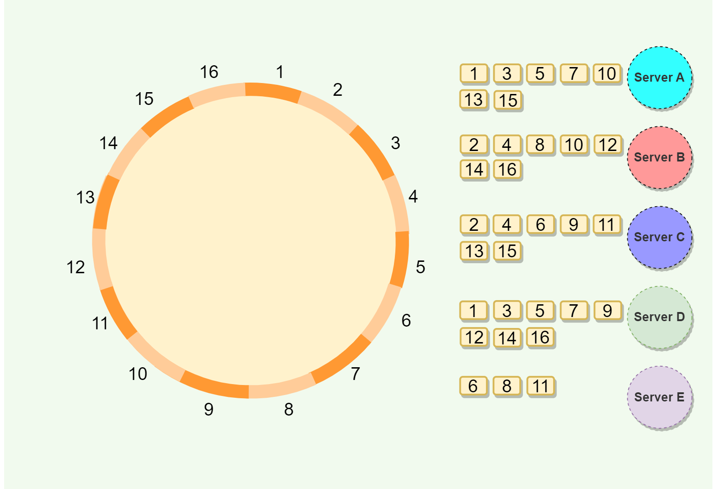

#### Advantages of Vnodes

Vnodes gives the following advantages:

1. As Vnodes help spread the load more evenly across the physical nodes on the cluster by dividing the hash ranges into smaller subranges, this speeds up the rebalancing process after adding or removing nodes. When a new node is added, it receives many Vnodes from the existing nodes to maintain a balanced cluster. Similarly, when a node needs to be rebuilt, instead of getting data from a fixed number of replicas, many nodes participate in the rebuild process.
2. Vnodes make it easier to maintain a cluster containing heterogeneous machines. This means, with Vnodes, we can assign a high number of sub-ranges to a powerful server and a lower number of sub-ranges to a less powerful server.
3. In contrast to one big range, since Vnodes help assign smaller ranges to each physical node, this decreases the probability of hotspots.

## Examples

**Dynamo** and **Cassandra** use Consistent Hashing to distribute their data across nodes.

Distributed Consensus

In a distributed system, multiple computers (known as nodes) are mutually connected with each other and collaborate with each other through message passing. Now, during computation, they need to agree upon a common value to coordinate among multiple processes. This phenomenon is known as Distributed Consensus.



**Imagine this:** Maya and Akash were feeling sporty. Akash proposed a game of cricket, his favorite pastime. Maya, a big cricket fan herself, immediately agreed. Without needing anything further, they both grabbed their gear and headed to the park – united in their enthusiasm for the common activity. This mutual agreement on a shared choice, in this case, cricket, is what we call consensus.

* **What it is:** Multiple computers (nodes) agree on a single value during computations, ensuring coordination and consistency.
* **Why it’s needed:** When nodes perform distributed tasks, they need a common reference point to stay in sync.
* **How it works:** Nodes communicate using protocols (like voting or proof-based approaches) to reach agreement.
* **Challenges:** Faulty nodes (crashed or behaving abnormally) can disrupt the process, requiring robust protocols.

**Key points:**

* **Agreement:** All non-faulty nodes must agree on the same value.
* **Validity:** The agreed value must come from a non-faulty node.
* **Termination:** Every non-faulty node eventually agrees on a value.
* **Crash vs. Byzantine failures:** Crash failures are easier to handle than Byzantine failures, where faulty nodes actively mislead others.

**Examples:**

* **Blockchain:** Nodes agree on the state of the ledger (transaction history).
* **Google PageRank:** Nodes agree on the ranking of web pages.
* **Load balancing:** Nodes agree on how to distribute workloads effectively.

**Consensus algorithms:**

* **Voting-based:** Like democratic elections, nodes vote on a value. (e.g., Paxos, Raft)
* **Proof-based:** Nodes provide proof (e.g., work done) to contribute to decisions. (e.g., Proof of Work, Proof of Stake)

**Distributed consensus is a critical building block for reliable and coordinated operation in decentralized systems.**

Distributed Locking

Imagine multiple applications sharing a resource, like a shared file or database record. To avoid collisions and data corruption, we need **Distributed Locking**. It’s like taking a ticket at a theme park before riding a popular attraction, but for applications instead of people.

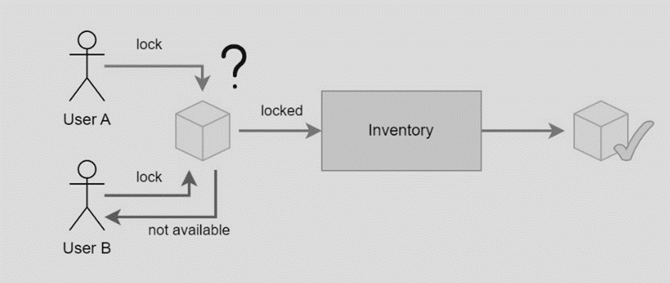

Here’s how it works:

1.     **Application requests a lock:** An application asks a “lock manager” (like a ticket booth) for exclusive access to the resource.

2.     **Lock manager grants or denies:** The manager checks if the resource is locked. If free, it grants the lock to the requesting application.

3.     **Application uses the resource:** The application safely accesses and modifies the resource, knowing no other application can do the same.

4.     **Application releases the lock:** When done, the application releases the lock, freeing it for others.

This ensures:

* **Mutual exclusion:** Only one application can access the resource at a time, preventing data conflicts.
* **Correctness:** Applications can rely on consistent data without worrying about concurrent modifications.

## Benefits of Distributed Locking

* **Scalability:** Handles many applications accessing resources concurrently.
* **Performance:** Prevents wasted effort from applications trying to access locked resources.
* **Reliability:** Even if some components fail, locks remain secure.

## Examples of Distributed Locking

* Coordinating updates to inventory levels in an online store.
* Preventing double-booking of appointments in a scheduling system.
* Ensuring consistent processing of financial transactions.

## Different implementations exist

* **Redis with Redlock algorithm:** Lightweight but might have limitations for strict correctness.
* **ZooKeeper:** Robust consensus system for highly secure locking.
* **Database-level locking:** Built-in locking mechanisms in databases like MySQL or PostgreSQL.

**Choosing the right locking approach depends on your specific needs.** Consider factors like:

* **Required level of correctness:** Are occasional lock failures acceptable, or is absolute accuracy crucial?
* **Performance needs:** How many applications need to access the resource concurrently?
* **Complexity and overhead:** Can you handle the setup and maintenance of a more complex locking system?

**Redlock’s flaws:**

* **Unnecessarily complex:** For **efficiency-based locks**, simpler single-node Redis locking suffices. Redlock’s heavier setup isn’t worth the benefit.
* **Unsafe for correctness:** When **lock accuracy matters**, Redlock fails due to:
* **Timing assumptions:** It relies on unrealistic expectations like bounded network delays and clock accuracy, failing if violated (e.g., network delays exceeding lock expiry).
* **Lack of fencing tokens:** It lacks a mechanism to prevent concurrent modifications after delays or pauses, causing data corruption.

**Alternatives:**

* **Efficiency-only locks:** Use single-node Redis with clear documentation highlighting the approximate nature of the locks.
* **Correctness-critical locks:** Avoid Redlock.
* Use a proper consensus system like ZooKeeper with fencing tokens enforced.
* Consider databases with strong transactional guarantees.

**Remember:**

* Redis, when used appropriately, is a valuable tool.
* Choose the right tool for the job: Redlock isn’t suitable for everything.

Checksum

**Checksums:** like digital fingerprints for files, ensuring authenticity and completeness.

**How they work:** a complex algorithm (hash function) creates a unique string (checksum) from your file. Any change, even tiny, results in a completely different checksum.

## Use cases

* **Verifying downloads:** compare downloaded file’s checksum to source’s (provided alongside the file) to ensure no errors during transfer.
* **Checking file integrity:** compare checksums over time to detect accidental or malicious changes.

## Benefits

* **Peace of mind:** knowing your files are genuine and error-free.
* **Security:** detecting corrupted or tampered files.
* **Efficiency:** avoid wasting time installing or running corrupted programs.

## Getting started

* **Checksum calculators:** free tools like FCIV, IgorWare Hasher, or JDigest generate checksums for your files.
* **Online tools:** upload your file to websites like MD5 file checksum tool to get its checksum.

**Remember:** checksums are a simple yet powerful way to protect your data and avoid trouble. Use them!

Domain Name System (DNS)

DNS, or Domain Name System, is a system used to translate human-readable domain names (e.g., [www.designgurus.com](http://www.designgurus.com/)) into IP addresses (e.g., 198.47.25.1) that computers can understand.

This translation process is crucial because computers and networking devices rely on IP addresses to identify and communicate with each other on the internet.

In simple terms, DNS acts like a phonebook for the internet, allowing users to access websites using easy-to-remember domain names instead of having to memorize numeric IP addresses.

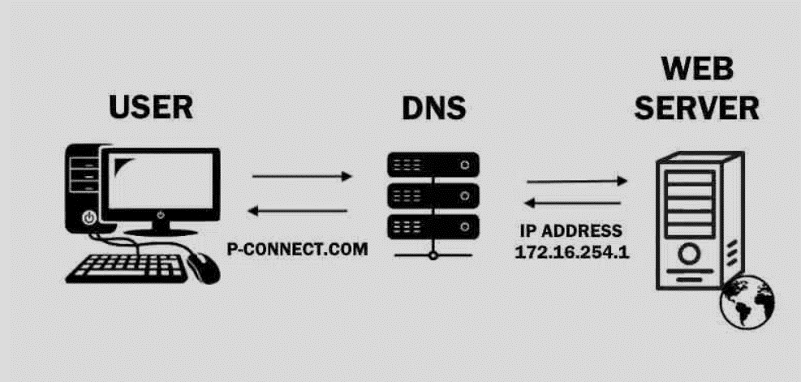

The primary purpose of DNS is to make it easier for people to access websites and other online resources. By providing a human-readable naming system for computers and other devices connected to the internet, DNS enables users to navigate the internet using familiar and intuitive domain names.

**Here’s the behind-the-scenes magic:**

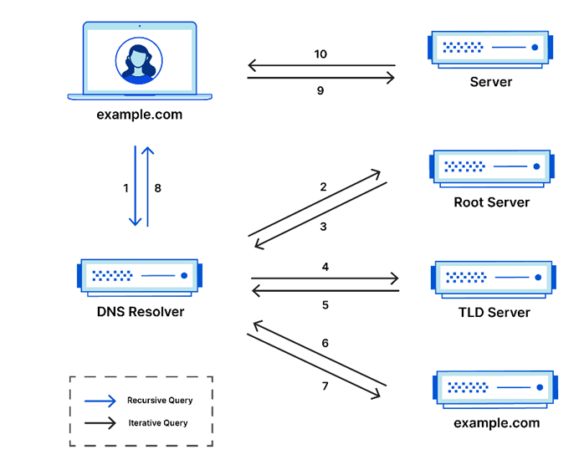

## 8 Steps to Web Magic

1.     You type “nytimes.com”.

2.     Your computer asks a **DNS resolver** (librarian) for the address.

3.     The resolver checks the **root nameserver** (catalog) for the “.com” section.

4.     The root nameserver points to the **TLD server** (.com).

5.     The TLD server points to the **domain nameserver** (shelf) for “nytimes.com”.

6.     The domain nameserver gives the **IP address** (book) to the resolver.

7.     The resolver sends the IP address to your computer.

8.     Your computer connects to the IP address and displays the website!

Up to four different types of servers can be involved in a DNS lookup, depending on whether the information is cached or not:

1.     **DNS Resolver:** This is your first point of contact, like a helpful librarian who starts the search for the address.

2.     **Root Nameserver:** A directory for top-level domains (like .com, .org, etc.), guiding the resolver to the right section of the internet library.

3.     **TLD (Top-Level Domain) Server:** A specialist for a specific domain category, narrowing down the search for the exact shelf .

4.     **Authoritative Nameserver:** The guardian of IP addresses for a specific domain, providing the final book (IP address) the resolver needs.

**Not every lookup involves all four types:**

* If the resolver has the IP address cached (stored in its memory), it can skip the search and provide a direct answer, like a librarian who knows where a popular book is.
* If the resolver has information about the authoritative nameserver, it can directly query that server, bypassing the root and TLD servers, like asking a subject expert for a specific book.

**Caching:** This librarian remembers! DNS servers often store recently requested addresses to speed up future searches.

**Types of Queries:**

* **Recursive:** The librarian finds the address for you (like asking for a specific book).
* **Iterative:** The librarian points you to other librarians who might know (like asking for a general genre).
* **Non-recursive:** The librarian already has the address in its memory (like knowing where a popular book is).

**Benefits of a Good DNS:** faster websites, fewer errors, and a more reliable internet experience.

**Remember:** DNS is the invisible force that connects you to the information you crave online. So next time you visit a website, take a moment to appreciate the magic behind the scenes!

Content Delivery Network (CDN)

Tired of slow-loading websites? A CDN’s your answer! It’s a network of geographically distributed group of servers that caches content close to end users. A CDN allows for the quick transfer of assets needed for loading Internet content, including HTML pages, JavaScript files, stylesheets, images, and videos.

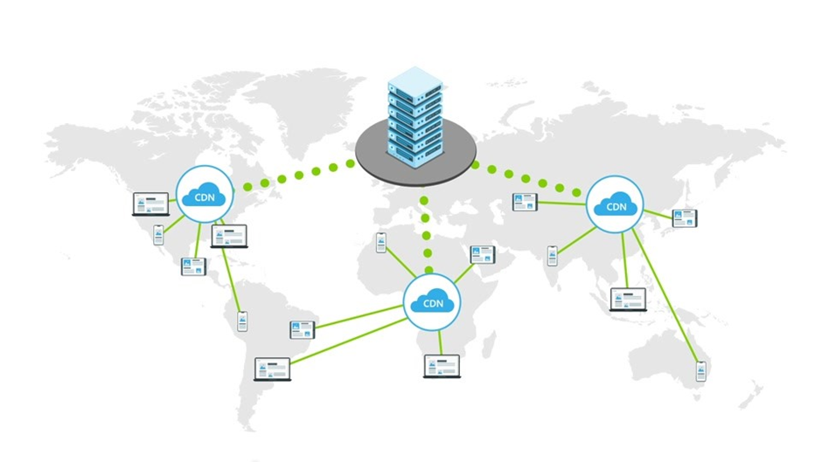

A Content Delivery Network (CDN) is a distributed network of servers strategically located across various geographical locations to deliver web content, such as images, videos, and other static assets, more efficiently to users. The primary purpose of a CDN is to reduce latency and improve the overall performance of web applications by serving content from the server nearest to the user. CDNs can also help improve reliability, availability, and security of web applications.

## How CDNs work?

When a user requests content from a web application, the request is routed to the nearest CDN server (also known as an edge server) based on factors such as network latency and server load. The edge server then checks if the requested content is already cached. If it is, the content is served directly from the cache; otherwise, the edge server fetches the content from the origin server, caches it, and serves it to the user. Subsequent requests for the same content can then be served from the cache, reducing latency and offloading traffic from the origin server.

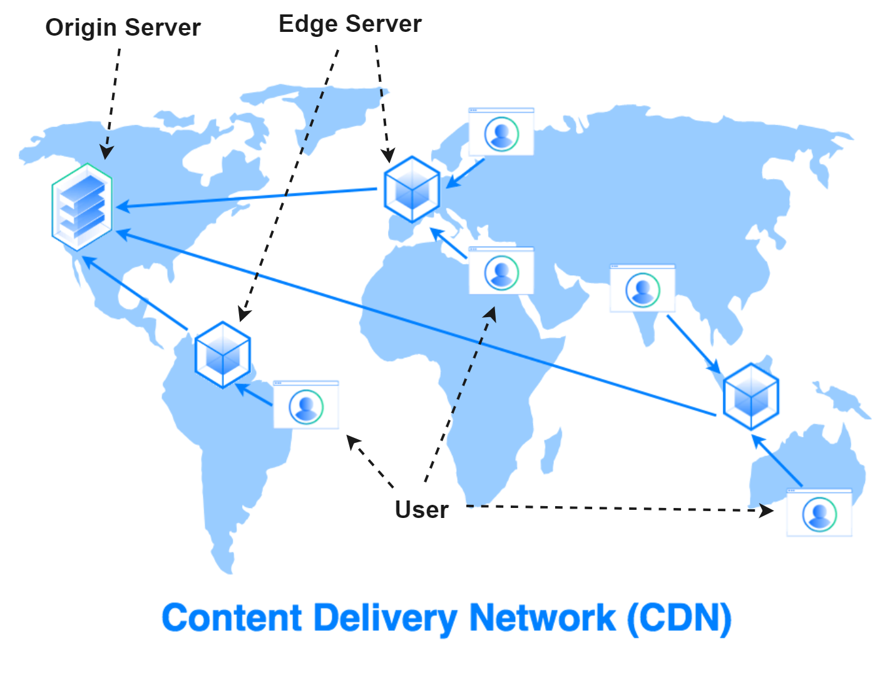

There are two main strategies used by CDNs to deliver content: **Pull** and **Push.**

**Pull CDN**:

* In a Pull CDN, the cache is updated based on request. When the client sends a request that requires static assets to be fetched from the CDN, if the CDN doesn’t have it, then it will fetch the newly updated assets from the origin server and populate its cache with this new asset, and then send this new cached asset to the user.
* This requires less maintenance because cache updates on CDN nodes are performed based on requests from the client to the origin server.
* The main advantage of Pull CDN is that unlike the Push CDN the PoP servers here in this case do all the heavy lifting, while our engineers can just relax and not be too exhausted from maintaining all the push operations.
* However, this also comes with some disadvantages, if a request to a particular CDN is updating the cache from the origin server to respond to a client, and the same query is re-queried to the same CDN node, this could cause redundant traffic.

**Push CDN**:

* In a Push CDN, the assets have to be pushed to the servers. It is the responsibility of the engineers to push the assets to the origin server which will then propagate to other CDN nodes across the network.
* The assets that are received through propagation are then cached onto these CDN servers such that when a client sends a request the CDN provides this cached asset.
* While configuring and setting up a Push CDN takes longer, it is far more flexible and precise when it comes to providing the appropriate material at the right moment.
* If by any chance the engineers don’t update the assets to the origin servers consistently without fail, then the user may receive stale data.

In general, Pull CDN is the preferred method for websites that get a lot of traffic because content remains relatively stable, and the traffic is pretty spread out. If you have a minimal amount of traffic, you might prefer Push CDN because content is pushed to the server once, then left there until changes are needed.

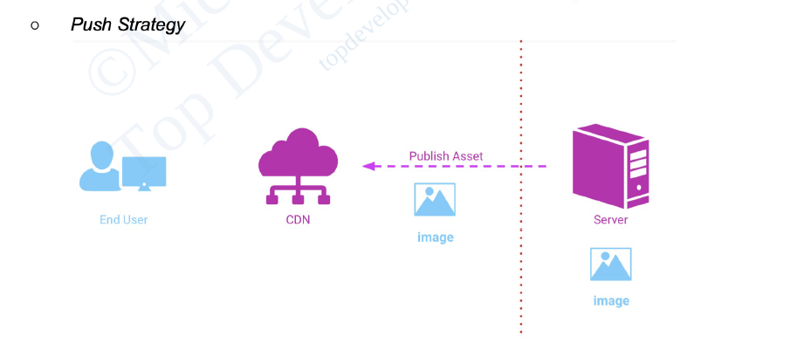

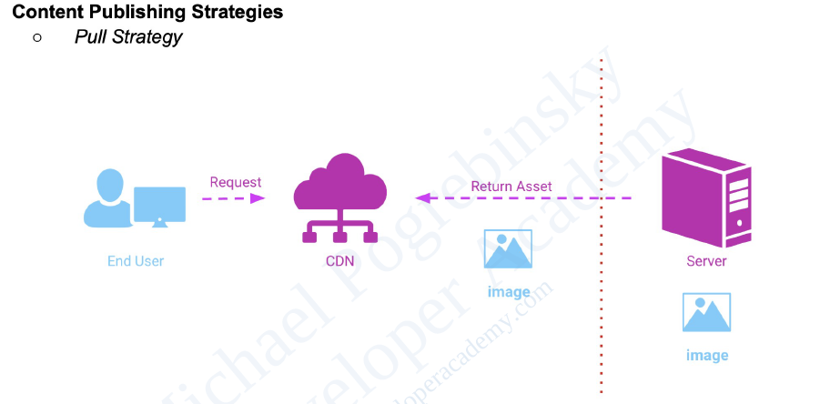

**Benefits:**

* **Faster websites:** Keep visitors happy with speedy loading times.
* **Lower costs:** Reduce bandwidth expenses with efficient data caching.
* **High availability:** Never worry about downtime thanks to redundancy and failover.
* **Enhanced security:** Protect your site from attacks with advanced security features.

**How it works:**

* Servers placed near users, reducing travel time for content.
* Optimizations like compression and smart routing speed things up.
* Redundancy ensures your site stays online, even if some servers go down.

Caching

The cache is a high-speed storage layer that sits between the application and the original source of the data, such as a database, a file system, or a remote web service. When data is requested by the application, it is first checked in the cache. If the data is found in the cache, it is returned to the application. If the data is not found in the cache, it is retrieved from its original source, stored in the cache for future use, and returned to the application.

Caching can be used for various types of data, such as web pages, database queries, API responses, images, and videos. The goal of caching is to reduce the number of times data needs to be fetched from its original source, which can result in faster processing and reduced latency.

The purpose of caching is to improve the performance and efficiency of a system by reducing the amount of time it takes to access frequently accessed data.

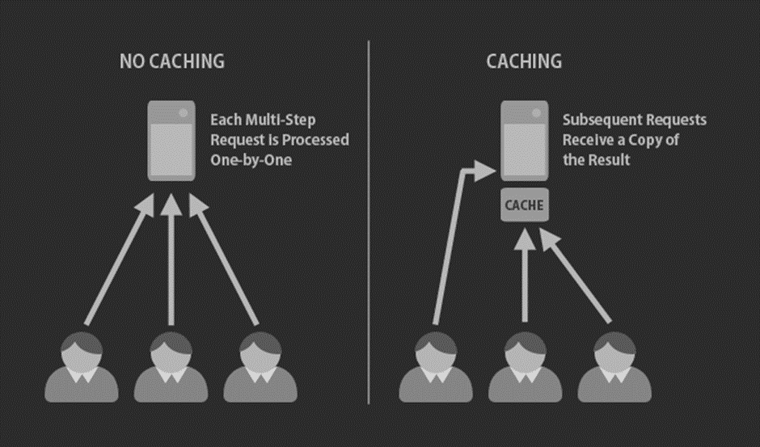

**Benefits:**

* **Blazing-fast websites:** Users worldwide get content from nearby servers, not some faraway library, slashing loading times.
* **Scalability galore:** Add more servers as your users and data grow, keeping everyone happily served.
* **Always online:** Even if one server stumbles, others pick up the slack, ensuring continuous service.
* **Cost-effective champion:** Reduce database load and bandwidth usage, saving you precious resources.

**How it works:**

* **Data spread across servers:** Your book copies (data) are placed on servers closer to users in different regions.
* **Requests fly to the nearest:** Users ask for data, and it zooms from the closest server, like grabbing your book from the nearby library.
* **Smart data distribution:** Special algorithms ensure data is evenly spread and efficiently retrieved.
* **Always fresh and reliable:** Copies are kept up-to-date so you always get the latest edition (data).

**Remember:**

* **Choose the right solution:** Redis, Memcached, Hazelcast, and more, each caters to different needs.
* **Keep data consistent:** Make sure all copies match the original source.
* **Monitor and fine-tune:** Optimize your distributed cache for maximum performance and efficiency.

## Cache Invalidation

If the data is modified in the database, it should be invalidated in the cache, if not, this can cause inconsistent application behaviour.

## Cache Eviction Policies

Following are some of the most common cache eviction policies:

* **First In First Out (FIFO):** The cache evicts the first block accessed first without any regard to how often or how many times it was accessed before.
* **Last In First Out (LIFO):** The cache evicts the block accessed most recently first without any regard to how often or how many times it was accessed before.
* **Least Recently Used (LRU):** Discards the least recently used items first.
* **Most Recently Used (MRU):** Discards, in contrast to LRU, the most recently used items first.
* **Least Frequently Used (LFU):** Counts how often an item is needed. Those that are used least often are discarded first.
* **Random Replacement (RR):** Randomly selects a candidate item and discards it to make space when necessary.

# Caching Patterns

If the data is modified in the database, it should be invalidated in the cache, if not, this can cause inconsistent application behavior. There are majorly five patterns to turbocharge your application’s data access:

## Cache Aside (Lazy Loading)

Cache Aside, also known as Lazy Loading, is a simple yet powerful caching pattern for storing frequently accessed data.

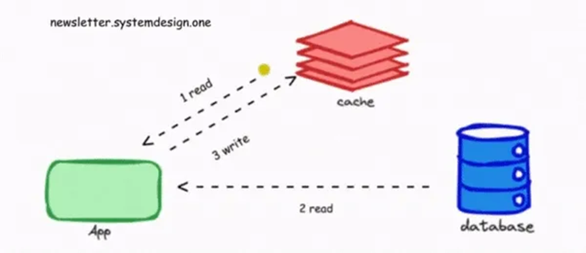

Here’s how it works:

1.     **Application checks the cache:** Your application first tries to find the data you need in the cache. Think of it as peeking on your bookshelf for your favourite book.

2.     **Cache hit? You’re golden!** If the data is there (a “cache hit”), you’re all set! The application grabs it from the cache and sends it right back to you, offering super-fast access.

3.     **Cache miss, no worries:** If the data isn’t in the cache (a “cache miss”), no big deal! The application simply retrieves it from the original data source, like fetching your book from the library.

4.     **Cache it for later:** Once the data is retrieved, the application stores a copy in the cache for future requests. That’s like adding your borrowed book to your own shelf for quick future reads.

5.     **Next time, straight from the shelf:** For subsequent requests for the same data, the application can skip the library trip and grab it directly from the cache, making your future access lightning-fast!

**Benefits:**

* **Simple to implement:** Easy to understand and integrate into your application.
* **Efficiently caches data:** Only stores what’s actually used, avoiding cluttering the cache.
* **Offers good performance:** Delivers fast access for frequently requested data.

**Drawbacks:**

* **Potential for stale data:** The cached data might become outdated if the source gets updated later.
* **Degraded latency on first request:** The initial data retrieval can be slower than subsequent cached reads.

**Overall, Cache Aside is a versatile and popular pattern for general-purpose caching, especially in read-heavy scenarios. It’s like having a well-stocked personal library for your most-needed books, offering quick access and convenience!**

## Write Through

In Write Through caching, imagine your favourite book is so precious that you update both your personal copy and the library version simultaneously! That’s the essence of this pattern:

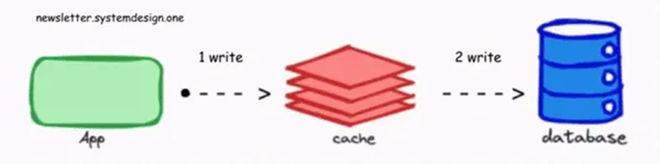

1.     **Application writes to the cache:** Whenever your application writes new data, it first updates the cached copy, just like putting the new edition on your bookshelf.

2.     **Cache talks to the database:** But unlike you, the cache doesn’t keep secrets! It immediately sends the updated data to the original data source, like handing the new book to the librarian.

3.     **Database updated, all in sync:** Once the database receives the data, it gets written there too, ensuring both the cache and the source have the latest version.

4.     **Application gets confirmation:** After successfully updating both sides, the cache sends a confirmation back to the application, like a satisfied nod from the librarian.

**Benefits:**

* **Data consistency guaranteed:** No stale data worries, because both cache and database always have the same information.
* **Fast read access:** Cached data stays fresh, resulting in quick retrieval for subsequent reads.

**Drawbacks:**

* **Slower writes:** Updating both cache and database adds an extra step, meaning writes take longer compared to other patterns.
* **Potentially unnecessary cache updates:** If most cached data isn’t frequently read, writing it to the database might be an unnecessary performance overhead.

**Overall, Write Through is ideal for situations where data consistency is crucial and you expect relatively few writes compared to reads. It ensures your personal book and the library copy always match, keeping everyone in the loop!**

## Read Through

Imagine you’re at your friend’s library, looking for a book you haven’t borrowed before. Read Through caching works like this:

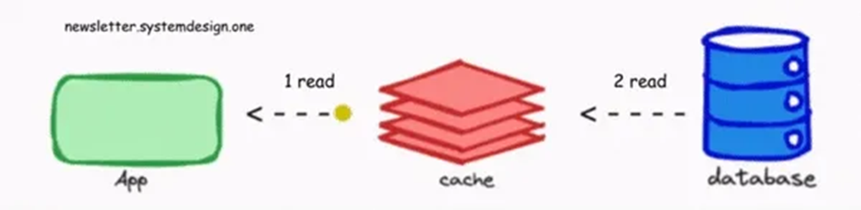

1.     **Application checks the cache:** You first peek at your friend’s bookshelf (the cache) for the book (data).

2.     **Cache miss? Ask the librarian (database):** If the book isn’t there, you politely ask the librarian (the database) to find it.

3.     **Librarian hands you the book:** The librarian retrieves the book (data) from their collection and gives it to you.

4.     **Your friend adds a copy to their shelf:** Your friend, seeing you enjoy the book, makes a copy and adds it to their bookshelf (the cache) for future guests.

5.     **Next time, straight from the shelf:** If you return for another read, the book is now conveniently on your friend’s shelf (the cache), offering quicker access.

**Benefits:**

* **Low read latency for frequently accessed data:** Cached data speeds up subsequent requests.
* **Improved read scalability:** Handles high read loads efficiently by reducing database trips.

**Drawbacks:**

* **Potential data inconsistency:** The cached copy might become outdated if the data source is updated later.
* **High latency on a cache miss:** The initial data retrieval can be slower than subsequent cached reads.

**Overall, Read Through is great for read-heavy workloads where data freshness isn’t critical and a high cache miss rate is acceptable. It’s like borrowing a book from a friend who updates their library regularly, offering convenience for most reads.**

## Write Back

**Imagine you have a super-fast personal library with a lazy librarian. That’s the essence of Write Back caching:**

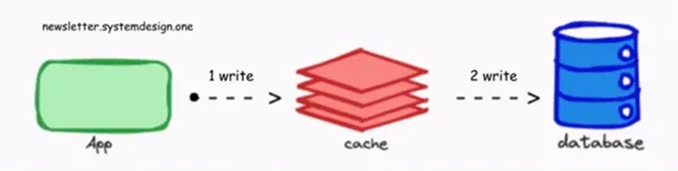

1.     **Application writes to the cache:** When you add a new book, you place it on your bookshelf (the cache) first.

2.     **Cache takes a nap:** The librarian (cache) decides to relax for a bit and doesn’t immediately update the library’s collection (the database).

3.     **Application gets a quick confirmation:** You get a swift nod saying the book is “added,” even though it’s only in your personal library for now.

4.     **Cache catches up later (asynchronously):** Eventually, the librarian wakes up, grabs the new books from your shelf, and updates the library’s records, ensuring everyone else can find them too.

**Benefits:**

* **Fast writes:** Updates are nearly instant, as you only need to update the cache.
* **Improved performance:** Batching writes to the database can reduce overall load and optimize performance.

**Drawbacks:**

* **Risk of data loss:** If the cache fails before updating the database, those precious new books might disappear!
* **Complex implementation:** Managing asynchronous updates and potential inconsistencies requires careful design.

**Overall, Write Back is ideal for write-heavy workloads where speed is crucial, and data durability isn’t the top priority. It’s like having a speedy personal library with an occasional nap-loving librarian—great for fast additions, but make sure to back up your cache!**

## Write Around

Write Around caching, like a secret library hidden deep within an ancient castle, prioritizes data security and minimizes unnecessary traffic.

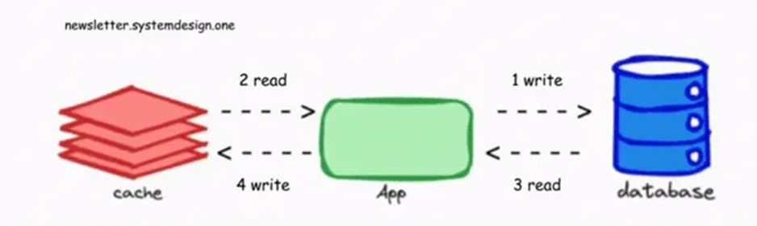

Here’s how it works:

1.     **Application writes directly to the source:** Imagine you sneak past the guards and scribble on your hidden parchment within the castle vaults (the database). You bypass the public library (the cache) entirely.

2.     **Only access the cache for reads:** When you need to reference the information, you venture back to the vaults (the database) again, ignoring the library altogether.

3.     **Cache stays untouched, unless…:** Only if you find yourself repeatedly visiting the same vault location (frequently accessing the same data), do you consider copying that parchment onto a readily accessible shelf in the library (caching the data).

**Benefits:**

* **Reduced risk of data loss:** Updates happen directly in the source, eliminating the chance of cache failures compromising data.
* **Reduced cache pollution:** No unnecessary data fills the cache, keeping it lean and efficient for frequently accessed items.

**Drawbacks:**

* **High read latency:** Initial data access requires trips to the source, making initial reads slower than cached scenarios.
* **High cache miss rate:** The cache is less utilized, leading to more database hits.

**Overall, Write Around excels in situations where data security and minimizing unnecessary updates are critical, even if it means sacrificing initial read speed. Think of it as a secure, hidden library for your most valuable information, accessed only when absolutely necessary.**

Remember, Write Around isn’t the fastest pattern, but it prioritizes data integrity and efficiency for specific scenarios.

## Summary

·        **Cache Aside (Lazy Loading):** Easiest to implement, caches accessed data only, ideal for general needs and read-heavy workloads.

·        **Write Through:** Ensures data consistency but slows down writes; good for few writes where fresh data matters.

·        **Read Through:** Low read latency for frequent reads, but potential inconsistency; okay for high cache miss rate scenarios.

·        **Write Back:** Fast writes, batch updates, but risky if cache fails; perfect for write-heavy workloads where durability isn’t crucial.

·        **Write Around:** Minimizes data loss and pollution, but suffers high read latency; ideal for rare updates and reads.

**Remember:** Combine patterns, choose wisely based on needs, and watch your data fly!

Distributed Caching

Distributed caching stores frequently used data across multiple servers, like having copies of your favourite book in libraries worldwide. This makes data access **faster** and **more reliable**, especially for geographically distributed applications.

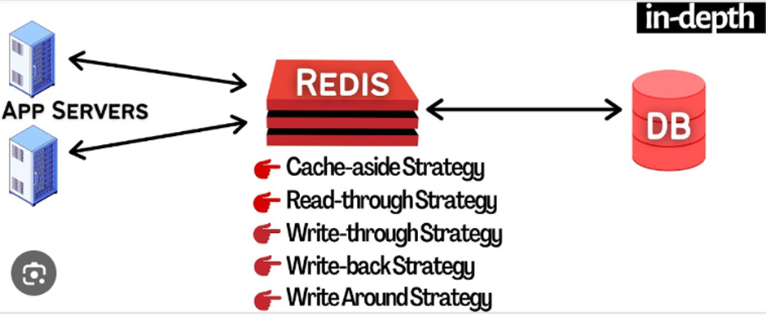

**Benefits:**

* **Scalability:** Add more servers as your data grows, keeping everyone served seamlessly.
* **Fault tolerance:** Server failures won’t disrupt service; data is available elsewhere.
* **Performance:** Data is closer to users, leading to faster response times.
* **Cost-effectiveness:** Reduces database load and bandwidth usage.

**Key components:**

* **Cache servers:** Store data across multiple nodes for efficient access.
* **Partitioning:** Divides data across servers for balanced distribution and retrieval.
* **Replication:** Backs up data on multiple servers for high availability.

**Popular solutions:**

* **Redis:** Versatile, high-performance cache, database, and message broker.
* **Memcached:** Simple, powerful cache for dynamic web applications.
* **Hazelcast:** Offers caching, messaging, and computing for cloud-native apps.
* **Apache Ignite:** In-memory computing platform with distributed caching, data processing, and transactions.

**Implementation and best practices:**

* **Choose the right solution:** Consider your application needs and infrastructure.
* **Configure and deploy:** Install software on servers and define data strategies.
* **Integrate with application:** Direct data reads and writes to the cache.
* **Monitor and fine-tune:** Adjust configurations for optimal performance.
* **Manage cache effectively:** Use eviction policies and monitor hit/miss rates.

**Remember:** Distributed caching is a powerful tool to boost your application’s performance, scalability, and user experience. Choose the right solution, manage it effectively, and watch your data access fly!

ACID Transactions

ACID stands for Atomicity, Consistency, Isolation, and Durability. These are four key properties that ensure reliable and consistent data handling in databases. Imagine them as safety nets for your data:

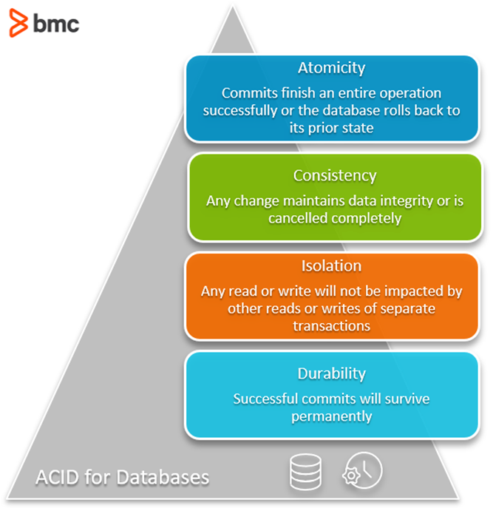

* **Atomicity:** Either all parts of a transaction succeed, or none do. No half-finished updates!
* **Consistency:** Data remains valid before and after each transaction. Think of it as keeping the books balanced.
* **Isolation:** Transactions don’t interfere with each other. One transaction’s update won’t affect another until it’s complete.
* **Durability:** Once committed, changes persist even if the system crashes. Consider it as writing in ink, not pencil.

## Benefits

* **Data integrity:** ACID protects your data from inconsistencies and corruption.
* **Reliability:** Even with failures, transactions ensure updates are correct and completed.
* **Consistency:** Data always maintains its logical rules and constraints.

## Trade-offs

* **Overhead:** ACID features add processing steps, potentially impacting performance.
* **Deadlocks:** Concurrent transactions waiting for each other can freeze up the system.
* **Scalability:** ACID can be challenging to implement in large, distributed systems.

## Alternatives

* **BASE:** Emphasizes availability over immediate consistency, suitable for high-volume systems.
* **CAP theorem:** Explains trade-offs between consistency, availability, and partition tolerance.
* **NoSQL databases:** Prioritize scalability and performance over strict ACID guarantees.

## When to use ACID

* Banking, healthcare, e-commerce: Crucial for accurate and secure financial transactions, patient records, and order processing.
* Mission-critical applications: Where data integrity and reliability are paramount.

**Remember:** ACID isn’t always the best fit. Evaluate your needs and consider alternatives like BASE for more flexible approaches in specific scenarios.

CAP Theorem

Imagine a distributed database: data scattered across different servers. Network failure strikes! Can you access all your data (availability) or ensure it’s always up-to-date (consistency)? The distributed system with replicated data can only offer two out of three: Consistency, Availability, and Partition Tolerance (dealing with network hiccups). So, you gotta choose!

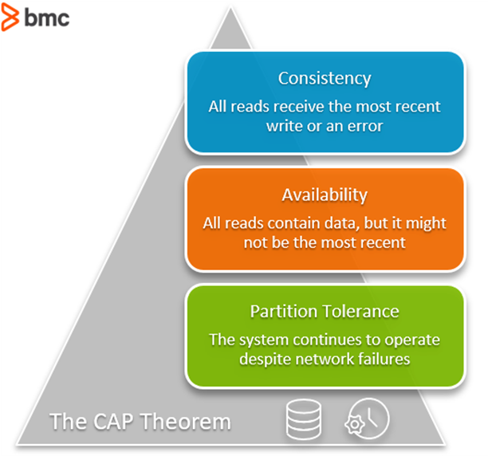

**CAP Theorem says: pick two!**

* **Consistency:** Latest data guaranteed, but might be unavailable during errors. (Think accurate bank balance.)

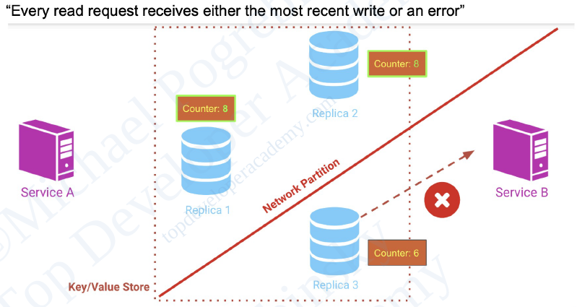

* **Availability:** Always accessible, but data might be outdated. (Think online shopping during peak hours.)

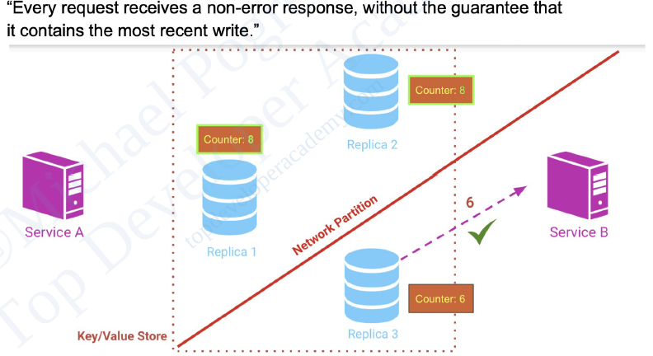

* **Partition Tolerance:** A system is considered partition-tolerant if it can continue to operate and maintain its guarantees despite network partitions, which are situations where communication between nodes in the system is interrupted or lost.

**Choosing your flavors:**

* **SQL databases:** Prioritize consistency for accurate data (think finances).
* **NoSQL databases:** Offer high availability for always-on services (think online shopping).

So, next time you design a system, remember the CAP Theorem – it’s the secret ingredient that keeps your data dancing between consistency and availability.

Data Replication

Data replication also known as database replication, is a method of copying data to ensure that all information stays identical in real-time between all data resources.

Data replication is like a safety net for your information, ensuring identical copies across multiple locations. Think of it as a real-time mirror for your data, constantly reflecting updates, whether across on-prem servers or to the cloud.

## Why is it important?

* **Instantaneous updates:** Say goodbye to refresh buttons and lag. Data replication keeps everyone in sync, boosting user experience and productivity.
* **Disaster recovery:** If your primary server fails, a replica seamlessly takes over, minimizing downtime and protecting critical data.
* **Performance boost:** Spread the workload across multiple instances for faster reads and writes, especially with data geographically distributed.
* **Reduced IT effort:** Automate data replication and focus on more strategic tasks.

## Types of Replication

* **Full vs. Partial:** Full replicates everything, while partial focuses on specific data, like financial data in a specific office.
* **Transactional:** Real-time mirroring of changes, ideal for consistency but demanding on resources.
* **Snapshot:** Captures data at a specific point, useful for backups and recoveries.
* **Merge:** Allows independent edits on each node, then merges them all.
* **Key-Based:** Efficiently updates only changed data but doesn’t replicate deletions.
* **Active-Active Geo-Distribution:** Real-time, global data syncing for geographically dispersed centers.

## Synchronous vs. Asynchronous Replication

* **Synchronous:** Writes happen on both primary and replica simultaneously, maximizing consistency but impacting performance.
* **Asynchronous:** Writes on primary first, copied to replica later, faster but prone to data loss in case of failure.

## Challenges to Consider

* **Cost:** Maintaining multiple instances requires significant resources.
* **Expertise:** Skilled professionals are needed to manage and troubleshoot.
* **Network bandwidth:** Heavy replication traffic can overload networks.

Data Redundancy

Data redundancy is when multiple copies of the same information are stored in more than one place at a time on same system. This can be helpful for backups and security, but it can also cause problems like increased storage costs, errors, and inaccurate data.

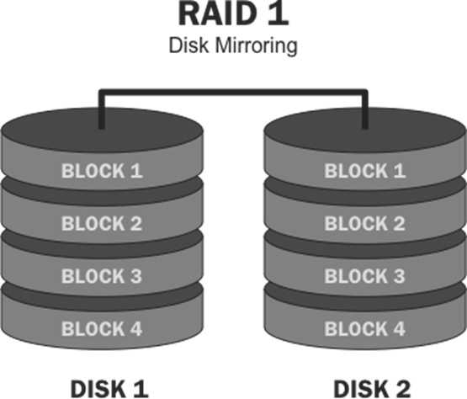

Redundancy refers to the duplication of critical components or functions to increase the reliability, availability, and fault tolerance of a system. The primary purpose of redundancy is to prevent system failures and ensure continuous operation, even in the event of hardware, software, or network issues. Redundant systems are designed to maintain functionality and performance despite component failures, providing increased resilience against downtime and data loss.

## How it happens

Unintentional redundancy can occur through various ways, like duplicate forms, multiple backups, or outdated versions.

## Types

* **Database vs. File-based:** Redundancy can happen in both, but structured databases typically offer better control.
* **Data replication vs. redundancy:** Replication is intentional (for accessibility), while redundancy can be intentional or unintentional.

## Benefits

* **Backups:** Provides extra copies in case of data loss.
* **Disaster recovery:** Ensures quick restoration after system failures.
* **Data accuracy:** Enables cross-checking for discrepancies.
* **Improved data protection:** Minimizes attack surface and data access points.
* **Increased availability:** Makes data accessible from multiple locations.
* **Business continuity:** Protects against data loss from internal issues or malware.

## Disadvantages

* **Data corruption:** Errors during storage or transfer can corrupt copies.
* **Increased maintenance costs:** Requires managing multiple copies.
* **Data discrepancies:** Updates may not be applied to all copies.
* **Slow performance:** Database functions can be hindered.
* **Storage waste:** Duplicate data takes up unnecessary space.

## Reducing redundancy

* **Delete unused data:** Implement data lifecycle rules and monitoring.
* **Design efficient databases:** Use common fields and architectures.
* **Set goals and plans:** Aim for reduction, not complete elimination.
* **Use data management systems:** Identify and address redundancy issues.
* **Implement master data strategy:** Integrate data from various sources for better management and quality.
* **Standardize data:** Makes redundancy and errors easier to detect.

**Remember:** Data redundancy can be both friend and foe. Use it strategically for backups and security, but actively manage it to avoid the pitfalls.

Database Scaling

When your application becomes popular, it needs to scale to meet the demand. Nobody sticks around if an application is slow — not willingly, anyway.

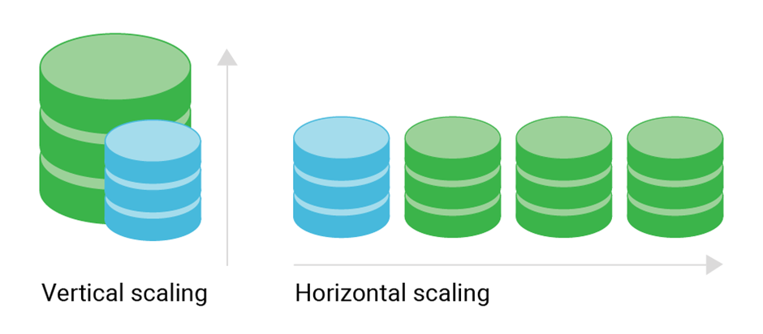

## Scaling Approaches

* **Vertical Scaling:** Increase resources on one node (like upgrading your computer). Simple, but limited growth.
* **Horizontal Scaling:** Add more nodes to share the workload (like adding more computers). More complex, but scales further.

## Horizontal Scaling Techniques

* **Sharding:** Split data across multiple nodes. Easy to implement, but requires managing the shard selector and can have imbalance issues.
* **Read Replicas:** Dedicated nodes for read requests, improving read performance without affecting writes. Simple and improves availability, but doesn’t improve write performance.
* **Active-Active:** All nodes handle both reads and writes, maximizing performance. Most complex, requires conflict resolution logic in your application.
* **Active-Active Geo-Distribution:** Active-Active across geographically distributed clusters, for global reach and improved latency. Advanced solution, managed by Redis Enterprise.

## Choosing the Right Option

* Consider your **performance needs, data size, budget, and technical expertise**.
* Start with **simple options like vertical scaling or read replicas** if complexity is a concern.
* **Sharding and Active-Active** offer more scalability, but require careful planning and implementation.
* **Active-Active Geo-Distribution** is for global deployments with high demands.

**Remember:** Scaling is a powerful tool, but choose wisely based on your specific needs and capabilities.

# Database Sharding

**Your database is struggling under the weight of your application’s rapid growth.** More users, features, and data mean bottlenecks and slow performance. Sharding might be the answer, but **understanding its pros, cons, and use cases is crucial before diving in.**

## What is Database Sharding?

Sharding splits your database across multiple servers, distributing the data load and increasing capacity. Imagine slicing a pizza: each shard (slice) holds a portion of the data, spread across different servers.

|  |
| --- |
|  |

## Do You Need Sharding?

Consider alternatives before sharding:

* **Vertical scaling:** Upgrade your existing server’s hardware like RAM or CPU.
* **Specialized services:** Offload specific tasks like file storage or analytics to dedicated services.
* **Replication:** Make read-heavy data available on multiple servers for faster access.

## When Sharding Shines

* **High read/write volume:** Sharding handles both reads and writes effectively, especially when confined to specific shards.
* **Large storage needs:** Increase total storage capacity by adding more shards as needed.
* **High availability:** Replica sets within each shard ensure data remains accessible even if a shard fails.

## The Downsides of Sharding

* **Query overhead:** Routing queries across shards adds latency, especially for queries spanning multiple shards.
* **Administrative complexity:** Managing multiple servers and shard distribution increases upkeep requirements.
* **Infrastructure costs:** Sharding requires more computing power, pushing up expenses.

## How Does Sharding Work?

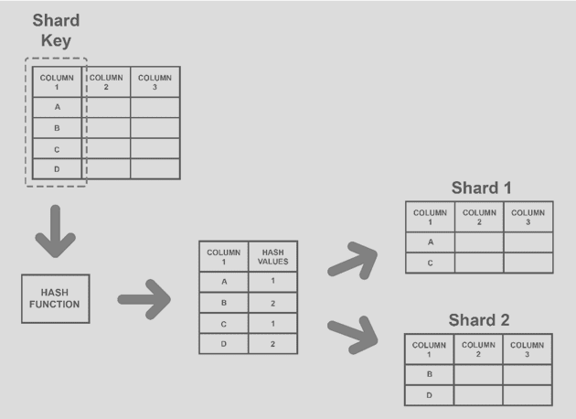

* **Data distribution:** Define how data is spread across shards. Popular methods include range-based (data ranges assigned to shards), hashed (hash function determines shard), and entity/relationship-based (keeps related data together).
* **Query routing:** Determine how queries are routed to the appropriate shards.
* **Shard maintenance:** Plan for redistributing data and adding new shards over time.

## Sharding Architectures

* **Ranged/dynamic sharding:** Easy to understand, relies on a suitable shard key and well-defined ranges.
* **Algorithmic/hashed sharding:** Evenly distributes data but may require rebalancing and hinder multi-record queries.
* **Entity-/relationship-based sharding:** Improves performance for related data access but can limit flexibility.
* **Geography-based sharding:** Ideal for geographically distributed data, improves performance and reduces latency.

**Remember:** Sharding is a powerful tool for large applications with demanding data needs. But weigh the complexity and costs against alternative solutions before making the leap. Choose the right sharding architecture based on your specific data distribution and query patterns.

Replication Strategy

Database replication is a crucial technique for ensuring data availability, fault tolerance, and scalability in distributed systems. It involves creating and maintaining copies of your database across multiple servers or locations. Here's a breakdown of key strategies to consider:

# Master-Slave Replication

Master-slave replication is a fundamental database replication strategy that prioritizes simplicity and efficiency. It's widely used for various purposes, including:

* **Scalability:** Distributing read traffic across multiple servers (slaves) can significantly improve performance for applications with high read loads.
* **Availability:** In case of a primary server (master) failure, a slave can be quickly promoted to become the new master, minimizing downtime.
* **Data Backup and Offloading:** Slaves can serve as read-only replicas for backup and disaster recovery purposes, while the master handles write operations.

**Master-Slave Architecture:**

The core structure involves two distinct server roles:

* **Master Server:**
  + Holds the primary copy of the database.
  + Responsible for processing all write operations (inserts, updates, deletes).
  + Replicates these changes to the slave servers.
* **Slave Server(s):**
  + Maintain read-only copies of the database, synchronized with the master.
  + Handle read requests from applications, offloading the master and improving performance.

**Replication Process:**

There are two main approaches to data synchronization between master and slave in master-slave replication:

1. **Statement-Based Replication:**
   * The master server logs the exact SQL statements used for write operations.
   * These statements are replicated to the slave servers and executed to update their databases.
   * Straightforward to implement but can be less efficient for complex queries.
2. **Row-Level Replication:**
   * Captures only the specific data changes made by write operations on the master (updated/inserted/deleted rows).
   * Replicates these changes to the slave servers, applying them to the corresponding rows in their databases.
   * More efficient for large datasets as only changed data is replicated, but requires additional processing for applying changes.

**Benefits of Master-Slave Replication:**

* **Simple to Implement:** Master-slave architecture offers a relatively easy setup and management compared to more complex replication methods.
* **Improved Read Performance:** By distributing read traffic across slave servers, master-slave replication can significantly improve read scalability for applications with high read workloads.
* **Enhanced Availability:** In case of a master server failure, a slave can be promoted to become the new master, minimizing downtime and ensuring data accessibility.
* **Data Backup and Offloading:** Slave servers function as read-only replicas, providing a readily available backup for disaster recovery. They can also offload read operations from the master, freeing up resources for write processing.

**Limitations of Master-Slave Replication:**

* **Limited Write Scalability:** Master-slave architecture doesn't directly address write scalability as writes are still processed by the single master server.
* **Single Point of Failure:** While a slave can be promoted to become a new master, the overall system remains dependent on the initial master server.
* **Read Consistency Issues:** Depending on the replication method used and network latency, there might be a slight delay (replication lag) before changes on the master are reflected on the slaves, potentially causing temporary inconsistencies.
* **Not Ideal for All Use Cases:** Master-slave replication is less suitable for scenarios requiring frequent writes across multiple servers or demanding high data consistency across all replicas.

# Multi-Leader Replication

Multi-leader replication, sometimes called leader-leader replication, involves the use of multiple primary nodes, also known as leaders, each capable of receiving and processing write requests. These leaders replicate data between each other to stay up to date. Each leader may also have follower replicas for read scaling.

[[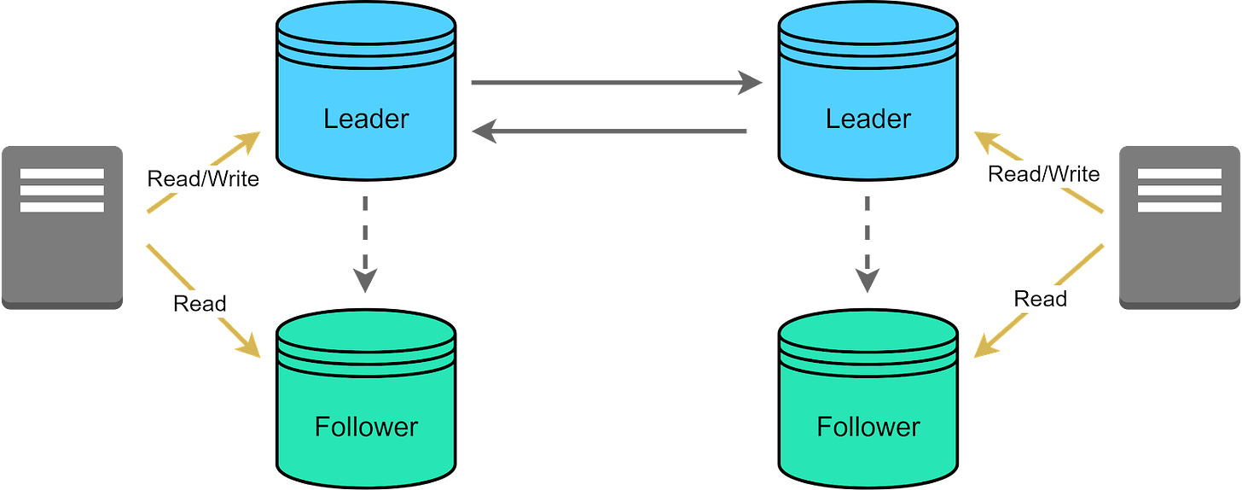](https://substackcdn.com/image/fetch/f_auto,q_auto:good,fl_progressive:steep/https%3A%2F%2Fsubstack-post-media.s3.amazonaws.com%2Fpublic%2Fimages%2F0444993c-e172-4252-9f50-6682d24f3178_1600x631.png)](https://substackcdn.com/image/fetch/f_auto,q_auto:good,fl_progressive:steep/https%3A%2F%2Fsubstack-post-media.s3.amazonaws.com%2Fpublic%2Fimages%2F0444993c-e172-4252-9f50-6682d24f3178_1600x631.png" \t "_blank)

The primary advantage of this model is increased write availability. With multiple active leaders, failure of one node doesn't disrupt writes - other leaders continue handling write requests. This improves upon leader-follower designs where a failed leader halts writes until a new leader is available.

[[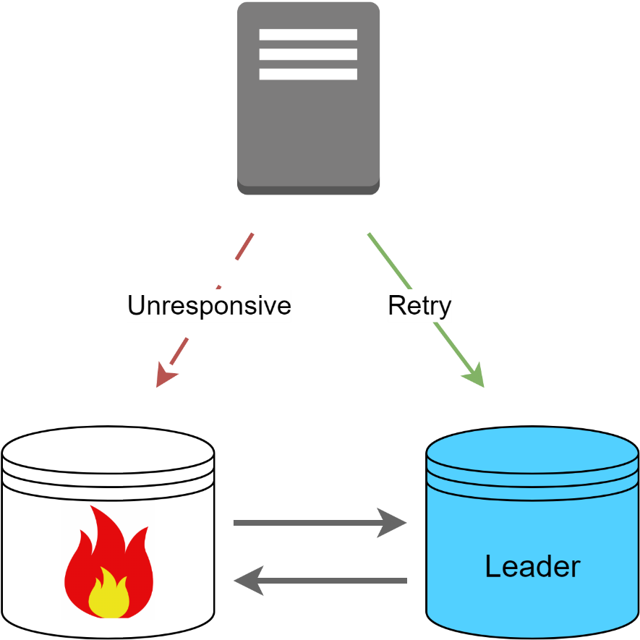](https://substackcdn.com/image/fetch/f_auto,q_auto:good,fl_progressive:steep/https%3A%2F%2Fsubstack-post-media.s3.amazonaws.com%2Fpublic%2Fimages%2F191d48d5-d9cd-41a3-b530-cc26422e99b1_1327x1327.png)](https://substackcdn.com/image/fetch/f_auto,q_auto:good,fl_progressive:steep/https%3A%2F%2Fsubstack-post-media.s3.amazonaws.com%2Fpublic%2Fimages%2F191d48d5-d9cd-41a3-b530-cc26422e99b1_1327x1327.png" \t "_blank)

However, multi-leader replication comes with its own set of challenges. For instance, with multiple leaders handling write requests, conflicting changes may occur when leaders modify the same data concurrently.

### Managing Conflict

Conflicts are a natural outcome in multi-leader replication models given that multiple leaders can perform write operations simultaneously. Effective conflict management is a complex task, but it is crucial for ensuring data consistency and integrity.

[[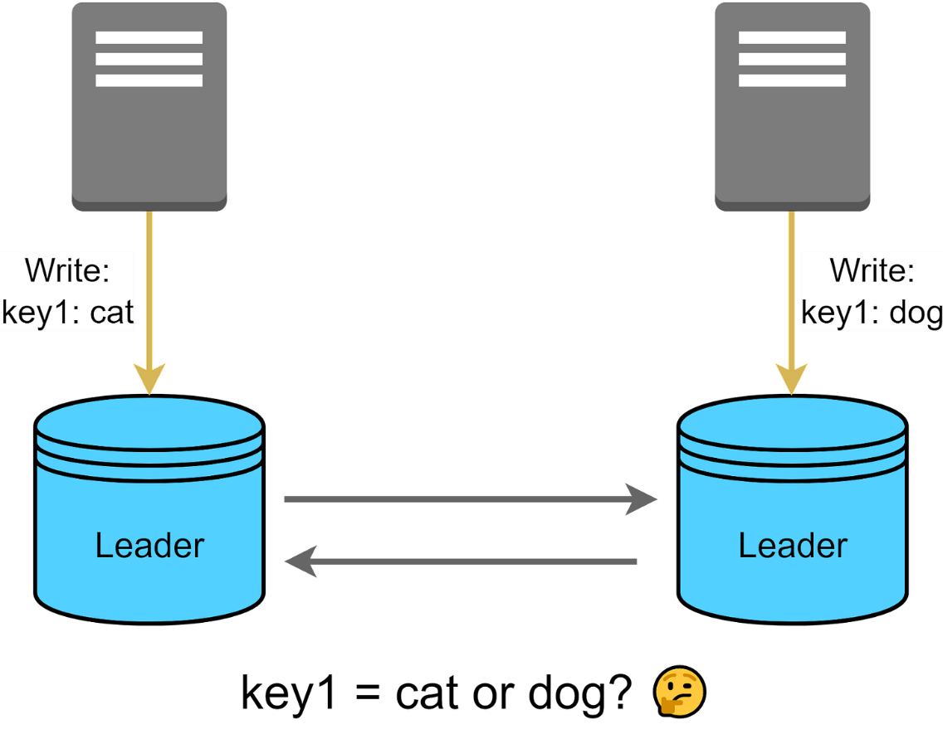](https://substackcdn.com/image/fetch/f_auto,q_auto:good,fl_progressive:steep/https%3A%2F%2Fsubstack-post-media.s3.amazonaws.com%2Fpublic%2Fimages%2F2792b68d-db9d-4e16-9a63-0e7502521280_1600x1247.png)](https://substackcdn.com/image/fetch/f_auto,q_auto:good,fl_progressive:steep/https%3A%2F%2Fsubstack-post-media.s3.amazonaws.com%2Fpublic%2Fimages%2F2792b68d-db9d-4e16-9a63-0e7502521280_1600x1247.png" \t "_blank)

Here are some commonly employed conflict resolution strategies.

[[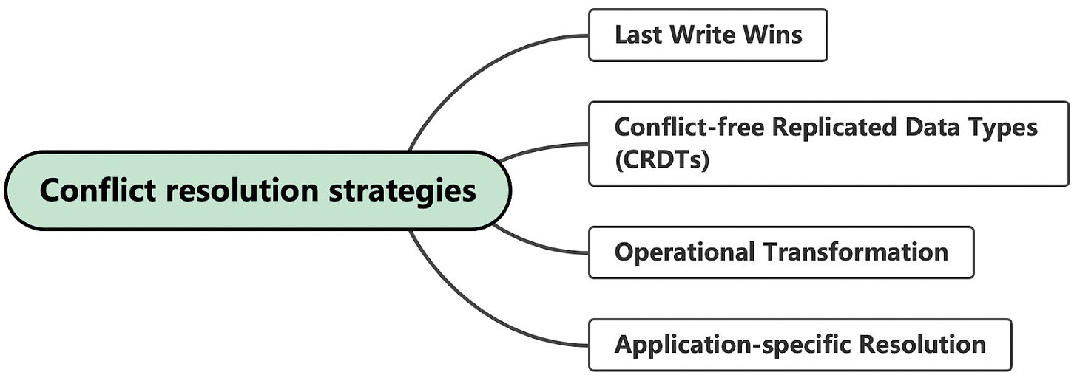](https://substackcdn.com/image/fetch/f_auto,q_auto:good,fl_progressive:steep/https%3A%2F%2Fsubstack-post-media.s3.amazonaws.com%2Fpublic%2Fimages%2F55560fc9-0d32-45c6-b5ea-0a52d44ebfc1_1600x558.png)](https://substackcdn.com/image/fetch/f_auto,q_auto:good,fl_progressive:steep/https%3A%2F%2Fsubstack-post-media.s3.amazonaws.com%2Fpublic%2Fimages%2F55560fc9-0d32-45c6-b5ea-0a52d44ebfc1_1600x558.png" \t "_blank)

#### Last Write Wins

This is a straightforward method where the most recent change takes precedence. While easy to implement, it risks discarding important updates.

#### Conflict-free Replicated Data Types (CRDTs)

CRDTs allow for seamless reconciliation of conflicting changes by merging them. CRDTs come in various types for different kinds of data like counters, sets, and lists, and automatically resolve conflicts without requiring a separate conflict resolution process.

#### Operational Transformation

Operational transformation is often used in real-time collaborative applications. It takes the operation itself into account, not just the state of the data. This method is complex to implement but offers fine-grained control.

#### Application-specific Resolution

In some cases, conflict resolution logic can be pushed to the application level. The application can employ domain-specific rules or even involve human intervention for resolving conflicts.

### Data Partitioning

Another alternative is to partition data across multiple leaders to minimize conflicting changes. However, implementing cross-partition transactions requires careful coordination, and potential hot spots on busy data partitions need to be managed effectively. It’s worth noting that this strategy can reduce the overall write throughput across the cluster.

### Replication Lag and Inconsistent Reads

As with leader-follower replication, multi-leader systems are susceptible to replication lag and inconsistent reads. They cause temporary inconsistencies between leaders until updates fully propagate. Applications must be designed with this in mind.

### Use Cases

What are some use cases for multi-leader replication? For applications that have users globally, multi-leader replication can reduce the latency for end-users by allowing them to interact with a nearby leader node.

Systems that cannot afford downtime, such as financial transaction platforms, can benefit from having multiple leaders. Even if one goes down, operations continue.

For applications with heavy write loads, distributing the write operations across multiple leaders can prevent any single node from becoming a bottleneck.

### Tradeoffs and Challenges

In essence, multi-leader replication is particularly useful for applications that prioritize high write availability, fault tolerance, and globally-distributed data accessibility. Many modern databases can leverage this replication strategy, either natively, or with an extension, with varying degrees of success.

Multi-leader replication provides high availability but requires careful design around consensus, conflict detection, and resolution mechanisms. When implemented well, it can be a powerful approach for maximizing write throughput and availability.

In the next section, we’ll explore the leaderless replication model which takes a different approach.

# Leaderless Replication

Leaderless replication takes a quorum-based approach. This concept may sound a bit strange, especially when we've just spent some time discussing models that operate under a clear hierarchy. In a leaderless system, any node in the network has the authority to accept write operations. The absence of a single leader fundamentally changes the dynamics of our system.

[[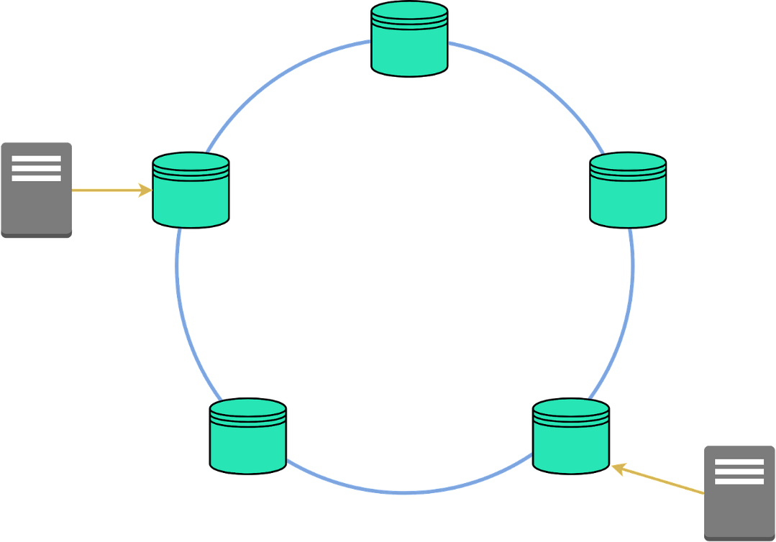](https://substackcdn.com/image/fetch/f_auto,q_auto:good,fl_progressive:steep/https%3A%2F%2Fsubstack-post-media.s3.amazonaws.com%2Fpublic%2Fimages%2Fcea65243-fbec-4531-9535-faf1b215adf6_1600x1122.png)](https://substackcdn.com/image/fetch/f_auto,q_auto:good,fl_progressive:steep/https%3A%2F%2Fsubstack-post-media.s3.amazonaws.com%2Fpublic%2Fimages%2Fcea65243-fbec-4531-9535-faf1b215adf6_1600x1122.png" \t "_blank)

### Quorum Writes and Reads

Now, let's start with a key concept that underpins leaderless replication: 'quorum writes and reads'. In a system without a leader, we don't rely on any single node to validate a read or write operation. Instead, we aim for consensus among a certain number of nodes. This number is called the 'quorum'. Using a quorum approach balances high availability with data accuracy, since we no longer require full consensus across all nodes.

In this system, we use three important values.

* 'n' is the total number of nodes in our system.
* 'W', the write quorum, is the minimum number of nodes that need to agree for a write to be considered successful.
* 'r', the read quorum, is the minimum number of nodes that need to agree for a read to be valid.

For strong consistency, a general guideline is to have w + r > n. It ensures that any read overlaps with any write and returns the most recent value.

For example, imagine a system with 3 nodes (n=3). If we configure w to 2, that means we need two out of three nodes to acknowledge a write request before it is deemed successful. If one of the nodes went down, the write operations could still continue. This idea works similarly for reads. If r is set to 2, the read operation would query 2 nodes and return the most recent data between the two.

[[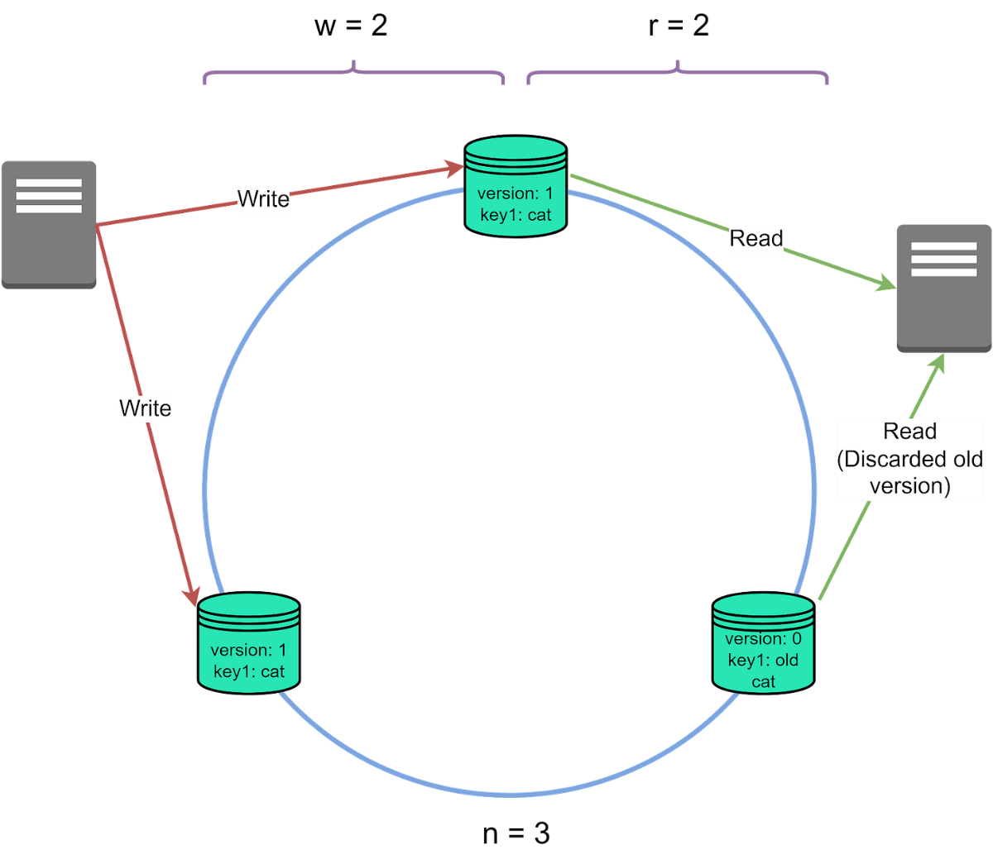](https://substackcdn.com/image/fetch/f_auto,q_auto:good,fl_progressive:steep/https%3A%2F%2Fsubstack-post-media.s3.amazonaws.com%2Fpublic%2Fimages%2F390efd96-5355-4510-816d-de1c3bc92405_1600x1386.png)](https://substackcdn.com/image/fetch/f_auto,q_auto:good,fl_progressive:steep/https%3A%2F%2Fsubstack-post-media.s3.amazonaws.com%2Fpublic%2Fimages%2F390efd96-5355-4510-816d-de1c3bc92405_1600x1386.png" \t "_blank)

SQL vs NoSQL

**Choosing the right database architecture**: When building applications, one of the biggest decisions is picking between structured (SQL) and unstructured (NoSQL) data storage. Both have unique strengths and cater to different needs, making this choice crucial for optimal data management.

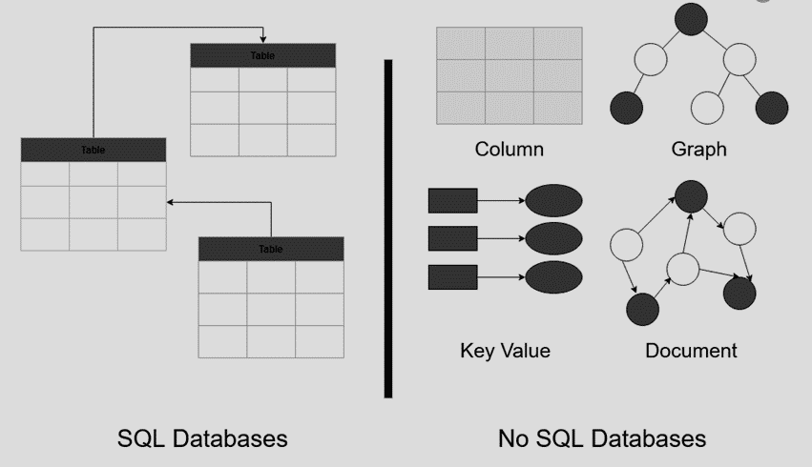

## Key Differences

* **Structure:** SQL uses rigid tables and predefined schemas, while NoSQL offers flexible document-based or key-value structures.
* **Queries:** SQL excels at complex relational queries, while NoSQL focuses on simple key-based lookups or document searches.
* **Scalability:** SQL scales vertically (adding more power to a single server), while NoSQL scales horizontally (adding more servers to the network).
* **Transactions:** SQL guarantees ACID properties (Atomicity, Consistency, Isolation, Durability) for data integrity, while NoSQL may not.

## When to use SQL

* **Structured data:** When data has a predefined schema and relationships between tables are well-defined.
* **Complex queries:** When your application needs to perform complex joins and analysis across multiple tables.
* **Transactions:** When data integrity is critical, and ACID properties are essential.

## When to use NoSQL

* **Unstructured data:** When data is dynamic, semi-structured, or constantly evolving.
* **High performance:** When your application needs fast responses and high scalability for large datasets.
* **Simple queries:** When basic lookups and document searches are sufficient for your needs.

## Popular Databases

* **SQL:** MySQL, PostgreSQL, Oracle, Microsoft SQL Server
* **NoSQL:** MongoDB, Cassandra, Redis, Couchbase, DynamoDB

**NewSQL:** a hybrid approach combining SQL’s ACID guarantees with NoSQL’s scalability. Useful for applications needing both features.

**Remember:** There’s no one-size-fits-all solution. Analyze your data and application needs to choose the best fit.

Database Indexes

An index is a database structure that you can use to improve the performance of database activity. A database table can have one or more indexes associated with it.

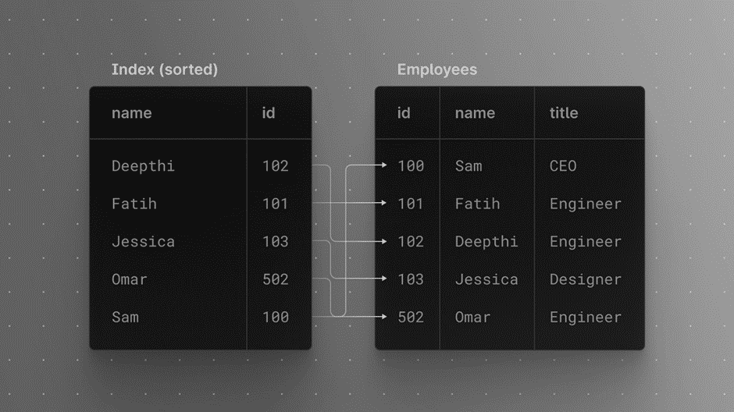

## What are indexes?

* Database structures for faster record retrieval.
* Think of them as bookmarks in a book, quickly directing you to specific pages.

## Benefits

* **Boosts search speed:** Especially for large tables.
* **Improves select queries:** Particularly effective for conditions matching the index expression.

## Trade-offs

* **Slower inserts/updates/deletes:** Maintaining indexes adds processing overhead.
* **Increased disk space:** Indexes consume additional storage.

## Choosing the right indexes

* **Consider how you use the table:** More retrievals? Create indexes for search criteria.
* **One field queries:** Simple indexes on individual fields.
* **Multi-field queries:** Concatenated indexes for frequently combined conditions.
* **AND vs. OR:** Indexes work well for AND conditions, not OR.

## Tips for optimal indexing

* **Match index expression to selection conditions.**
* **Use concatenated indexes for frequent multi-field searches.**
* **Prioritize AND conditions over OR in the Where clause.**

## Joins & indexes

* Indexes on second table’s join field significantly improve performance.
* Create indexes on join fields for subsequent tables in the From clause.

**Remember:**

* Indexes aren’t a magic bullet. Analyze your database usage and create indexes strategically.
* Too many indexes can be counterproductive. Find the balance for optimal performance.

What is a Distributed File System?

Distributed File Systems are a type of file system that manage the storage and retrieval of data across multiple servers and locations, making the distributed nature of the storage transparent to the user. These systems are designed to provide reliable, efficient access to files over a network, typically in a large-scale environment.

Distributed file systems (DFS) revolutionize data storage by enabling seamless access to files across multiple servers or locations. Imagine a vast network of storage units working together, appearing to users as a single, unified file system. This empowers large-scale environments to manage data efficiently and reliably.

**Core Concepts:**

* **Distribution:** Data is physically scattered across multiple storage servers, potentially located in geographically diverse locations.
* **Transparency:** Users interact with the DFS as if it were a local file system, unaware of the underlying distributed storage infrastructure. The system handles data location, retrieval, and replication behind the scenes.
* **Scalability:** DFS can easily scale to accommodate growing data volumes by adding new storage servers to the network.
* **Availability:** Data redundancy across multiple servers ensures continued access even if one server fails.

**Benefits of Distributed File Systems:**

* **Improved Scalability:** Effortlessly accommodate massive datasets by adding storage capacity on demand.
* **Enhanced Availability:** Redundant storage across servers minimizes downtime and ensures data accessibility in case of server failures.
* **Performance Optimization:** Distribute read and write requests across multiple servers, potentially leading to faster access times.
* **Centralized Management:** Simplify file system administration from a central console, managing policies and access control across the entire distributed storage network.

**Challenges of Distributed File Systems:**

* **Complexity:** Setting up and managing a DFS can be more complex than traditional file systems due to the distributed nature of storage.
* **Latency:** Accessing data across a network might introduce slight latency compared to local storage, potentially impacting performance for applications requiring real-time data access.
* **Security Considerations:** Securing data spread across multiple servers requires robust security measures and access control mechanisms.

**Common Use Cases for Distributed File Systems:**

* **Large-Scale Data Storage:** Ideal for organizations managing massive datasets, such as media and entertainment companies, scientific research institutions, or large enterprises.
* **Cloud Storage:** Many cloud storage services leverage DFS principles to provide scalable and reliable storage solutions for users.
* **Content Delivery Networks (CDNs):** DFS plays a crucial role in geographically distributing content across servers, enabling faster content delivery to users worldwide.

**Types of Distributed File Systems:**

* **Clustered File Systems:** Multiple servers collaborate to provide a single, shared file system within a cluster environment.
* **Network Attached Storage (NAS):** Dedicated file servers provide storage access to clients over a network.
* **Wide Area File Systems (WAFS):** Optimize file access across geographically dispersed locations, typically used in geographically distributed enterprises.

**Choosing the Right Distributed File System:**

The selection of a DFS solution depends on factors like:

* **Storage requirements:** The volume and type of data you need to store.
* **Performance needs:** The level of performance and access speed required by your applications.
* **Scalability considerations:** The anticipated growth of your data storage needs.
* **Security requirements:** The level of security and access control needed for your data.

## Strong vs Eventual Consistency

**Imagine your laptop notes like data in a distributed system.**

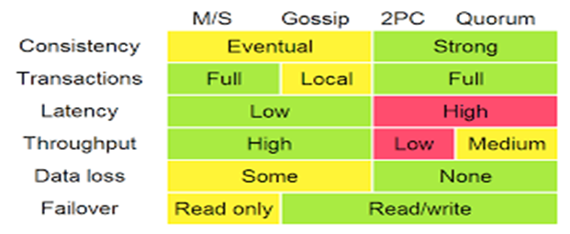

* **Master-Slave:** This is like **copying your notes to an external drive**. Both versions are consistent, but updating the drive takes time. You might read stale notes if it hasn’t been updated recently.
* **Eventual:** Think of this as **sending your notes to Dropbox**. Updates happen eventually, but not instantly. Reading before an update reaches Dropbox could give you outdated information.
* **Strong:** This is like **typing directly on your notes in Dropbox**. Updates are immediate and everyone sees the latest version. But writing takes longer as Dropbox syncs with all devices.

## Choosing the right model depends on your needs

* **High availability:** Eventual wins for fast reads and uptime, even if data might be stale sometimes.
* **Data consistency:** Strong guarantees the freshest data, but reading/writing might be slower.
* **Simple application logic:** Strong keeps things predictable, but eventual can be easier to manage.

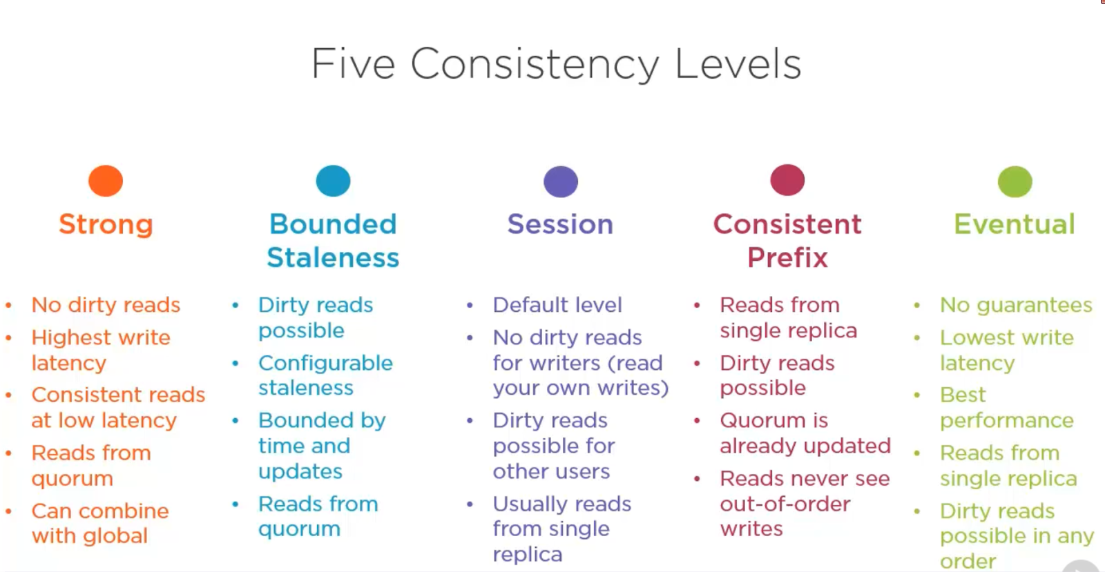

**Remember:** Each model has its trade-offs. Choose the one that best balances your needs for availability, consistency, and performance.

**Bonus:** Linearizability and Causal Consistency are stricter cousins of Strong and Eventual, respectively. They offer finer control over data ordering for specific situations.

Fault Tolerance

Fault tolerance describes a system’s ability to handle errors and outages without significant disruption. Think of it as a system’s backup plan when things go wrong.

## Why is it important?

Uptime is crucial for mission-critical applications. High availability, achieved through fault tolerance, minimizes downtime and keeps your system running smoothly even during hiccups.

## Key concepts

* **Multiple hardware/software:** Redundancy is key. Having backups for servers, databases, and software instances ensures continuity during failures.
* **Backup power:** Generators and failover systems protect against power outages.
* **Graceful degradation:** Some outages might result in reduced functionality, but the system remains mostly operational.
* **Survival goals:** Define how much the system should handle, from single node failures to entire cloud region outages.
* **Cost vs. impact:** Weigh the cost of fault-tolerant setups against potential losses from downtime.

## Real-world example

A major electronics company needed a scalable, fault-tolerant database. Manually sharding MySQL seemed complex and expensive. Migrating to CockroachDB, a managed, inherently fault-tolerant database, reduced manual tasks and saved millions in labor costs.

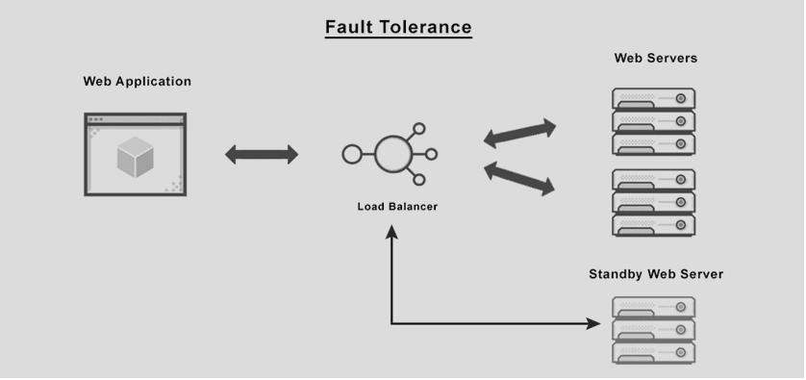

## Different fault tolerance approaches

* **Cloud-based, multi-region architecture:** Microservices running in Kubernetes clusters across regions provide high availability for both application and database layers.
* **CockroachDB:** This distributed SQL database offers inherent fault tolerance and scales horizontally, eliminating the need for manual sharding.

**Remember:** Fault tolerance is a spectrum. Choose the level that suits your needs and budget, aiming for minimal disruption and maximum user experience.

Distributed Messaging System

One of the common challenges among distributed systems is handling a continuous influx of data from multiple sources. Imagine a log aggregation service that is receiving hundreds of log entries per second from different sources. The function of this log aggregation service is to store these logs on disk at a shared server and also build an index so that the logs can be searched later. A few challenges of this service are:

1. How will the log aggregation service handle a spike of messages? If the service can handle (or buffer) 500 messages per second, what will happen if it starts receiving a higher number of messages per second? If we decide to have multiple instances of the log aggregation service, how do we divide the work among these instances?
2. How can we receive messages from different types of sources? The sources producing (or consuming) these logs need to decide upon a common protocol and data format to send log messages to the log aggregation service. This leads us to a strongly coupled architecture between the producer and consumer of the log messages.
3. What will happen to the log messages if the log aggregation service is down or unresponsive for some time?

To efficiently manage such scenarios, distributed systems depend upon a messaging system.

## What is a messaging system?

A **messaging system** is responsible for transferring data among services, applications, processes, or servers. Such a system helps **decouple** different parts of a distributed system by providing an **asynchronous** way of transferring messaging between the sender and the receiver. Hence, all senders (or producers) and receivers (or consumers) focus on the data/message without worrying about the mechanism used to share the data.

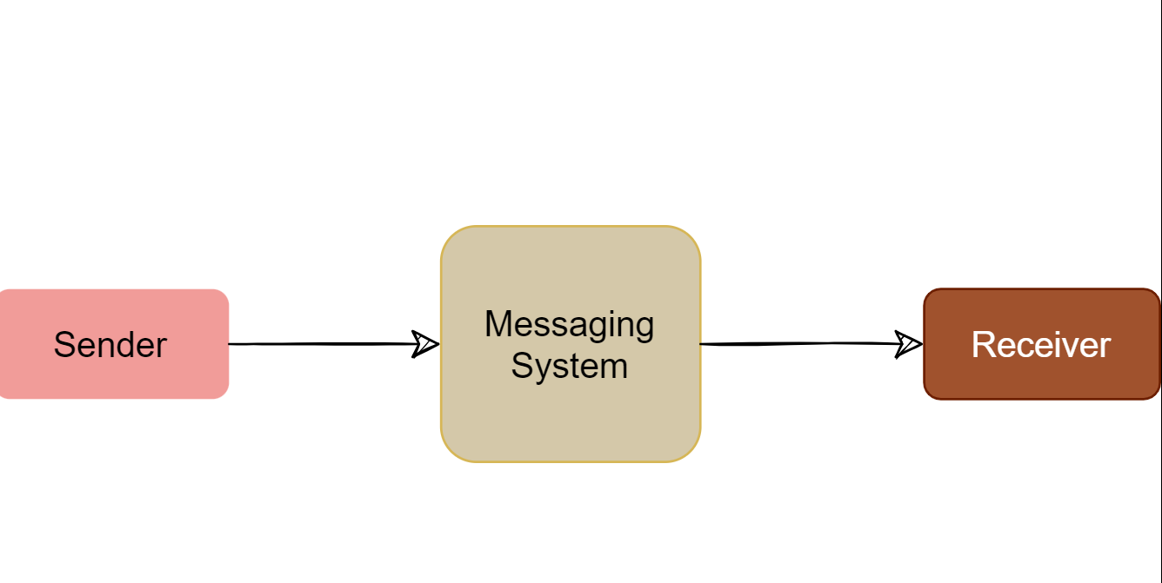

There are two common ways to handle messages: **Queuing** and **Publish-Subscribe**.

### Queue

In the queuing model, messages are stored sequentially in a queue. Producers push messages to the rear of the queue, and consumers extract the messages from the front of the queue.

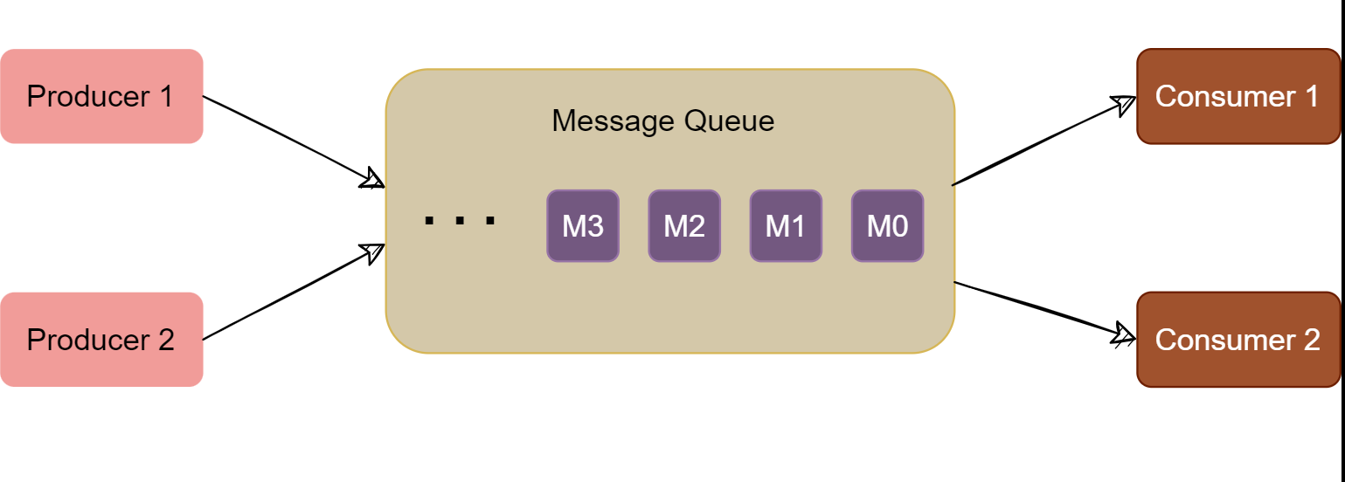A particular message can be consumed by a maximum of one consumer only. Once a consumer grabs a message, it is removed from the queue such that the next consumer will get the next message. This is a great model for distributing message-processing among multiple consumers. But this also limits the system as multiple consumers cannot read the same message from the queue.

## Publish-subscribe messaging system

In the pub-sub (short for publish-subscribe) model, messages are divided into topics. A publisher (or a producer) sends a message to a topic that gets stored in the messaging system under that topic. Subscribers (or the consumer) subscribe to a topic to receive every message published to that topic. Unlike the Queuing model, the pub-sub model allows multiple consumers to get the same message; if two consumers subscribe to the same topic, they will receive all messages published to that topic.

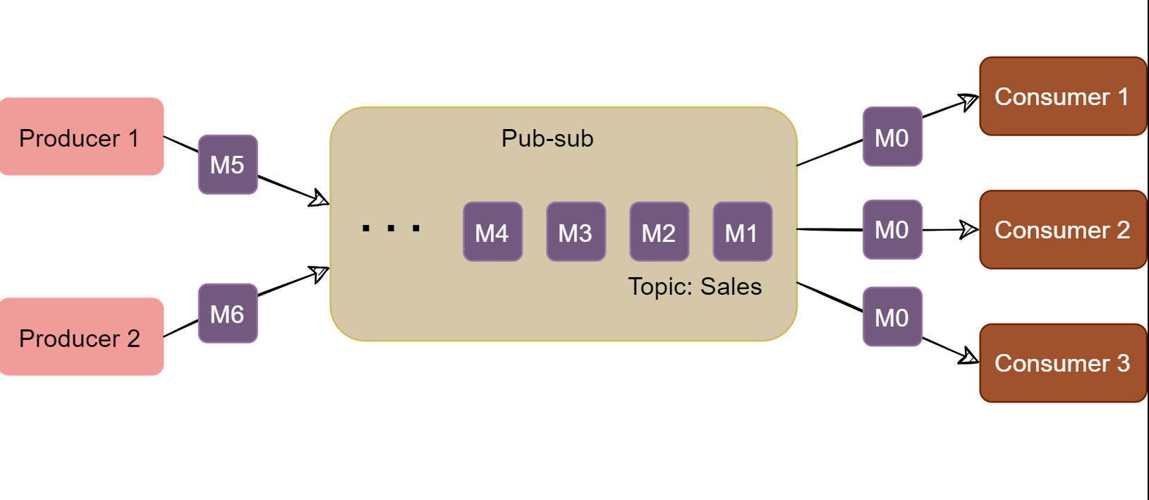

The messaging system that stores and maintains the messages is commonly known as the message **broker**. It provides a loose coupling between publishers and subscribers, or producers and consumers of data.

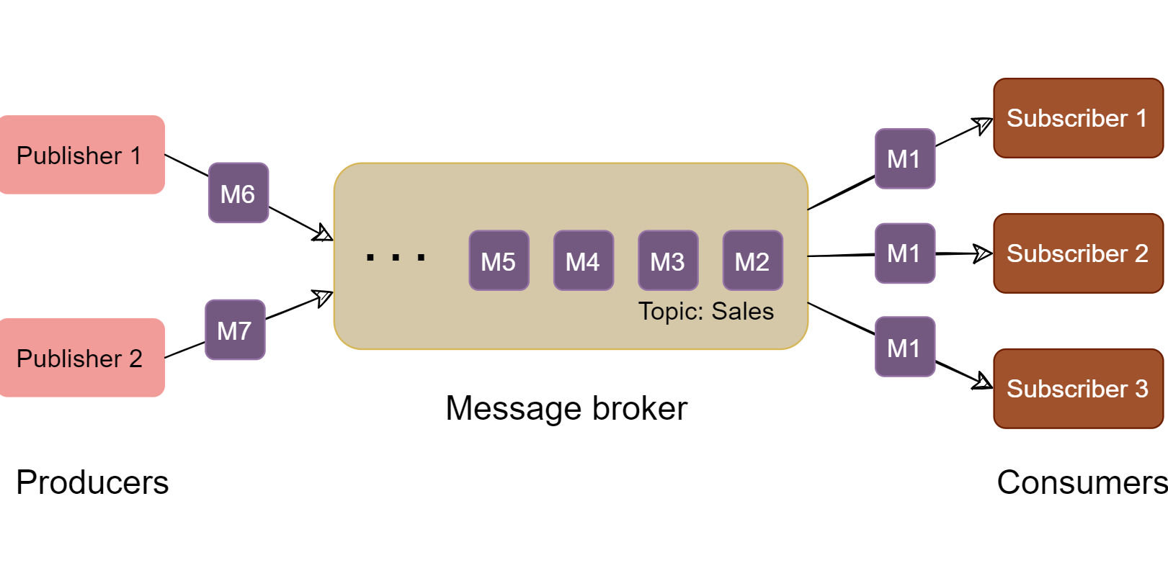The message broker stores published messages in a queue, and subscribers read them from the queue. Hence, subscribers and publishers do not have to be synchronized. This **loose coupling** enables subscribers and publishers to read and write messages at different rates.

The messaging system's ability to store messages provides **fault-tolerance**, so messages do not get lost between the time they are produced and the time they are consumed.

## Design with Message Queues

* **Offline vs. in-line work:** Choose based on user experience (e.g., task scheduling vs. immediate updates).

**Microservices and Message Queues:**

* **Decoupling services:** queues allow services to communicate asynchronously without blocking each other.
* **Message broker:** acts as a “mailman” delivering messages between services.
* **Example:** RabbitMQ, a popular message broker for microservices.

**Message Brokers:**

* **RabbitMQ:**
* Components: producer, consumer, queue, exchange (routes messages).
* Function: producer sends to exchange, exchange routes to queues, consumer receives from subscribed queues.
* Use CloudAMQP for ease of use.
* **Apache Kafka:**
* More complex, ideal for high-volume streaming data.

**Choosing RabbitMQ or Kafka:**

* **RabbitMQ:** Simpler, good for moderate workloads, microservices.
* **Kafka:** Scalable, high-throughput, complex setup, real-time streaming.

## Batch Processing vs Stream Processing

Batch processing vs. stream processing are two different approaches to handling data. Batch processing involves processing large volumes of data at once, at scheduled intervals. In contrast, stream processing involves continuously processing data in real time as it arrives.

## Need-to-know concepts

* **Real-time vs. scheduled processing:**
* Stream processing analyzes data immediately as it’s generated, enabling instant insights and reactions.
* Batch processing handles data in predefined chunks at scheduled intervals, offering high throughput for large datasets but with higher latency.
* **Applications:**
* Stream processing is ideal for fraud detection, real-time analytics, and live dashboards.
* Batch processing shines in ETL jobs, data backups, and generating reports.
* **Key differences:**
* **Latency:** Stream is low-latency (real-time), batch is high-latency (waiting for batch completion).
* **Data flow:** Stream handles continuous data streams, batch deals with finite chunks.
* **Complexity:** Stream can be more complex due to fault tolerance and data order issues.
* **Scalability:** Both can scale, but stream often horizontally (adding more machines).

## Understanding the big data angle

* Both methods handle vast amounts of data, but the approach differs.
* Batch processing aggregates data for deeper analysis later, while stream processing focuses on real-time insights and alerts.
* Choosing between them depends on the nature of the data, desired response time, and specific business objectives.

## Pros and cons

**Batch processing:**

* **Pros:** Simplified processing, high throughput, good for deep analysis, resource-efficient, mature tools.
* **Cons:** Delayed insights, inflexible once started, complex error handling, scalability challenges.

**Stream processing:**

* **Pros:** Real-time insights, flexible and adaptable, continuous data flow, suits modern data-driven apps, horizontally scalable.
* **Cons:** Complex infrastructure, potential consistency issues, requires advanced fault tolerance, resource-intensive, potential data order problems.

## Practical examples

* **Batch:** Financial statements, daily data backups, data warehouse ETL processes.
* **Stream:** Real-time fraud detection, social media sentiment analysis, live analytics dashboards.

**Remember:** There’s no one-size-fits-all solution. Choose the best processing method based on your specific data needs and desired outcomes.

WebSockets and Server-Sent Events

## Key Considerations:

* Communication Direction:
  + WebSockets: Full-duplex, enabling bidirectional, real-time communication between server and client.
  + SSE: Unidirectional, server-to-client only.
* Data Formats:
  + WebSockets: Support text and binary data.
  + SSE: Limited to UTF-8 text data.
* Setup Complexity:
  + SSE: Simpler setup, leveraging standard HTTP infrastructure.
  + WebSockets: More complex, requiring a dedicated WebSocket server or library.
* Browser Compatibility:
  + SSE: Supported by most modern browsers.
  + WebSockets: Near-universal support, but might require fallbacks for older browsers.

#### Use Cases and Recommendations:

* WebSockets:
  + Chat apps
  + Real-time collaboration tools
  + Multiplayer games
  + Live dashboards
  + Financial trading platforms
  + Interactive maps
  + IoT device communication
* SSE:
  + Live stock tickers
  + News feeds
  + Sports scores
  + Notification systems
  + Status updates
  + Social media activity streams

#### Additional Considerations:

* Latency: WebSockets generally offer lower latency than SSE.
* Scalability: WebSockets can handle more concurrent connections, but may require more server resources.
* Reliability: SSE has built-in reconnection mechanisms, while WebSockets may require manual handling.
* Security: Both protocols can be secured using TLS/SSL.

#### **Best Practices:**

* Clearly define communication needs: Understand whether bidirectional or unidirectional communication is required.
* Evaluate data format requirements: Determine if binary data support is necessary.
* Consider setup and maintenance overhead: Assess the complexity of implementation and management.
* Test for browser compatibility: Ensure support across target browsers.
* Plan for scaling and security: Implement measures for handling growth and protecting data.

**In Conclusion:**

The ideal choice depends on your specific application requirements. Prioritize WebSockets for full-duplex, real-time communication with lower latency and potential for higher scalability. Opt for SSE for simpler, unidirectional updates with less overhead and wider browser compatibility.

SLA, SLO, SLI

1. **SLA (Service Level Agreement)**: An SLA is a contract between a service provider and the end user that defines the level of service expected from the service provider. SLAs are output-based in that their purpose is specifically to define what the customer will receive. SLAs are typically made up of one or more SLOs.
2. **SLO (Service Level Objective)**: SLOs are specific measurable characteristics of the SLA such as availability, throughput, frequency, response time, or quality. These objectives must be met to achieve the SLA. They are often agreed upon between the provider and consumer of a service.
3. **SLI (Service Level Indicator)**: SLIs are metrics or measures used to define the SLOs. They measure compliance with an SLO. For example, if your SLA specifies that your systems will be available 99.95% of the time, your SLO is likely 99.95% uptime and your SLI is the actual measurement of your uptime.

Here are some benefits of using SLAs, SLOs, and SLIs:

* They allow companies to define, track, and monitor the promises made for a service to its users.
* They help teams generate more user trust in their services with an added emphasis on continuous improvement to incident management and response processes.
* They ensure that metrics are closely tied to business objectives.

However, there are also some challenges:

* SLAs are notoriously difficult to measure, report on, and meet.
* These agreements often make promises that are difficult for teams to measure.
* They don’t always align with current and ever-evolving business priorities, and don’t account for nuance.
* They require collaboration between IT, DevOps, legal, and business development to develop SLAs that address real-world scenarios.